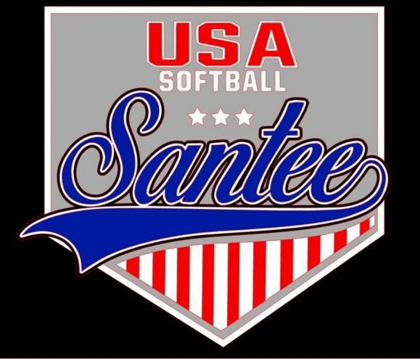
MINUTES TO BE APPROVED AT THE NEXT BOARD MEETING. THESE MINUTES ARE NOT CURRENTLY POSTED AND SHOULD NOT BE DISTRIBUTED UNTIL APPROVED BY USASSCS BOARD.
Board Meeting Minutes April 8, 2024
Location: Santee City Hall
Attendees Shown with Marked Box
President | Jay Strandberg | x | Field Prep | Kevin Hopkins
1st VP/ Field Prep | Erik Ruiz |  | Field Prep | Trevor Henton | x
2nd VP | Kelli Timanus | x | Field Prep | James Timanus | x
Treasurer | Tiffany Lynch | x | Field Prep | Nate Anderson
Secretary/Safety Coordinator/Head Scorekeeper | Bryan Scholar | x | Field Prep | Brad Allen | x
Tax Advisor | Lori Britt |  | Field Prep/Equipment | Shane Frary | x
Player Agent | Lance Craw | x
UIC/Parliamentarian | Felicia Leca | x | Head Team Parent Coordinator | Dana Hisaw | x
Field Scheduler/Fall Ball Coordinator | Chris Klima |  | Uniform Coordinator | Erik Ruiz | x
Webmaster/Social Media/All-Star Coordinator | Alexis Ruiz | x | Picnic Coordinator/Pictures | Kat Vecchione | x
BOTH Tournament Coordinator | Kayleigh Ponciano-Ahue | x | Snackbar #1 | Amy Ramirez
Sponsorships | Kylee Scholar | x | Snackbar #2
Awards | Janis Aiello | x | Social Media Coordinator | Sophia Vigil | x

Guests: Josh Teague
Meeting called to order: 7:07PM
Meeting Minutes
Amy Ramirez motioned to approve minutes from March 2024. Brad Allen seconded the motion.
Meeting rule – One Topic at a Time
Financial Update (Tiffany L)
[lp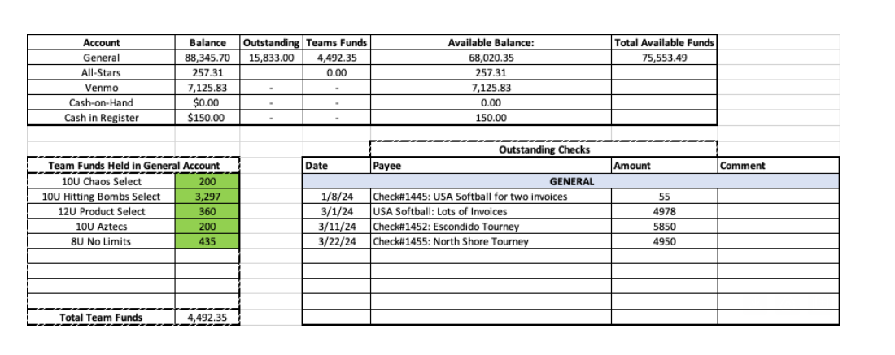

Complaints
None this month
Fields
- Should have enough supplies to get through the rest of the spring rec season
- 1st bases will be replaced at some point in the near future
Advanced Player Skills Clinic
- Sunday, April 21
- 8am – 10 am 8U/14U (Field 1 and 5)
- 11am – 1 pm 10U/12U (Field 1 and 5)
  - QR code to be created to capture uniform information
All Star Eligibility League Age Change
End of Season picnic
- Committee to meet on 4/9

Meeting Adjourned: 9:16 pm
Next Meeting: April 24

