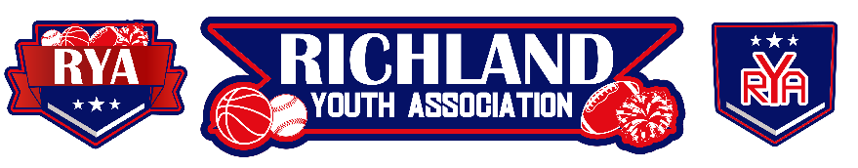
RYA August 2023 BOARD MEETING
Meeting Date: August 2, 2023 – 6:30pm
Board Member Attendees: Mike Cowan, Richard Stutheit, Eric Gomez, Lisa Willis, Kevin Vorpahl, Erica Stutheit, Tammy Treadwell, Emily Standifer
Absent: n/a
Non-Board Member Attendees: n/a

General Board Items / Old News
- The City of North Richland Hills will provide a “Home of RYA” banner to hang on the outfield fence at RF1. Need to finalize the logo that we will be providing them to add to the banner.
  - The RYA Board approved the banner at the top of these meeting minutes.
- Keys are being made and the city will rekey the locks at both parks – Richfield and Cross Timbers. New keys will be given to Mike and he will hand out appropriate keys to each board member as necessary.
- Richard has been added to the “big” RYA bank account, but still needs access to the “small” account. Richard and Mike will follow-up with Wells Fargo this week.
- Concession Stand Notes:
  - A new snow cone machine will be ordered for the Richfield Park Concession Stand, due to the previous one being only on loan. RYA Baseball will also be purchasing a new refrigerator for the Richfield Concession Stand, as the large “Coke fridge” is not cooling properly.
  - Mike is working on scheduling final appointments with the health inspector and city Parks officials to review concession stands.
  - Two new part-time employees will be hired to work in the Concession Stands for Fall Baseball programs. Each employee will be given a key to the Concession Stands. These employees could be available for working Basketball if needed.

Basketball: Vacant
- Still searching for a new Basketball director. Erica will work on registration building, while Mike and Richard will follow up with vendors for practice and game facilities.

Rec Baseball: Richard Stutheit
- Tammy is working on a fundraising RYA Baseball Craft Fair. She was advised to loop Emily and Special Events into the event coordination.
  - Estimated expenses would be $250 for site deposit/rental, $100 for portable trash cans, and $320 for magnet sign rental to advertise event.
  - Spaces would be rented out for $50/parking space.
  - The goal would be to get 40-60 vendors.
  - The estimated profit for this would be between $2,000 and $3,000 after approximately $700 in expenses.
- Richard requested new locks for the latches on all fields, due to several having rust damage. The city is also replacing the lock on the RF2 storage building.
- Registrations are ending for Fall Rec Baseball. Pre-season items include the Player Look, Coach Draft, and interlock agreements with Justin and Haslet Youth Associations for 10u, 12u, and 14u.

Premier/Tournament Baseball: Kevin Vorpahl
- There are three planned tournaments for this Fall, with one in September, October, and November.
- In talks with up to 7 teams to participate in RYA Premier Leagues, no teams locked in place at this time.

Football: Eric Gomez
- Football beginning practices.
- NWTX is still finalizing game schedules, but RYA will host pre-season games at RHS.
- No budget has been submitted to the Treasurer for Football this season. Eric is working on getting this submitted to the Treasurer.

Cheer: Lisa Willis
- Cheer beginning practices.
- Uniforms are ordered; Lisa will follow up with Richard and Mike to get uniform orders paid for weekly.

Communications: Erica Stutheit
- Assisting with Basketball registration building. Also soliciting volunteers for the open Basketball Director board position via social media and email.

Special Events: Emily Standifer
- Working with Richard on Fall Baseball opening day, bounce houses.

RYA Bank Accounts total of $48,908.92 and $524.10

Meeting adjourned at 8:23 pm

