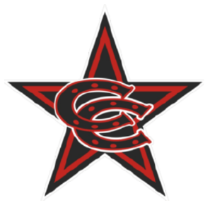

Spring 2026 11U Select Team Roster

Coppell Cowboys
Coach Porter
- Andrew Morchower
- Artham Goyal
- Brayden Porter
- Connor Newton
- Easton Turner
- Elisha Benge
- Isaac Martinson
- McKai Morningstar
- Nikhil Rao
- Om Kadam
- Paul Behrens

