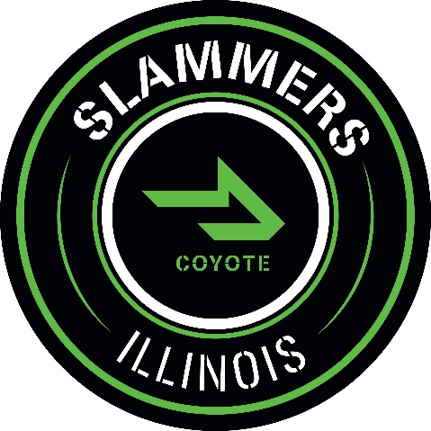

14u Slammers-Coyote Tournament Schedule
2021
Head Coach: Frank Berry
Assistant Coach: Blake Barr

Date: | Tournament: | Location:
4/1-7/5 | LSFBL AA Division | North Shore, IL
4/23-4/25 | Cream City Classic | Franklin, WI
5/28-5/31 | Hitters Invite | Kenosha, WI
6/4-6/6 | PBR Rock Championships | Franklin, WI
6/24-6/27 | PBRT Great Lakes National Qualifier | Westfield, IN
6/30-7/4 | Amateur Baseball Championship | Westfield, IN
7/9-7/11 | LSFBL Playoffs | North Shore, IL
7/15-7/18 | PG Super 25 Qualifier | Chicagoland, IL

14u Slammers-Illinois Tournament Schedule
2021
Head Coach: Adrian Brown
Assistant Coach: Zack Pawlowski

Date: | Tournament: | Location:
4/1-6/20 | MSBL A Division | Chicagoland, IL
4/9-4/11 | Dairyland Kick-Off | Franklin, WI
5/28-5/31 | Salute the Troops | Glenview, IL
6/9-6/13 | PGBA Indiana June Games | Westfield, IN
6/23-6/27 | MSBL Tournament | Elk Grove, IL
7/1-7/3 | Independence Day Classic | Chicagoland, IL
7/9-7/12 | WWBA North Championship | Cedar Rapids, IA
7/16-7/18 | Turf War | Wheeling, IL

14u Slammers Tournament Schedule
2021
Head Coach: Aaron Kasting
Assistant Coach: Steve Yeater

Date: | Tournament: | Location:
4/1-6/20 | MSBL A Division | Chicagoland, IL
5/14-5/16 | The Great Lakes Showdown | Franklin, WI
5/28-5/30 | May Madness @ The Rock | Franklin, WI
6/9-6/13 | PGBA Indiana June Games | Westfield, IN
6/23-6/27 | MSBL Tournament | Elk Grove, IL
7/1-7/3 | Independence Day Classic | Chicagoland, IL
7/9-7/12 | WWBA North Championship | Cedar Rapids, IA
7/16-7/18 | Turf War | Wheeling, IL

