Hitting Fundamentals

Adjust your stance. To get a nice swing, you first need to have the right stance. You should position yourself in the middle of the batter’s box to ensure that you can take a swing at anything in the strike zone. Place your feet parallel to the direction that home plant is pointing towards, and shoulder-width apart.
- Bend your knees a little, and try to distribute your weight evenly on the balls of your feet.
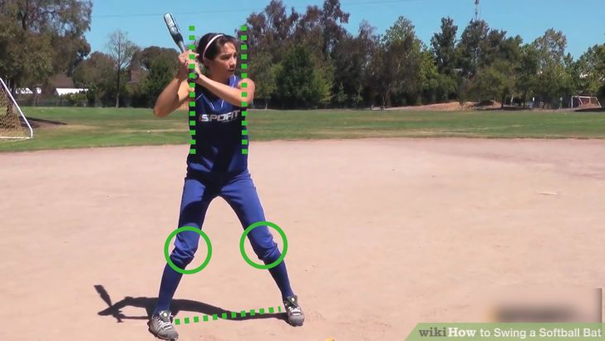

Check your grip. Take hold of your bat and grip it in both hands. If you are right-handed, the right hand is the top hand and the left hand the bottom hand. It is reversed for left-handers. The hands should be placed against each other, with the middle knuckles (or door-knocking knuckles) in a straight line. Grip the bat fairly loosely, and keep some flexibility in your wrists.^{[2]}
- Hold the bat a couple of inches up from the knob at the end of the bat.
- If the bat seems a little long, heavy, or hard to handle, choke your hands up the handle an inch or two.
- Choking up can increase the amount of control you have as you swing, but will generally mean you hit with less power.

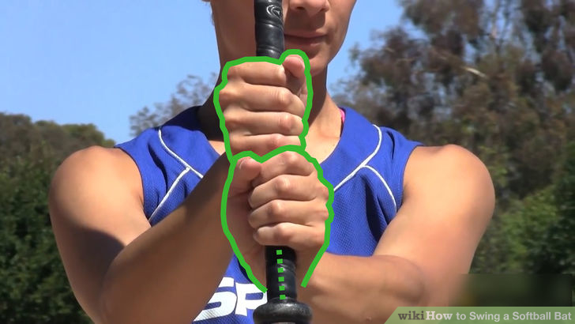

Position your hands and arms correctly. When your grip and stance are set, you are almost ready to swing. First, check your hand position. As you hold the bat, your hands should be quite close to your body, around three or four inches in front of your chest. Ensure your elbows are down and your shoulders are relaxed and free of tension.
- Then move your hands out a little, so they are around five to seven inches in front of your chest.
- Point the bat upwards, and angle it towards you slightly as you turn your head to face the pitcher.
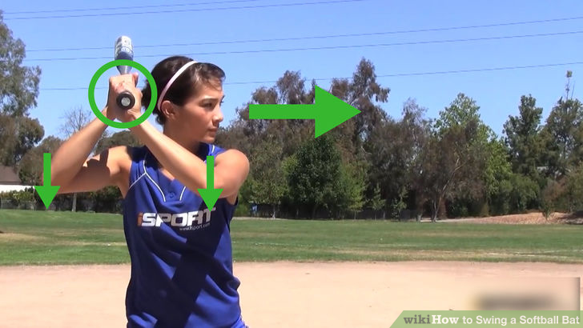

Swinging the Bat
Shifting your weight
Weight transfer from 50/50 to 60/40 on back leg. The weight transfer (load) must begin during the pitchers wind up. You cannot load as the pitcher is releasing the ball as there is not enough time to load and start the swing. The batter should load as the pitcher loads. The batter should be able to stay in a loaded position without losing balance as the pitcher completes the wind up.
- Lift the front foot slightly to feel the weight transfer.
- Hands stay at shoulder level and bat is still pointed up

Make a small forward movement. Now you are in position and are awaiting the pitch. Once you see the pitcher moving towards the release, you need to make a small movement forward with your front foot. This is known as the stride, or the toe tap, and helps you get forward momentum into your swing. Step your front foot (left if you are a right hander) forward a few inches, and place it at an approximate 45 degree angle to the pitcher.^{[5]}
- The amount you step forward will generally depend on how tall you are. The taller you are, the longer your stride is likely to be.
- For most people your stride will be between 2 – 8 inches. Make sure it is a small and fast movement.^{[6]}
- As you make this movement your front hip and shoulder may turn in a little. Try to keep your hips parallel and your front shoulder slightly lower than your back shoulder.

Make contact with the ball. Lead with your elbow, not your hands, as you swing your bat towards the pitch. For a pitch down the middle you should be aiming to make contact with the ball directly in front of your front hip. At the point of contact, both arms should be bent at angles close to 90 degrees, but by the time you have driven the bat through the ball, both arms should be fully extended.^{[10]}
- If you make contact when your arms are already fully extended, you will not get the kind of power you would if you make contact when you have a slight bend in your elbow and wrist.
- When you make contact, your top palm should be facing down to the ground. The palm on your bottom hand should be facing directly up to the sky.
- Make sure you keep your eye on the ball, watch it onto your bat, and hit through it on a level plane.

Follow through. The swing isn’t finished when you have made contact with the ball. The follow through is an essential element in a great softball swing. Straight after you make contact, your top hand will take over from your bottom hand as you roll your wrists through the swing. Keep your swing going through your arms so that your hands finish high above and behind your head, and your chest is angled slightly upwards towards the sky.
- When you finish your swing, your front foot should be open at a 45 degree angle to the pitcher.
- Your front leg should be locked, and your back leg bent as the weight is shifted back.
- Keep your eyes focused on where you made contact with the ball.

