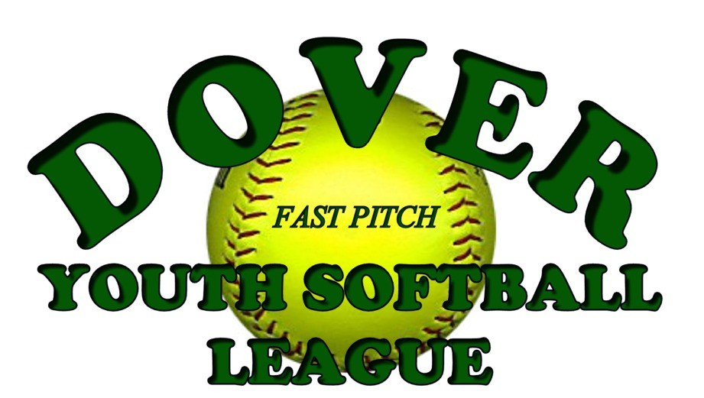

Constitution
Revision October 2017
Supersedes Amendments dated February 2014

ARTICLE I: GENERAL

SECTION A - TITLE
The organization governed by this constitution shall be known as the Dover Youth Softball League, or hereinafter by the designation DYSL. DYSL is affiliated with Babe Ruth League Softball. DYSL also provides organizational support to other nationally affiliated (i.e., ASA, NSA, USA Softball, etc.) summer tournament teams.
SECTION B - MISSION STATEMENT
The purpose of DYSL is to oversee organized youth softball for Dover, NH, specifically to provide an enjoyable training ground for softball players, and to promote good sportsmanship, good citizenship and the value of teamwork.
SECTION C - JURISDICTION
Dover, NH shall be defined to include the City of Dover, NH, with other surrounding communities to be included on an exception basis to a specific activity, as voted by the DYSL Board of Directors. DYSL serves ages 4-18, as conforming to established charter organizations.
As a member of Babe Ruth League Softball, DYSL currently accepts players from Dover, Durham, Lee and Madbury.
DYSL also accepts players from Somersworth jurisdiction when Somersworth is not able to field a team. This exception is renewed as required with NH Babe Ruth Softball.

SECTION D - PHILOSOPHY

- To accept the youth of the area served, without exception to race, religion, nationality, or gender.

- To accept the youth of the area served, regardless of financial status.

- An attempt will be made to ensure minimum playing time to all enrolled youth in the spring league.

- To promote teamwork, skills, recreation, sportsmanship, and the ability to attain individual goals, with competition as the means, not the goal.

- To provide the best possible level of instruction and organization to the end that the purpose of the DYSL is best served.

- To place an emphasis on serving all players in the league through spring, summer tournament and fall seasons.

SECTION E - RULES

Except where otherwise noted in this constitution, the DYSL business will be conducted according to the rules as set forth in the most current issue of Robert’s Rules of Order. These rules can be found at http://www.rulesonline.com/.

In conjunction with the rules listed herein, DYSL also reserves the right to conduct email votes of the Board when the President deems appropriate. The following criteria must be met in order for an email vote to be considered valid:

- The email vote must be sent to all members with voting rights (i.e., Board members and head coaches; and
- A quorum of ballots (or responses) must be returned to have a valid email vote. Unless otherwise stated, that would be 1/2.

SECTION F - ORGANIZATION

  - The DYSL is a non-profit organization under the rules and regulations of the State of New Hampshire and the federal Internal Revenue Code.

  - Section 1.6.F of the DYSL Constitution may not be amended unless to maintain full compliance with the rules and regulations attendant upon tax-exempt non-profit organizations as put forth by the IRS or subsequent appropriate federal tax body

  - Notwithstanding any other provisions of these articles, the organization is organized exclusively for one or more of the purposes as specified in Section 501c(3) of the Internal Revenue Code, and shall not carry on any activities not permitted to be carried on by an organization exempt from Federal income tax under IRC 501c(3) or corresponding provisions of any subsequent tax laws.

  - No part of the net earnings of the organization shall inure to the benefit of any member, trustee, director, officer of the organization, or any private individual (except that reasonable compensation may be paid for services rendered to or for the organization), and no member, trustee, officer of the organization or private individual shall be entitled to share in the distribution of any of the organization’s assets on dissolution of the organization.

  - No substantial part of the activities of the organization shall be carrying on propaganda, or otherwise attempting to influence legislation except as otherwise provided by the IRC 501(h) or participating in, or intervening in (including the publication or distribution of statements) any political campaign on behalf of or in opposition to any candidates for public office.

  - In the event of dissolution, all of the remaining assets and property of the organization shall after payment of necessary expenses thereof be distributed to such organizations as shall qualify under section 501c(3) of the Internal Revenue Code, or corresponding provisions of any subsequent Federal tax laws, or to the Federal government or State or local government for a public purpose, subject to the approval of a justice of the Supreme Court of the State of New Hampshire.

  - In any taxable year in which the organization is a private foundation as described in IRC 509(a), the organization shall distribute its income for said period at such time and manner as not to subject it to tax under IRC 4942, and the organization shall not:
- engage in any act of self-dealing as defined in IRC 4941(d),
- retain any excess business holdings as defined in IRC 4943c,
- make any investments in such a manner as to subject the organization to tax under IRC 4944 or
- make any taxable expenditure as defined in IRC 4945(d) or corresponding provisions of any subsequent Federal tax laws.

Adopted:

Signature President Date

/S/ Jamie Stevens 10/31/2017

Signature Vice-President Date

/S/ Aaron Frigon 10/31/2017

Signature Secretary Date

/S/ Jennifer Hutchinson 10/31/2017

