Purgatory Ski Team Handbook
Alpine

P.O. Box 4104
Durango, CO 81302
www.purgatoryskiteam.org

Contents

INTRODUCTION ...................................................................................................................................................................3
PST BOARD MEMBERS AND COACHING STAFF.....................................................................................................4
SCHOLARSHIP OPPORTUNITIES..................................................................................................................................5
ATHLETE CODE OF CONDUCT...................................................................................................................................6-7
WE ARE ALL A TEAM........................................................................................................................................................ 8
PARENTS CODE OF CONDUCT.......................................................................................................................................9
ROLE OF THE PARENT....................................................................................................................................................10
WINNING AND LOSING ............................................................................................................................................11-12
VOLUNTEERING ................................................................................................................................................................13
RACE DAY JOBS ..................................................................................................................................................................14
GENERAL TEAM INFO...............................................................................................................................................16-18
CONCUSSION POLICY ......................................................................................................................................................19
PST PROGRAMS ...........................................................................................................................................................20-28
POINTS AND PENALTYS...........................................................................................................................................29-30
SCORED VS NON SCORED AS A U14 .........................................................................................................................31
DRYLAND AND CONDITIONING…………………………………………………………………………………………….32
CHOOSING A “WILDCARD”……………………………………………………………………………………………………34
SUBSTANCE ABUSE POLICY………………………………………………………………………………………………….35
DISIPLINE POLICY……………………………………………………………………………………………………….......36-40

INTRODUCTION
Welcome to the Purgatory Ski Team. It’s an honor to have you and your athlete join the PST family. We hope that this handbook will help you understand the Policies and Procedures of the team. In this handbook you will find all sorts of useful information on all of our Alpine Programs. Take some time to familiarize yourself with the General Information pages as well as the age specific sections. This handbook is only one resource and there are many others, especially in the Recommended Reading section. And if you still can’t find the answer to your question, please feel free to contact any of the staff, we are happy to help.

PST MISSION STATEMENT
Our mission is to provide an opportunity for the youth of our community to become successful individuals and to achieve their personal goals through the participation in alpine skiing, freestyle skiing, freeride and snowboarding.

PST VISION STATEMENT
To support our mission the Purgatory Ski Team shall:
- Strive to provide a dedicated and qualified staff to guide, encourage and motivate athletes to accomplish their goals in an environment where skills in both winter sports and life lessons are taught.
- Provide its athletes a solid foundation of skills in a manner that is both safe and fun and that offers its members the potential for athletic success.
- Ensure that every child with the desire to participate will be given that opportunity and facilitate that the Durango Winter Sports Foundation will, when able, offer scholarships and financial assistance.
- Promote the development of the core values of: Respect, Sportsmanship, Confidence, Perseverance, Responsibility, Camaraderie, and Accountability.
- Instill life-long enthusiasm for skiing and snowboarding.

PURGATORY SKI TEAM SCHOLARSHIP PROGRAM

A goal of the Purgatory Ski Team and the Durango Winter Sports Foundation is to ensure that every child in the community that wishes to participate in winter sports has that opportunity. To support that goal, the DWSF provides funds to the Alpine, Freeride, Freestyle, Snowboard and Nordic Ski Teams to be used for scholarship programs.

PST Tuition Scholarship Program

- Full or partial scholarships may be awarded
- Both new members and returning athletes are eligible from various income levels
- All decisions to award scholarships are final and will be made at the sole discretion of the DWSF scholarship committee

Eligibility Requirements

- Application due by November 1st
- Scholarships awarded by November 15th
- Must demonstrate financial need and a strong desire to participate
- Consideration given to multiple athletes on team from the same family.

Distribution of Funds
- Scholarship funds are applied directly to the participants PST tuition
- A portion of scholarship funds may be retained for later disbursement to aid in travel expenses

PST ATHLETE CODE OF CONDUCT AND RESPONSIBILITIES

Each athlete is expected to act in a sportsmanlike manner and is responsible for their actions. The sponsorship and support of Purgatory Resort is our most valuable asset and it is a privilege to ski at Purgatory. Please think about your actions while on the mountain. You represent yourself and our team at all times through your behavior.

Good sportsmanship includes but is not limited to:
- Respect for event officials and volunteers, ski area employees, coaches, and staff, the skiing and snowboarding public, fellow teammates and fellow competitors.
- Self-control, responsible behavior, consideration of others’ physical and emotional wellbeing.
- A positive attitude promoting team spirit and team unity.
- Honest conduct.
- Maintaining the expected responsible behavior during away competitions. This includes time traveling, racing, and after competition.

PST will NOT tolerate:
- Skiing out of control
- Cutting in lift lines
- Profane or abusive language or behavior
- Cheating, lying, and/or theft
- Disrespect towards any coach, parent, lift operator, skier/snowboarder, ski patrol, event officials, etc.
- Any conduct reflecting poorly on the team while participating in any race, event, training or function
- The use of alcohol, illicit drugs or tobacco products

PST athlete responsibilities include the following:
- Academics are more important than athletics. Please make every effort to maintain a good grade point average and to satisfy your parents’ academic expectations.
- Competitors are expected to attend all training activities of their program. You are required to be on time and prepared for the day. This includes:
  - Having skis properly tuned and in good condition.
  - Wearing suitable clothing and be prepared for changing weather conditions.
  - Helmets and goggles are required at all times for training and competitions.
  - Make arrangements for your meals, bring a packed lunch including snacks or bring money to purchase a meal on the mountain.
  - Bring a positive attitude and be ready to ski.
  - While training and competing, each athlete owes it to themselves, coaches and competitors to put forth their best effort.
  - Athletes are required to remain with the team and/or ski as instructed by their coaches at all times unless arrangements made prior.

Skier Safety Responsibility Code:

1. Always stay in control and be able to stop or avoid others.
2. People ahead or downhill of you have the right of way. It is your responsibility to avoid them.
3. You must not stop where you obstruct a trail or are not visible from above.
4. When starting downhill or merging into a trail, look uphill and yield to others.
5. Always use devices to help prevent runaway equipment.
6. Observe all posted signs and warnings. Keep off closed trails and areas.
7. Know how to load, unload, and ride lifts safely prior to using them.

We all play a role in the “Team”
By joining PST, you have joined a team of adults that are here to ensure that your child is safe, has fun, and learns the skills and values of ski racing. This team includes the parent, the coach, and the athlete. The parents are a critical piece of the ‘team’ but it is important that parents understand what that role means and how to act in order for everyone to have a positive and successful season.

Job Descriptions
Parent: Love and Support
Coach: Teach and Challenge
Athlete: Work and Play (have FUN)

The relationships that exist among the ‘team’ go a long way toward determining the quality of the experience that the child has in the program. Some parents do not realize this and at first are surprised to find out that their participation is just as important as the coaches. When this happens, they miss opportunities to help their children grow, and sometimes do things that interfere with their children’s development without realizing it.
The child/athlete has rights as a member of the ‘team’. They have the right to participate and the right not to participate. Although the parent might choose to encourage participation, the child should not be pressured into participation. If they feel forced, their chances of receiving the benefits of the program are decreased and many times leads to the child quitting at an early age.

Congratulate your child if they win, congratulate them if they are last and support them if they fall

You’re supporting their effort....not their result
PST PARENTS CODE OF CONDUCT DURING THE SKI SEASON

- It is a team policy that parents are not to instruct their kids during training or competition. It can be very confusing for the competitors to hear differing messages from their parents and coaches. If you would like to discuss certain aspects of the training, please discuss with the coaches at the end of the training and/or race day. Please leave the instruction to the coaching staff, and do not plan on skiing with your child’s group. Instead meet them for the appointed lunchtime.

- Parents are encouraged to participate in a variety of roles in support of the team and are expected to volunteer. This includes assisting at events, organizing team events, planning for competitions, acting as chaperones for team members, and helping with fundraisers.

- Parents are expected to act and behave in a positive, constructive, and appropriate manner at all times, especially while in the presence of the team athletes. Please remember you are a role model to our kids and to other teams as well as a representative of the PST. Inappropriate actions will not be tolerated and can result in you and your child being excluded from training and competitions.

- When traveling, we require at least one parent chaperone for every six athletes to supervise athletes in the evening. The coaches cannot be responsible to chaperone athletes in the evenings. It is not the responsibility of PST or its coaches to transport your child, regardless of age.

- If your child is 12 or younger, it is mandatory for you to either travel with your child to events, or have a designated adult directly responsible for them for the entirety of the event.

- Make every effort to ensure that your competitor arrives at practices and events on time with all equipment necessary to participate. Equipment and bindings should be tested and in good condition and prepared in advance of the event or practice.

The role of the parent on race day is just that; parent not coach.
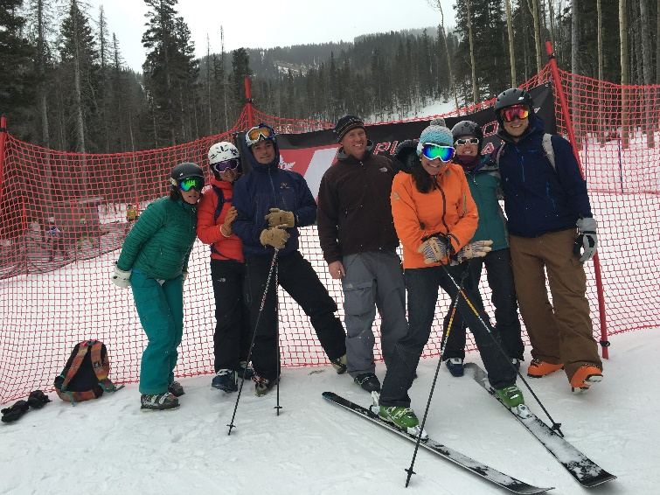
Your collective group of coaches have many years of experience with every kind of racer/athlete and there is very little we have not dealt with before. While we realize that many parents want to be involved on the day, it typically works best for the athlete if they keep to the routine that has been established in training. It is not just the ski racing we prepare for on training days but also race routine, what you do/think/say before, during and after the race.
Inspection, warm up, course reports, post-race feedback; these are all jobs for the coaching staff. This allows them to control certain information, which we believe is beneficial to the athletes. If you believe certain info is not being delivered to your athlete, please talk to the coach first, instead of to the athlete.
The start area is a coach/athlete environment. It is the start of their prep for the race, so they need to have focus and follow a routine. Swing by the top of the course to say “good luck” by all means, but then allow the athletes to get back to their normal routine which they have been preparing for. The start area is a skier’s dugout, so please respect the boundaries.
So what is your job on race day? You are their support network, their positive re-enforcement, and their cheering crowd in the finish area. This is a difficult sport and every great run has an element of luck in it. Some days we have it.....some days we don’t.
But by following a well-practiced routine from the start to the finish of the process we can hope to maintain an even keel, allowing the athlete to perform to their best in a familiar environment.

Winning...and losing

What’s the priority? Where do the kids learn the most? Is losing important?

In terms of the educational benefits of sports, kids learn from both winning and losing. But for this to occur, winning must be placed in a healthy perspective. The emphasis on enjoyment of sports and working hard for something increases their chances of having a positive experience.

Winning isn’t everything, nor is it the only thing. Young athletes can’t possibly learn from winning and losing if they think that they have failed if they didn’t win. Does this mean that children should not try to win? Definitely not! It would be naive and unrealistic to believe that winning is not an important goal in sports. But, winning it is not the most important objective at this age.

Fundamental skill development is the priority

It is important that we not define success only as winning. Not every athlete can win each race or become the next Mikala Shiffrin. Yet, every athlete can experience the true success that comes from trying his or her best to win. The opportunity to strive for success is the right of every young athlete.

Losing. It isn’t all bad

Valuable lessons can be learned from losing. Kids can learn to persist in the face of obstacles and to support each other even when they do not achieve victory. They can also learn that mistakes are not totally negative but are important stepping stones to achievement.

Kids learn the most from Failure

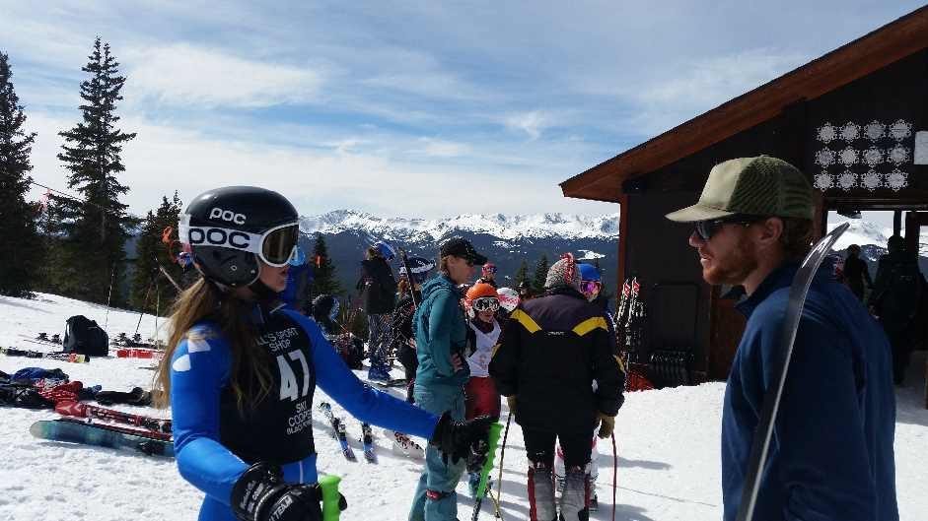
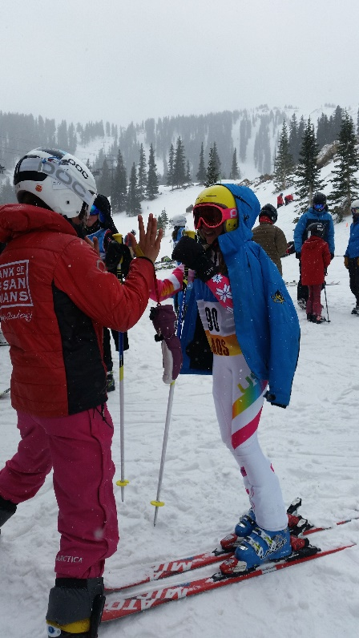
Success is not necessary winning. Success is feeling a new movement. Success is making your first arc. Success is finishing 25th when your previous best result was 40th. The winner isn’t the only athlete that has success. The important idea is that success is related to effort. The only thing that athletes have complete control over is the amount of effort they give on every run and on every day. They have only limited control over the outcome that is achieved. Kids are never “losers” if they give maximum effort!

The athlete’s development and personal performance
always comes first.

VOLUNTEERING

PST needs family involvement to run a successful program and quality events. The races and social events are fun, you get to know other families in the program, and if you pick the right position to volunteer for, you’ll have the best seat on the mountain to watch your son/daughter compete.

Volunteer Requirements

Many clubs require a “work deposit” that is refunded to the family after so many hours of volunteer time is completed. PST removed this policy in 2015 and has opted to test an honor system, knowing that everyone’s commitment levels are different. If this new policy results in the lack of volunteers, the work deposit system will be re-instated. But by removing the deposit we are helping with the already high cost of ski racing.

So what does the honor system for volunteering mean?

Certain jobs take more time or require more expertise, so the volunteer time will vary. Depending on how much time you have to give will determine your job. We ask that everyone volunteers for something at some point. That can be anything from prepping for events, running events, cleaning up after events, helping with admin duties, coordinating team travel and lodging, selling team apparel, and much more.

Alpine Officials Needed:

Alpine/Competition Officials are needed on race day. The commitment to become a CO is not a big one, but the position is critical. Some positions on the hill require certified AO/CO’s and events can’t happen without them. If you’re interested in becoming an AO/CO, contact the Program Director to find out what needs to be done. http://rmsro.org/clinics/

ALPINE OFFICIAL- long term commitment options: Race Admin/start finish refs/timing assistance

Sign up for a Alpine Official's License from USSA. Commit to a 1-day USSA Referee/Jury Officials course. Pass test. You will then be qualified to work as Start Referee, Finish Referee, Head Gatekeeper and other certified Race Worker jobs.
RACE DAY JOBS
MARK YOUR CALENDAR NOW
SOUTHERN SERIES SG AND GS JANUARY 13-16, 2017

REGISTRATION:
Greet racers, hand out bibs, assist the race administrator, etc. Indoors

BIB COLLECTOR:
Collect bibs in the finish area. Outdoors

BIB SORTER:
Sort bibs into their appropriate order post-race. Indoors

SCOREBOARD:
Post times on the outdoor scoreboard. Report to timing building. Outdoors.

SCOREBOARD PREP:
Prepare scoreboard for race. Write names and clubs of participants on board. Can be done the day/night before the event at home.

GATE JUDGES (GATEKEEPERS):
Record any missed gates by racers and help keep the course in good shape. You get to be at the best place to watch a race. Outdoors. On skis

COURSE MAINTENANCE:
Best job on the hill. Be on the lift early to help with hill set up, fencing, and general race prep before the event. Help with gate repair, slipping, and course maintenance during the race. Take down supplies, gates, and equipment after the race. Outdoors. On skis. See the race close up.

TIMING-Learning:
For those interested in learning about the timing of an event and wants to be a part of the crew in the future. Sit in on the events and learn how it’s done. Inside/Timing jobs include computer assistance, back-up timer assistant, and announcer. Inside.

HAND TIMING:
Record racers back-up stopwatch times at the Start or Finish area. Outdoors.

STARTER:
The job requires you to be at the start and communicate with the timing crew and then signal the start for each individual athlete. Outdoors.

ASSISTANT STARTER:
The job requires you to organize the athletes in the correct start order at the start area. Outdoors.

HILL STEWARD:
Bring coffee, hot chocolate, water, donuts, candy and hand-warmers to the on-hill workers (course crew, gate keepers, starters, etc.) during the race. Outdoors. On skis.

RACE MEAL DELIVERY:
Pick up lunches and deliver to the finish timing building. Collect and dispose of trash post-lunch. Outdoors. On skis.

AWARDS:
Organize awards pre-race and distribute post-race.

GENERAL INFORMATION

AVOID LOST EQUIPMENT

Please put athletes name on all pieces of gear and clothing, this will save you time and frustration when things get misplaced or get mixed with other athletes stuff. Please make sure that you and your child account for all gear, lunch boxes and clothing at the end of your day to help avoid confusion.
CELL PHONES
Cell phones can be a great tool but can also make for a big distraction. We prefer our athletes leave phones in the lodge but if you prefer your child ski with their phone that’s ok but please instruct them that cell phones during ski team are for emergencies only and will be taken away if it becomes a distraction. No cell phone use on the lifts! Cell phone use during lunch is discouraged. Be social at lunch and on the lift- make a new friend.
CHECK AND READ EMAILS

Email is a primary form of communication for directors and coaches to reach parents about upcoming events. Please check your e-mail regularly so you don’t miss out on any important information or fun opportunities. Make sure your email on file with the team is current and that it doesn’t end up in your junk mail. If you feel you are still missing important info, contact the program director right away. Emails may come directly from the director, the coach or a third party software’s such as Team Snap.
COMMUNICATIONS VIA TEAM SNAP

Team Snap has been a great way for coaches to post training and race schedules and communicate with the parents. After registration, your email will be added to your Team Snap account from there, parents are responsible for “accepting the invite” and making sure all the contact info is current and up to date. Team Snap is also used to send group texts on travel weekends.

COMPETITION WAIVERS
Every competition venue will have its own release form…please make sure you are aware of this before every event and come prepared. While we like to encourage parents to accompany their children to away events, we understand that this cannot always happen. PST encourages parents to help each other with travel to away competitions and make sure the waivers are signed and delivered. Many away events use online waivers, which is great and links will be emailed before the race as to where to find them.
HEADPHONES
PST prohibits the use of headphones or ear buds during training and competitions for the safety of our athletes.

HELMETS -- ATHLETES
Helmets are mandatory for all athletes for on hill training sessions, as well as, all of the events in which we participate. U14 and up must meet USSA/FIS standards. No athlete will be allowed on the hill without a helmet. No exceptions.

HEALTH
All athletes are required to have personal health insurance with proof required at the time of registration. Please inform the coaches about any allergies, food allergies, medical conditions or learning disabilities prior to the start of the season.

RACE DAY CONDUCT

Athletes: It is the athlete’s responsibility: to be on time, have their own equipment ready to go, have their ski pass, and be properly dressed for the weather. Use the restroom and eat something nutritious before meeting on snow. A snack in the pocket is a must. A water bottle at the start is also a good idea.
Parents: As the event day approaches, make sure you have communicated your volunteer availability to the Program Director. Make sure that your athlete/s are registered for the event with waivers signed. Know when and where you need to be for your volunteer position.

SKI PASSES

The pass should be kept in a safe and secure place where it can be easily scanned by the ticket checkers. It can also be attached to the helmet which makes things much easier on race days and cold weather days. Make sure your athlete has their pass with them whenever they ski, they will not be allowed on the lifts without it. Each child is responsible for their pass and if it is forgotten they will have to sit out until they can get it replaced either by themselves or with a parent. Tracking down a pass is not the coaches’ responsibility. If the pass is lost during training, the coach will call the parent and assist in finding a solution.

TAKE GOOD CARE OF EQUIPMENT

Please keep your athlete’s gear properly tuned & waxed. Coaches are not responsible for tuning gear but can help make recommendations and give helpful tips. Older athletes should know how to wax and tune their own skis. PST will host various tuning clinics throughout the season. Make sure to conduct a binding check at the start of each season with a local shop. Also, keep in mind that most ski shops have tuning & waxing included in their season-long rental programs.

TERRAIN PARKS

PST permits the use of the terrain parks as a learning tool when with the coaches. There are a variety of parks at Purg, and the coaches are asked to use the parks that are appropriate to the age and ability of the group they are working with. The parks are an important learning tool for ski racers, but safety and proper park use is critical. Athletes are asked to stay out of the park when lapping runs without a coach during ski team training and or race days.

TUITION REFUND POLICY
No Refund will be granted for any reason. Optional Tuition refund insurance may be purchased through AIG at the time of tuition enrollment if this is a concern.
CONCUSSION POLICY

Any Purgatory Ski (PST) athlete under the age of 18 years suspected of having sustained a concussion or traumatic head injury must be removed immediately from participation in PST/USSA sporting events (e.g. sanctioned training, practice, camps, competitions or tryouts), by a USSA Technical Delegate/Supervisor or USSA member coach or PST member Coach overseeing such sporting event. The minor athlete will be prohibited from further participation until evaluated and cleared in writing to resume participation in above sanctioned sporting events by a qualified “health care provider” as defined under C.R.S. § 25-43-102(1). The qualified health care provider must certify to PST and/or USSA in the clearance letter that he /she is a doctor of medicine, doctor of osteopathic medicine, licensed nurse practitioner, licensed physician assistant, or licensed doctor of psychology with training in neuropsychology or concussion evaluation and management. Upon removal of a minor athlete from participation for a suspected concussion or traumatic head injury, the USSA TD or member coach or PST Member coach, making the removal must inform USSA Competition Services. Athletes who have subsequently been medically cleared to resume participation must provide such medical clearance (as described above) to PST and USSA Competition Service in order to be permitted to participate in PST or USSA sporting events.
A concussion is a type of traumatic brain injury (TBI) caused by a bump, blow, or jolt to the head. Concussions can also occur from a fall or a blow to the body that causes the head and brain to move quickly back and forth. Doctors may describe a concussion as a "mild" brain injury because concussions are usually not life-threatening. Even so, their effects can be serious.
Risk of Continued Participation
A repeat concussion that occurs before the brain recovers from the first-usually within a short period of time (hours, days, or weeks)-can slow recovery or increase the likelihood of having long-term problems. In rare cases, repeat concussions can result in edema (brain swelling), permanent brain damage, and even death.
The USSA, USASA and PST recommend that Members review the Center for Disease Control's resources on concussion awareness at the following link: http://www.cdc.gov/concussion/HeadsUp/online_training.html
Many youth sports programs are starting to require baseline testing prior to participation. These valuations help to monitor athletes’ recovery once a concussion has taken place. The Impact Test can be a great tool to determine the status of recovery following a suspected brain injury. PST does not require the Impact Test but highly recommends it and will advertise when and where testing will take place. For more info, https://www.impacttest.com/
PST Alpine Programs
In an effort for promote team unity and create more efficient training environments, there has been some recent changes to the structure of our programming. The former “Snow Demons” and “Race Tigers” programs is now a hybrid of the two- the Snow Tigers- designed specifically for ages 6-8 as a feeder program for PST for alpine and freeride. Keep in mind that our Freeride Devo program does not start until age 10. Therefore, we ask 9 year olds who are looking to join Freeride spend a season in the U10 Alpine program to progress fundamental skills and technique as a pre requirement to their first year in Freeride. (see Freeride handbook for further details.)
The former “Team Southwest” will simply be referred to as “Purgatory Ski Team” and the groups will be based on the USSA Age Class structure. Tuitions will be based on part time and full time commitment. This will bring the team back under one umbrella so to speak, especially when it comes to Southern Series events where we had a lot of cross over between Race Tigers and Team Southwest but not everyone felt part of the “team” due to such classifications. The “Purg Cup” option is still available as a Saturday only program within the age groups as a cost effective alternative to help keep older athletes racing with the goal of someday bringing back a high school ski team.
The training groups are then defined as so:
Snow Tigers ---- U10/U12 ---- U14/U16 ---- U18/U21

Each age class is very specific. What the athletes learn and when they learn is crucial in their development as athletes and will help their progress as ski racers. Fun, free skiing, technical free skiing, drill courses, and full training courses are all pieces used at various ages.
Around age 10 and up, things either start to pick up for a ski racer who has had some years of racing experience or can also be an age where athletes might decide they want to start racing. We provide coaching for all situations and like to make everyone feel like part of the team regardless of their skill level.
Every year our ski groups spark controversy and concern amongst the parents. Please trust your professional coaches to make decisions for the good of our whole team with a specific purpose in mind. If you have a problem or concern with anything to do with our team please approach the Head Coach. Do not let problems fester or get blown out of proportion. Let’s take care of problems quickly.
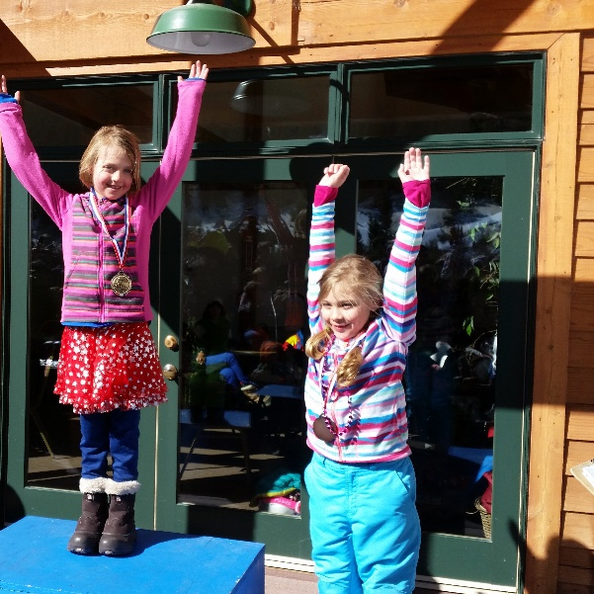
Snow Tigers Program Age 6-8
This program is a great way to keep young skiers excited about skiing. With fun skiing games and drills coaches will help students continue to build on the basic skills- from balance and stance, pressure, edging and carving. The goal is to create well rounded and responsible skiers. Tigers are expected to already know how to ski in control at an intermediate level. The intent is to then enhance those skills through an all-day program for those skiers who need more time on snow and are ready for more of a challenge. Athletes will experience all aspects of skiing from basic skills to moguls, tree skiing, park and pipe as well as training on slalom and giant slalom race courses. Much of the day will be spent skiing various terrain with a focus on skill development and refinement. RACING IS NOT REQUIRED but there are race options available through the local race series and we encourage Snow Tigers to try at least one. The focus of this program is developing skiers, not necessarily racers. This is a great introductory program leading up to the alpine race, freeride and freestyle programs. Participation in the Snow Tigers program will help determine what aspect of the Purgatory Ski Team the athlete wants to explore next. Snow Tigers ski from 9-3 with appropriate lunch breaks and snack/water breaks.
Tuition Includes:
- 10 Saturdays at Purgatory to develop fundamental skills in a team atmosphere while learning to explore and ski comfortably on the entire mountain
- 6 Skills & Drills Nights at Chapman Hill Jan-Feb (day of the week TBD)
- Dedicated training access to NASTAR Race Course
- Ski tuning discounts at Second Avenue Sports
- Ski Tuning Support and Clinics (parents welcome)
- Total coaching time approx. 70 hours
Tuition does NOT include:
- Purgatory Resort Ski Pass/Chapman Hill Ski Pass
- Seasonal Ski Rental/other equipment
- Purg Cup/special events entry fee
GOALS for Graduating Snow Tigers

Personal Accomplishments:

- Gets along with others on the team
- Communicates with the coach about needs and feelings
- Can look after and be responsible for their own equipment
- Can safely ride all lifts
- Demonstrates respectful lift line etiquette (no rope ducking or cutting)

Skiing Accomplishments:

- Ability to put on and buckle boots
- Carry own equipment to and from base area
- Maintain a good athletic stance in most conditions on Intermediate trails
- Understands and demonstrates the ability to flex at the ankle
- Ski in parallel with completed turns
- Have an understanding of Balance and ability to demonstrate skiing while balanced over the middle of the ski.
- Can lift inside ski and maintain balance over the outside ski in a turn
- Pole Plant correctly
- Ability to skate across flats
- Ability to ski Powder on a blue trail
- Has participated in a Purg Cup event
- Safely negotiates the features in the mini park and tree trails
- Has the ability to make controlled short radius turns on moderate steeps

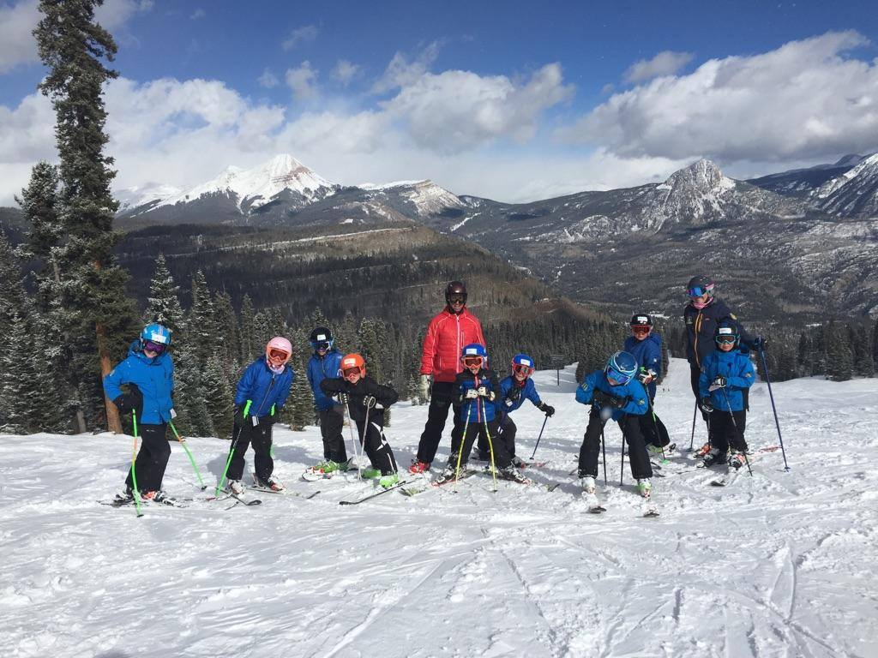
Alpine Saturday Program
Great for U10/U12 Age 8-11

With a strong focus on skill building in all types of terrain, coaches will also develop the athlete’s introductory knowledge of racing skills, techniques and tactics. Athletes are required to ski at a strong intermediate level- this is parallel turns on any blue or easy black while maintaining speed and control. Graduating from Snow Tigers or another PST program is helpful but not required before starting this program.
This is a good age to expand the athlete’s knowledge of the race arena so the athlete can determine if they want to pursue racing more seriously in the future or explore other avenues of skiing. We focus on more drills while also incorporating fun and challenging free skiing opportunities. Gate training is about 30-40% of the training.
Racing is not required and coaching will be provided on weekends that some of the team is travelling. Opportunities for local and club races are available as well as participation in USSA sanctioned races for higher competition. For those choosing to participate in USSA races, we offer the Southern Series races which consists of three-four events located usually at Purgatory, Flagstaff and Taos. Racers do not have to attend all events to participate in the Southern Series. U10s are welcome to participate at the U10 Championships in Telluride with no need to qualify and the U12’s are welcome to attend the U12 Championships in Powderhorn with no need to qualify.

Part-time/full time Programs
U10/U12 Age 8-11 and U14/U16 Age 12-15
Although this program is designed for the serious ski racer who is dedicated to learning technical and tactical skills and wants to compete against the best in their age group through the USSA Rocky Mountain Division (RMD) and/or the local Purg Cup series, it is not limited to those who want to start racing around age 12 or up. The Purg Cup option to the U14/U16 age group is thus the solution for both keeping those involved that maybe can't commit to full time travel schedules and for those who want to start racing at a later age. The part time/full time tuition will reflect more training time for those that are committed to more competition.
Depending on age group, the team trains about 40-60% of the time in gates to focus on tactic and techniques important to ski racing. However, an emphasis on free skiing is also incorporated into training, keeping in mind that to build a strong racer, you must first have a strong skier. There are multiple levels of commitment for this age group including additional mid-week training opportunities at Purg for those whose academic schedules are flexible.
The part-time program focuses on weekend training, Saturdays & most Sundays plus 1 or 2 days a week of mid-week training at Chapman Hill.
This schedule allows for increased skill retention, more time on snow, appropriate gate training in slalom, giant slalom and entry level speed elements.
The goal is to increase the fundamental mileage necessary for upper level skiing, competition and future development. Part Time U14 athletes will participate in the USSA Southern Series events as well as special USSA events and local events. Speed elements for U14 available. Part Time U16 will participate in the USSA Ability Class events, special events and speed element opportunities. U14/16 will have the opportunity to qualify for the Rocky/Central Junior Championships.

The full-time program focuses on weekend training, Saturdays and Sundays plus 3 days a week of mid-week training at Chapman Hill with alternating weeks of in-season strength and conditioning once a week.
Racers will be encouraged to participate in early season conditioning and early season skiing opportunities leading up to the season. Full-time athletes will focus on individual goal setting, training/competition objectives and health and wellness practices. This will help determine the individual’s strengths, areas of improvement, skill set and overall goals for the program.
Full-time athletes must commit to mid-week training (some exceptions may apply). Full-time athletes also must maintain a B/3.0 average in school by properly managing their training, travel, competition and academics.
The goal is to increase the commitment and intensity for upper level skiing, competition and development to create the necessary foundation for future success in FIS or collegiate level skiing.

The U14/U16 Purg Cup program focuses on Saturday only training plus 1 night of mid-week training at Chapman Hill. This program is designed for both the racer who is unable to commit to travel but wants to enhance their race performance and compete against local racers and fellow team members and those new to the sport who want to race. Athletes, ages 12 and up only, will be required to ski at a strong-intermediate level with good fundamentals. Athletes will train with part-time and full-time racers where schedules overlap. Athletes will compete at the local Purg Cup series and the Purg Southern Series events with the purchase of a short term athlete USSA membership $15-25/per day depending on age. Additional nights at Chapman may be added with an increase in tuition.

Mid-week Purg training
For those who have adjusted their academic schedules to allow for more training opportunities, there will be coaches available based on a set schedule that fits the majority of the group.
Athletes that are not regularly scheduled to attend such sessions are welcome to participate when their schedules allow for an additional per use fee.

Example Mid-Week Schedule:
Monday: Off/Rest
Tuesday: Purg 9:00am-12pm Chapman 6:45 pm-8:45pm
Wednesday: Chapman 6:45 pm-8:45pm
Thursday: Purg 9:00am-12pm Dryland 5:00pm 6:00pm
Friday: Purg 9:00am-12pm or travel for races

U18/U21 Program Age 16-18

At the U18/21 level we are looking for athletes to be fully responsible for their own training. This means communicating with the coach, knowing what your training schedule is, asking your coach if you don’t know, and knowing how to find out information by checking PST resources and emails. The coaches are looking for the athlete to be punctual to training and to communicate if they are not going to be there.
We are looking for the athlete to be self-sufficient and to take the initiative, both from experience and by following others good examples. We are looking at this age group to be positive role models and set the standard for the rest of the team to follow.
A U18/21 athlete should have the confidence to travel without their coach and attend projects at other mountains where they may not know the coaching staff, while being able to represent their home team in a fitting manner.
As athletes move up into the older age groups, the sport becomes more equipment demanding and is somewhat dictated by your personal goals. IE: US Ski Team, Colligate, local races or recreational.
If your path is to become an all-round 4 event skier with aspirations of the US Ski Team, you will eventually need 2 pair of skis for each discipline, one being a trainer and one for racing, training skis and race skis should be the same so the transition from train to race is seamless. (Please contact coaches as to recommendations when it comes to this)
If you are on a Colligate path, the speed skis no longer play a role because Colligate racing is only SL and GS. However, SG is recommended as a training tool but not mandatory.
If you are on more of the social path (for the fun of it) you can get away with one pair of ski per discipline.
There are rule & requirements as to ski lengths and radiuses so please refer to the current equipment rules page of the comp guide. www.ussa.org Go to Alpine-Coaches-Rules-2016 Alpine Comp Guide-Equipment Rules (this will also give boot regulations)

Points/Penalty Explanation

It is important to recognize and remember that PST is NOT a “points” driven club because a racer that gets caught up on worrying about points has an increased chance to lose focus of our long term core values and personal performance. However, as our racers advance to higher competitions, it is still important to understand how the system works.
When Junior Racers enter the U16 level, they become eligible to 'score' USSA points. To be eligible, they must have joined the USSA as a scored 'Competitor'. Each new U16 will start the season with 990 points in each discipline (SL, GS, SG, DH, and SC). As they finish races, their points will be reduced.
The competitors 'points' will be used to determine their race start position. The lower the points, the earlier the start (except for the 15 competitor's with the lowest points).
Competitors with 990 points will have their start position determined by a 'random draw', and will start after all the other competitors. The first 15 starts will go to the 'top 15' competitors (with the lowest points), who will also have their start position determined by a 'random draw'. The aim of this system is to give the best competitors a chance to run the race course early, before it gets too beaten up. Every time a competitor finishes a race, their finish time is compared to the finish time of the winner, and multiplied by a factor (published by USSA - different for each discipline), to determine their 'race points'. The race winner automatically gets ZERO
This system would allow a competitor to lower their points considerably by finishing well in a race with a mediocre field; while the same competitor racing against Daron Rahlves, or Kristina Koznick would end up with very high points. To make the system fair, a 'race penalty' is added to each competitors 'race points'. This 'race penalty' is a complex calculation based on the starting and finishing points of the best competitors in the race. When racing against Daron Rahlves, the 'penalty' would be very low. The 'penalty' will be high when racing against mediocre competitors. The aim is to make the total of the 'race points' and 'penalty points' become the same, no matter whom the competitor is racing against. Details of the calculation methods for both 'race' points and 'penalty' points is explained in chapter three of the 'USSA Competition Guide - Alpine'.
The USSA publishes a point list several times a year. Each competitor's 'points' are calculated by taking the average of their two best results (for each discipline). This means that a competitor will have different points for SL, GS, SG, and DH.
A competitor's race start position is determined by the points listed in the LAST USSA published list (NOT by the average of the latest best results). After each race, the points for all finishers are sent to the USSA. The USSA has a 'Closing' date a few days before each new list is published. They will take the points for all the races that all athletes have finished, up to the 'Closing' date, and use the best two results in each discipline to calculate an athlete's points for the new list. The new list will be published on the 'Valid' date. The 'Closing' and 'Valid' dates for each list can be found near the front of the USSA Competition Guide.
At the end of each race season, the USSA adjusts the points of every racer in the US. This is because it is possible for the best in the US to get negative points, and the best in the US is supposed to have zero points. The adjustment is different for each discipline. Don't be surprised if the hard-won point’s reductions for this season are adjusted upward for
A new U16 racer can get their points for a specific discipline (SL for example) off the 990 base, by competing in, and FINISHING at least one race before the 'Second Points List' closes - usually just after the New Year. This will get them a fair start position in all races of that discipline after the 'Second Points List' is valid. If only one race is finished, the list will contain the points earned in that race, plus an adjustment because only one
The first season for a new U16 will be spent trying to COMPLETE two races in each discipline so that they will get fair starts in their later races. The points generally reduce rapidly at the start of a U16's racing career, but it becomes harder and harder to reduce points as the competitor's career progresses.
New U18 racers start this process again with FIS (International Ski Federation) points starting at 990. There are several FIS lists published each year, with the points of every racer in the world. FIS has different dates to the USSA - with the FIS list usually valid just before the USSA list closes.
For FIS races taking place within the United States, races are "dual scored". This means competitors in FIS races earn both FIS and USSA points. Each is calculated separately based on their own points list. The calculation of race points is the same, however, the
FIS penalty and USSA penalty will almost always be different.

Full details of the 'points' system can be found in the 'USSA Competition Guide – Alpine.' We encourage athletes and parents of all ages to be familiar with the Rule book in general.
Scored Verses Non-Scored as a U14

There will be a few times throughout the season where U14’s have the option to enter a “scored” race. There is no right or wrong answer to whether the athlete should be in the scored or non-scored race, however if you and your athlete are trying to make that decision, please do so with a coach as there are many factors to consider and the coach will help determine the best choice in relation to the athletes current mental/emotional state and long term goals.
Here is a good example of a response from a coach when asked by a concerned parent as to what race to register their U14- scored or non-scored:
“That seems the be a tricky question, not just for us in the south but a lot of clubs are trying to figure out which kids should be chasing points as a 1st year U14 and which as a 2nd year U14. The benefit in the end of chasing points is for those athletes going into their U16 year with a better start position as they have already dropped from the 990s. But, here is my opinion as I saw us struggle last year. For the competitive kids in the North Rockies it is advantageous for them to "chase points". For the kids that are not super competitive I saw it as detrimental to their desire to race and compete and it did not improve their start order over a whole year running in the 90's vs 110's not much different given the cost and travel. We had a few girls end up back of the pack a few times and they just got down on themselves.

In the southern series though, it is a low key way to drop your points from the 990's for the next year. Our field sizes are smaller and it isn't as intimidating and they can drop their points in a big way. For some of the first years traveling to the low point races they may still not drop points a lot if they are far behind the 1st place for the penalty. Just my 2 cents, but I think it's better as a first year U14 to build confidence and get some points at the same time at a smaller field to start.”

ATHLETE CONDITIONING AND DRYLAND
Conditioning has become a major factor in athletic success as well as injury prevention. It is imperative to train year round whether you are on snow of not. The training components listed below are guidelines as to what should be incorporated into your “Dryland” training. Organized team dryland practice will be offered for an additional fee starting in mid-Sept and run until mid Nov. Some training groups will continue with an in-season dryland during the ski season.
Here is what we strive for with dryland
• Strength: how much one can push or lift (weight training-U16 and older)
• Power: how quickly one can push or lift
• Quickness: rapid response
• Agility: the ability to move quickly in multiple plans
• Plyometric: Explosive power (jumping, leaping, bounding)
• Core: abdominal muscles, upper, lower, oblique’s, transverse abdominals (palates)
• Flexibility: stretching, Yoga
• Endurance: ability to sustain a prolonged stressful effort
• Body awareness: knowing where all parts of your body are at a giving moment and being in control or them while static or in motion
• Balance: both static and dynamic (while in motion)
• Rest & recovery: being rested allows one to perform at ones highest level recovery: flushing of lactic acid build up from excessive work load

TEAM TRAVEL
Team travel will be limited to a select schedule of USSA sanctioned events. Coaches will make the appropriate call as to which events athletes will go to. In other words, parents do not dictate the race schedule. PST is site assigned to the Southern Series for all athletes under U16. Some exceptions may apply where race schedules do not conflict.
The coaches will accompany the team to these events. For most “away” events, accommodations will be secured for athletes by parents and athletes will travel with their parents or car pool with fellow team members. Most races will offer discounts for group lodging at select locations and we prefer everyone stay at or near the same lodging venue.
Each athlete will be responsible for the tuning and care of his or her equipment. It is expected that your competition equipment be prepared and travel waxed for the next day’s event(s) before leaving for the competition(s).
During team travel, parents, coaches and athletes will obey our codes of conduct, discipline policy and drug and alcohol policy.
TRAVEL FEES
To compensate for the extra coaching time, coaches meals, lodging and coaches transportation, it is a PST policy that each family will be billed $50 per day/per athlete for race days and pre-race day trainings at the venue. Once the athlete is registered for the event, the travel fee will be billed and paid for before the event. If the travel fee is not paid within one week after the event, a late fee of $5 per day will be applied to the bill. Scholarships may be applied to travel fees.

CHOOSING A “WILDCARD” FOR SPECIAL CAMPS
RMD TEAM selections from the Rocky Mountain Division U16 and U14 are invited to attend a special dryland training camp in the fall at the Olympic Training Center in Colorado Springs. RMD selections from U12 and up are also invited to attend a spring on snow camp.
Each club is also granted 1 male and 1 female “wildcard” to attend the camp that did not make the RMD team. PST has set specific guidelines to determine the wild card. If there is a tie or multiple ties based on the criteria of nomination, the athlete’s names will be entered into a hat and drawn at random.
The criteria for the RMD TEAM in general is based on age-eligible athletes that are selected based on International Team Selection (ITS) method of the Rocky/Central U16 Junior Championship results, the Rocky/Central U14 Junior Championship results and RMD U12 Championship results. (U12’s may make the RMD team but are not eligible for the OTC camp)
The team size may be expanded to include every athlete that appears on the same line of the ITS that the eighth athlete is selected.
The USSA breakdown of the RMD selection criteria is as follows:
- U16 Team: Top 8 men and 8 women from Rocky/Central U16 Junior Championships (00 YOB) and top 8 men and 8 women from Rocky/Central U14 Junior Championships (01 YOB).
- U14 Team: Top 8 men and 8 women from Rocky/Central U14 Junior Championships (02 YOB) and top 8 men and 8 women from RMD U12 Championships (03 YOB).
- U12 Team Top 8 men and 8 women from the RMD U12 Championships (04 YOB).
The PST criteria for the OTC Wildcard Selection is based on the following:
- Coach nomination with specific examples from the season
- Attendance of on and off snow training, PST events, participation in fundraisers, etc.
- Overall outstanding qualities in sportsmanship, teamwork, leadership and comradery
- Letter from athlete as to why they want to attend the OTC camp and how it will benefit their long term goals.

Final approval of the Wildcard participants will be determined by the PST program director.
DRUG, ALCOHOL & TOBACCO POLICY
PST will not tolerate the use of drugs, alcohol or tobacco while participating in PST activities. PST will strive to provide an environment free of drugs, alcohol and tobacco for our athletes and our staff.
RISKS & NEED FOR POLICY
Underage drinking and drug use is against the law. It is against the law to sell tobacco to individuals under the age of 18. Substance use negatively impacts athletic and academic performance. Alcohol and drug use interferes in learning processes, brain development and increases the chance of physical injury while participating in athletic competition. As a result of the risks associated with youth substance use, the National Standards for Youth Sports adopted by the National Youth Sports Coaches Association states: “Parents must encourage a drug, tobacco and alcohol-free environment for their children” and youth sports organizations must “establish policy and implementation procedures for immediately dealing with substance use by coaches and players and communicate these policies to coaches, players, and parents.”
ATHLETES & STAFF -- ABSTAIN FROM DRUGS, ALCOHOL & TOBACCO
All PST athletes and staff (including coaches) shall abstain from the use of illegal drugs, consumption of alcohol and any form of tobacco while involved in any club related activity, this includes all aspects of team travel, practices and competition activities.
ATHLETES & STAFF WHO NEED HELP
PST is creating an atmosphere where individuals who are experiencing difficulties with substance use/abuse are able to seek help in a comfortable and safe environment. An individual who seeks help or makes a self-report of a violation of this PST policy will be dealt with in a supportive manner. Such effort to seek help, providing the athlete/participant seeks help prior to a violation of policy, is reported to a staff member of PST, will result in less severe sanctions being instituted against the athlete/participant.

DRUG, ALCOHOL & TOBACCO FREE FACILITIES
PST facilities such as Chapman Hill and Purgatory Resort are a “Drug, Alcohol and Tobacco Free Zone”
Violation of this policy will result in disciplinary action, and law enforcement may be notified. Being under the influence of the above substances while involved in club related activities, or being in possession of paraphernalia for the use of the same, is also deemed a violation of these rules.
TESTING
On a case by case basis, PST reserves the right, for cause, to require any athlete or staff member to submit to a drug test and/or counseling to determine the use of drugs or alcohol. Failure to submit to a test shall result in the loss of all membership privileges. These services are provided to protect the athlete’s rights. The coaches, staff and Board of PST are dedicated to providing a positive and rewarding experience for all its members. It is only with the help of the members themselves, that this can be achieved.

DISCIPLINARY POLICY AND PROCEDURES
(Adapted with permission from Telluride Ski and Snowboard Club)
PST’s primary objective in all discipline procedures will focus on respect for coaches, parents, teachers, personal and resort equipment/facilities as well as each other. Respect is the foundation from which we can develop our athletes both on and off the hill. This overall personal development is critical to the success of our athletes and the club in general.
PST coaches will always make every effort to set up our groups and individuals for successful experiences. Some factors we consider when striving to create such an environment are:
1. The age of the athletes; what is developmentally appropriate for this age?
2. What is an acceptable physical expectation for this group, do they have the stamina?
3. Do the athletes have the ability to comprehend your instructions or plans?
4. Does this activity lend itself to creating more successful experiences in the future for these athletes? Is it a constructive activity? When these few factors are considered when providing our group with tasks or instructions, we find that we have less need for disciplining our group.
One of the most important aspects of discipline is to be sure that the individual being disciplined clearly understands what behavior was unacceptable. The consequences of their actions will be clear and consistent throughout the club and in line with our mission statement.
Two things PST strives to remember are: 1. Criticize the act, not the person. 2. The purpose of discipline is to change the behavior. The objective of discipline and follow up of unacceptable behavior is to teach acceptable alternative behavior. Each athlete must learn from disciplinary experiences in a positive manner, which will result in his or her continued growth within the program. Our task here is to work with the athletes to build character and sportsmanship, and to become strong individuals. This goal will always be kept in mind when suspension of privileges or disciplinary action is enforced. While we cannot name every specific situation, we can provide some guidelines for situations that require immediate intervention.
Category I Offenses:
- An athlete does not comply with the Code of Conduct
- An athlete is late for an inexcusable reason
- Foul language
- Does not clean up
- Does not carry out assigned tasks
- Is disruptive to the group
- Shows lack of respect for coaches, athletes, teachers, parents, or assignments

Category II Offenses:
- Abuses teammate or another verbally
- Leaves group without permission

Category III Offenses: (either during or not during ski team related activities)
- Abuses teammate or another physically
- Uses another athletes or coach’s equipment without permission
- Destroys or attempts to destroy club or another’s property
- Violated PST Substance Policy

The athlete and athlete/parent handouts you received outline what our expectations are of our athletes and the athlete’s obligations. If an athlete does not meet their obligations and expectations, then we are obligated to invoke disciplinary action.
In all cases it is our policy to notify parents of any discipline actions we take. Required actions are outlined below:
Category I Offense Action:
First Time Offense: 1 hour additional work for club to be assigned that day. Acceptable assignments: clean chapman house, provide training environment maintenance, etc. Apology letter if situation allows.
Second Time Offense: Suspend club privileges for the day. Have parent pick up athlete. If a parent is not available, send to program director with an assignment and to wait for your return. If the athlete is not there upon your return, then immediate notification of parents and a 1 week suspension of privileges.
Third Time Offense: One week suspension of club privileges. Notify parents and recommend all skiing privileges be revoked for the same duration. Athlete must write an essay detailing what they did, why they did it, what is an acceptable alternative behavior, and why they want to be in the Club; and submit it to their coach prior to returning to Club activities. Meet with parents to discuss recommendations to correct the behavior. Any further infractions shall result in additional weekly suspensions and meetings with parents and program directors until an acceptable action plan can be agreed upon in an attempt to correct the behavior. If the athlete is traveling with PST, a third time offense shall constitute immediately sending the athlete home at the parents’ expense.
Category II Offense Action:
First Time Offense: Suspend Training privileges for the day. Have parent pick up athlete. If a parent is not available, send to the program director with an assignment and to wait for your return. If the athlete is not there upon your return, then immediate notification of parents and a 1 week suspension of privileges.
Second Time Offense: One week suspension of club privileges. Notify parents and recommend all skiing privileges be revoked for the same duration. Athlete must write an essay detailing what they did, why they did it, what is an acceptable alternative behavior, and why they want to be in the Club; and submit it to their coach prior to returning to Club activities. Meet with parents to discuss recommendations to correct the behavior.
Third Time Offense: One month suspension of club privileges. Notify parents and recommend all skiing privileges be revoked for the same duration. Athlete must write an essay detailing what they did, why they did it, what is an acceptable alternative behavior, and why they want to be in the Club; and submit it to their coach prior to returning to Club activities. Athlete will also be assigned 10 club service hours. Meet with parents to discuss recommendations to correct the behavior. Any further infractions shall result in suspension of club privileges for the season and more if deemed necessary by the parents, coach and program director. Additional corrective action shall be agreed upon by all parties involved. If an athlete is traveling with PST, a second time offense shall constitute immediately sending an athlete home at the parents’ expense.
Category III Offense Action:
These offenses are much more serious. Physical abuse is illegal. Notify your program director and parents. Corrective action plan and the decision of whether the authorities will be notified will be made by all parties involved. Borrowing someone’s stuff without permission is considered theft. Immediate action is required. Notify your program director and the parents. Destruction of property is considered vandalism. Suspension of club privileges is required. Notify your program director and parents. Corrective action plan and the decision of whether the authorities will be notified will be made by all parties involved. Use of Drugs or alcohol is illegal. Suspension of club privileges is required. Notify your program director and parents. Corrective action plan and the decision of whether the authorities will be notified will be made by all parties involved.
First Time Offense: Two week suspension of club privileges. Notify parents and recommend all skiing privileges be revoked for the same duration. Athlete must write an essay detailing what they did, why they did it, what is an acceptable alternative behavior, and why they want to be in the Club; and submit it to their coach prior to returning to Club activities. Meet with parents to discuss recommendations to correct the behavior.
Second Time Offense: One month suspension of club privileges. Notify parents and recommend all skiing privileges be revoked for the same duration. Athlete must write an essay detailing what they did, why they did it, what is an acceptable alternative behavior, and why they want to be in the Club; and submit it to their coach prior to returning to Club activities. Athlete will also be assigned 15 club service hours. Meet with parents to discuss recommendations to correct the behavior.
Third Time Offense: One season suspension of club privileges. Extreme cases which may include, but are not limited to, excessive use, selling, distributing, etc. may constitute notification of the proper authorities and permanent expulsion from club activities. Notify parents and recommend all skiing privileges be revoked for the same duration. A minimum of 40 club service hours will be required to be completed if reinstatement of club privileges is granted. Program director and parents will meet to discuss corrective action plan. Any further infractions shall result in suspension from club privileges for the season and more if deemed necessary by the parents, coach and program director. Additional corrective action shall be agreed upon by all parties involved. If an athlete is traveling with PST, a first time offense shall constitute immediately sending an athlete home at the parents’ expense.
The above outlined actions are NOT negotiable! So let’s all behave and have a GREAT SEASON!

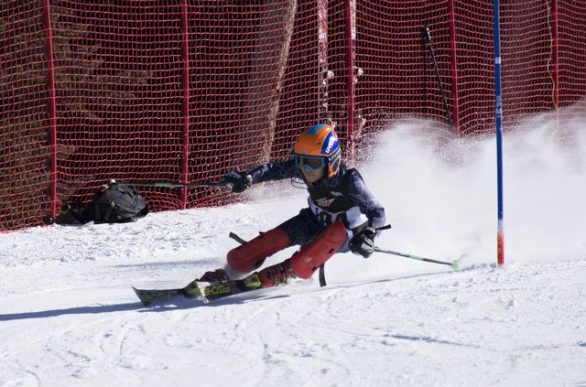

ADDITONAL RESOURSES:
The PST Handbook covers a lot but certainly not everything and is always changing. Coaches and staff will send and post informational articles, websites and recommended readings throughout the season via emails, Team Snap, newsletters and social media. If there are any questions at any point or something is unclear, please ask.

