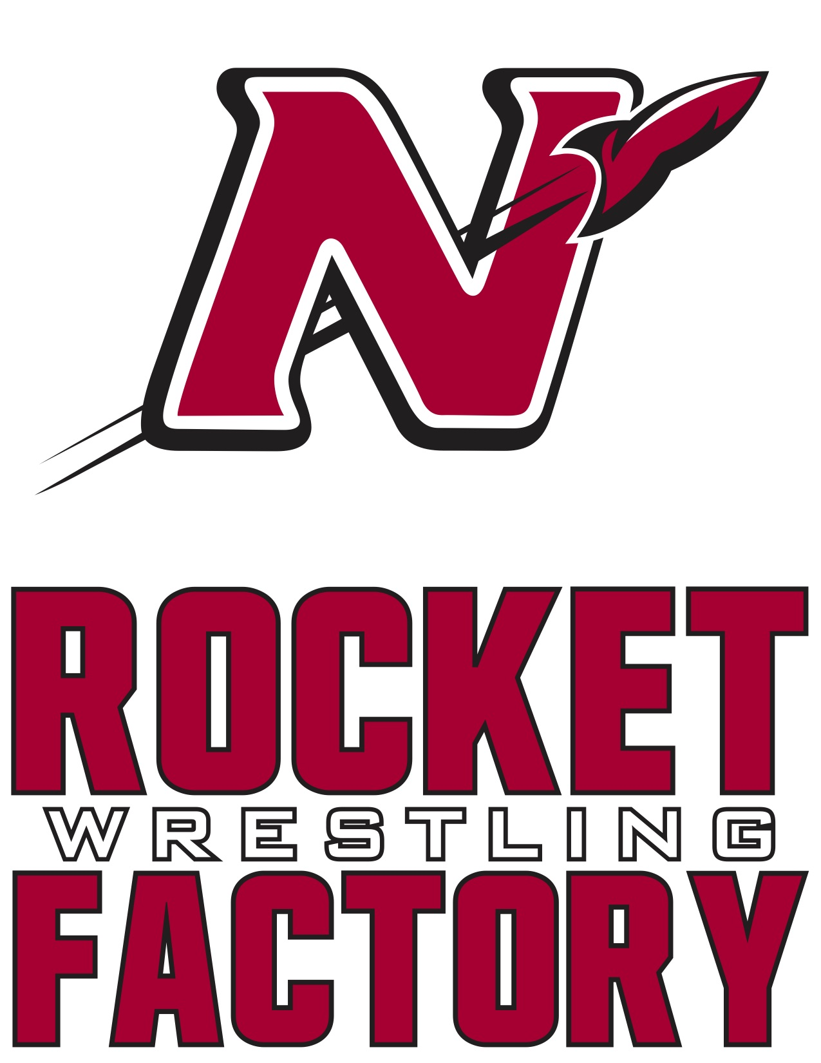

2020-2021 Schedule
Date Meet/Opponent Start Time Location/Site
Friday Nov 27th Thanksgiving Scrimmage 9:00 AM Denmark
High School

Thursday Dec 3rd Dual vs Hortonville 6:15 J.V. Hortonville
7:00 Varsity High School
Friday Dec 4th Kimberly Friday 5:30 PM Kimberly
JV Tournament High School

Thursday Dec 10th Dual vs Oshkosh West 6:15 J.V. Oshkosh West
7:00 Varsity High School

Friday Dec 11th Neenah Varsity 4:00 PM Neenah
Individual Tournament High School

Saturday Dec 12th Port Washington 9:00 A.M. Port Washington
J.V. Invitational High School

Thursday Dec 17th Dual vs Appleton North 6:15 J.V. Appleton North
7:00 Varsity High School

Saturday Dec 19th Badger State 10:00 A.M. Alliant Energy
Depart 1:00 Fri 18th Varsity Invitational Center
hosted by Stoughton Madison, WI

Tuesday Dec 22nd Dual vs Kimberly 6:15 J.V. Pickard
Rumble at the Rocketorium 7:00 Varsity Auditorium
Alumni Night Neenah
Business Sponsorship Night High School

Tuesday Dec 29th Oshkosh on the Water 9:30 Varsity Kolf Sports Center
Wednesday Dec 30th Varsity Invitational 9:00 Varsity Oshkosh, WI

Thursday Jan 7th Dual vs Appleton East 6:15 JV Appleton East
7:00 Varsity High School
Saturday Jan 9th WWCA Challenge Series 9:30 A.M. Neenah
Regional Tournament High School
Varsity Reserve/J.V.

Sunday Jan 10th Neenah Youth Tournament 9:15 A.M. Neenah
***HS Wrestlers required to work High School

Thursday Jan 14th FVA Double Duals Appleton North
Dual #1 vs Oshkosh North 6:00 High School
Dual #2 vs Fond du Lac 7:45

Friday January 15th Freedom JV Duals 5:00 PM Freedom
High School

Saturday Jan 16th Warhawk 10:30 Varsity Arrowhead Union
Varsity Duals High School

Thursday Jan 21st Dual vs Kaukauna 6:15 JV Kaukauna
7:00 Varsity High School
Friday Jan 22nd Highlander Friday Night 4:00 PM Homestead
Varsity Invitational High School

Saturday Jan 23rd WWCA Challenge Series 10:00 A.M. Wausau West
State Tournament High School
Qualifiers from 1/9

Thursday Jan 28th Dual vs Appleton West 6:15 J.V. Neenah
*Youth Night 7:00 Varsity High School
*Middle School Night
*Senior Night
*Parent Night

Saturday Jan 30th Mill City Melee 9:30 A.M. Shattuck
Middle School Duals Middle School

Saturday Feb 6th FVA Conference 9:30 A.M. Kimberly
Varsity Tournament High School

Tuesday Feb 9th FVA Conference 4:15 P.M. Kaukauna
J.V. Tournament High School

Saturday Feb 13th WIAA Regional 9:30 A.M. Kaukauna
Wrestling Tournament High School

Tuesday Feb 16th WIAA Team Sectional 7:00 P.M. Appleton North
Dual High School

Saturday Feb 20th WIAA Sectional 10:00 A.M. Ashwaubenon
Wrestling Tournament High School

Thur, Fri, Sat WIAA State Individual TBD Kohl Center
Feb 25th, 26th, 27th Wrestling Tournament Madison WI

Friday March 5th WIAA Team State TBD UW Fieldhouse
Saturday March 6th Wrestling Tournament Madison WI
Home Duals and Tournaments in RED

