2026 Rosemount Track and Field Season Information
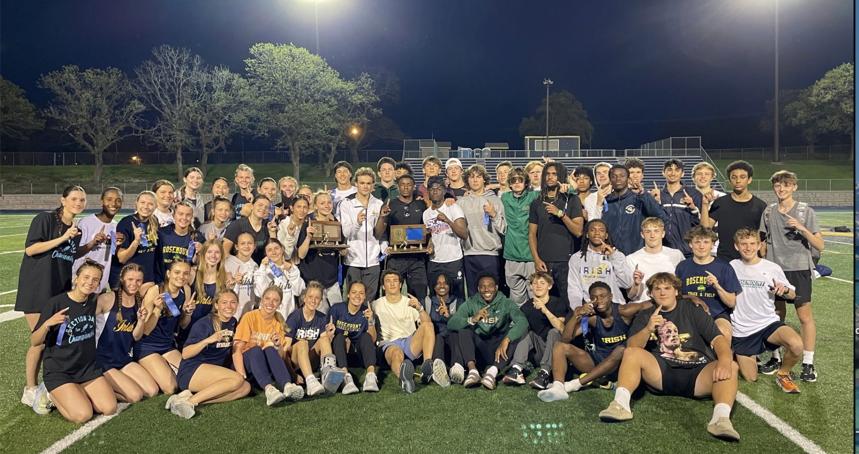

MSHSL State Champions
2024, 2023, 2021, 2008

True Team State Champions
2022, 2021, 2011, 2009

True Team State Meet Appearances
2025, 2024, 2023, 2022, 2021, 2019, 2018, 2014, 2013, 2012, 2011, 2010, 2009, 2008, 2007, 2006, 2005, 1992

Section Champions
2025, 2024, 2023, 2022, 2021, 2019, 2014, 2011, 2010, 2009, 2007, 2006, 1975

Conference Champions
2025, 2024, 2023, 2022, 2021, 2019, 2014, 2013, 2011, 2009, 2006, 1976, 1975, 1974, 1969
Communication

E-mail:
New this year: Communication to parents and athletes will primarily be via ParentSquare. All parents and athletes should check settings and have messages delivered immediately vs. once/day.

All team members should also join the 2025 Boys Track & Field Schoology group. You can access it by entering the code SZ48T-GTPCB. This will be the primary method of communication between coaches and athletes. ALL critical information will be communicated this way.

Website:
Timely track and field information will be found at www.rosemounttrack.com. Additionally, upcoming events, meet results, records, etc. will live there. The website is a great resource for parents to keep up to date with schedules, etc.

Twitter:
Follow @rosemounttrack for the updates and accomplishments within our program

First Day of Practice: Monday, March 9

Parent Meeting: Sunday, March 8 at 6:00 pm (RHS student center)

Rosemount Track and Field Philosophy

Athletes
- Athletes will have every opportunity available to pursue their individual goals, whatever they may be. Success is contagious and breeds more success. The reason coaches coach is to see athletes succeed.
- We will be a team. It will be understood that in a select number of track meets, individual accomplishments will be sacrificed for a larger team goal. (i.e. conference meet, section and state true-team meets). Track is more fun and rewarding as a team sport!
- We will always set our team goals so as to continue to improve until we reach our ultimate goals—conference, section, and state champions. From meet to meet and season to season, always prepare yourself to improve!
- It is expected that members of this team will be individually committed as well as committed to the success and growth of our program. We will be a proud program through our sense of teammates, former and future Rosemount athletes, and ourselves. No one is bigger than the program.
- COMPETE! Trust that your coaches will not overextend you throughout the season. Therefore, compete hard every time you put on your uniform.
- Have fun! Track and Field is a great sport. If YOU want to, YOU can accomplish great things. You will be rewarded when walking away from your race or event, and ultimately your career, by knowing that you gave everything you had, and that RHS track and field is better for having you.

Coaches
- Coaches will continue to learn and be the best event coaches we can be.
- Coaches will put athletes in positions to be successful.
- Coaches will always reinforce the team concept.
- Coaches will coach ANY athlete who shows excitement for the program and a willingness to improve.

Generalities
- We will be athletes and coaches that understand our sport.
- We will always demonstrate good sportsmanship, while at the same time never backing down from competition.
- No race or meet has ever been won by a time or mark on a performance list. Rarely, if ever, has a race or meet been determined by an official. Train, prepare mentally, and compete. We ALWAYS control our own destiny.
- You are extremely important to us. We need everyone to achieve our goals. Accept your responsibility to the program and you will have a fun and rewarding experience.

2026 Coaching Staff

Mr. Hatleli Head Boys Coach
651-423-7501
jay.hatleli@district196.org

Mrs. Hatleli Head Girls Coach
651-423-7501 Girls Distance
sara.hatleli@district196.org

Mr. Anderson Girls Horizontal Jumps

Dr. Tim Conboy Director of Throwing Events

Mr. Harder Boys Distance

Mr. Williams Boys and Girls Hurdles

Mr. Gilbertson Boys Sprints/Relays

Mr. Larson Girls Sprints/Relays

Mr. Tom Hatleli Horizontal Jumps

Mr. Walsten Pole Vault

Mr. Bills Throws

Mr. Trombley Boys and Girls High Jump

Mrs. Kresky-Griffin Boys and Girls Horizontal Jumps

Mr. Lindsay Boys and Girls Throws

Meet Schedule (subject to change)

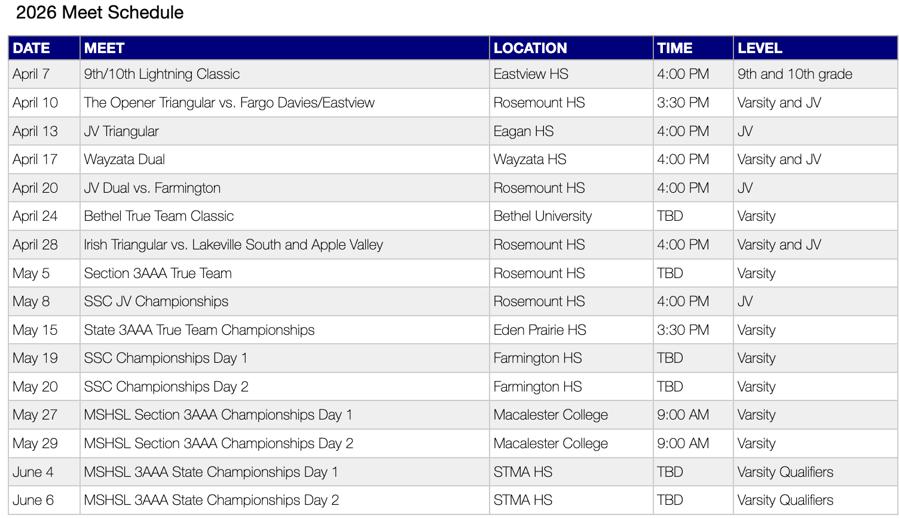

*Check our team website www.rosemounttrack.com regularly for updates, additions, or changes to the season schedule.

Practice Format and Expectations

-------------------------------------------------------------------------------------------------

Daily Practice Schedule
Practice will start at 2:45 and will be done by 4:30 on most days.

There will be Saturday practices for certain event groups. Coaches will set times

Practice Format
2:45 – Report to your core event group and begin warm-up (Throwers, Distance, Sprinters/Jumpers)

Sprint/Jump/Hurdle Group Lifting
Athletes should sign up for morning champion’s club lifting

Practice Expectations:
Be at practice on time, every day as you would for any other sport or activity. In case of an emergency, contact your event coach.

Have the appropriate gear in your locker. We run outside every day, regardless of rain, wind, or snow.

Have spikes in your locker to use at practice if needed.

You may leave practice when you are done with your workout for the day, have cooled down and stretched.

General Team Expectations

Spring Break
This is a critical time within our season in terms of training and event preparation. Missing workouts during this week will significantly hinder your chances of success, and ultimately, our team’s chances of success.

We will have practice (time and location TBD) Monday-Thursday of spring break week. We expect all athletes who are not out of town with family to be at practice. Understand that our program is built on leadership and dedication. Expectations are high. If out of town for spring break, workouts will be provided.
Injuries
If you become injured, tell a coach. The coach will likely direct you to the training room. You must report to the track at 2:45 every day to check in with your coach before going to the training room. Special circumstances may arise where this policy is changed on an individual basis. Failure to report to the track at the start of practice will be considered an unexcused absence.

Meet Conduct and Expectations

Before the Meet
Pack your bag at home and plan accordingly. It is often 65 degrees at 3:30, when the meet starts, but may be 45 degrees by the end of the meet. Have proper warm-up gear and extra warm gear for when you are done competing.

Bring food. Most meets last through the dinner hour. You should have a light snack such as fruit or a granola bar to eat before or right after your event. You should have something more significant to eat after you are completely done competing.

When we leave school early, respectfully ask your teachers if you may leave at the designated time. Your teachers will have been notified of your excuse beforehand, but they still appreciate a respectful reminder at the beginning of class.

Hustle to the locker room and change. Be on the bus by the time it is scheduled to leave. Understand that field event competitors are very limited on time at the beginning of the meet. Be considerate of your teammates by being on time.

Not everybody on the bus enjoys your personality as much as you think they do! Be aware of the fact that most upperclassman mentally prepare themselves for the meet on the bus ride.

Change your spikes the day before the meet.

At the Meet
Follow upperclassmen to the team camp area. This will be an area that is sheltered from sun and wind. Generally, this is a good place to leave your bag while warming up and competing because there will always be Rosemount teammates in camp and able to keep people who should not be in our camp out of our camp.

Pay attention to the pace of the meet. If there is a meet schedule, it will have been passed out the day before. If the meet is on a rolling schedule, pay attention to the pace events and calls.

Generally, allow for 45 minutes of warm-up time before your first event of the day. You are responsible for checking in to your event a predetermined amount of time before the event begins. Figure this out when and where this is before you begin your warm-up.

Your own competition is most important. Focus and prepare accordingly. However, when you are done competing you are expected to be a good teammate. Be a visible supporter of your teammates.

After the Meet
A track meet is a team competition. Do not plan on leaving the meet early without prior permission. Would you leave a football game in the 3rd quarter if you were done playing? However…we are reasonable and flexible. If there is a circumstance that requires you to leave early it is your responsibility to talk to your event coach ahead of time and ask permission.

Track Rules
You must know the rules of your sport. Here are a few rules that newcomers do not always know and can get you disqualified from competition:

Uniforms
You must wear your team issued uniform. There cannot be more than 1 visible logo on the clothing.

Electronics
All electronics are banned from the competitive area at a track meet. At most locations, this is anywhere inside the stadium. So, as soon as you walk into the facility you are in the competitive area. You may not use a cell phone, i-pod, video camera, etc. at any time. This rule is rarely enforced at small meets and we sometimes forget about it. It will be strictly enforced at Conference, Section, and State meets.

Pacing
You may not run alongside a teammate at any time during their race. You will get them disqualified by doing so. Cheer for teammates while standing in one location. Do not force an official to make the decision.

Traditional Track Meet Scoring Criteria

1. Meets that score 3 places: 4. Meets that score 8 places
- first place = 5 points - first place = 10 points
- second place = 3 points - second place = 8 points
- third place = 1 point - third place = 6 points
- fourth place = 5 points
2. Meets that score 4 places - fifth place = 4 points
- first place = 5 points - sixth place = 3 points
- second place = 3 points - seventh place = 2 points
- third place = 2 points - eighth place = 1 point
- fourth place = 1 point
5. Meets that score 9 places
3. Meets that score 6 places - first place = 12 points
- first place = 10 points - second place = 10 points
- second place = 8 points - third place = 8 points
- third place = 6 points - fourth place = 6 points
- fourth place = 4 points - fifth place = 5 points
- fifth place = 2 points - sixth place = 4 points
- sixth place = 1 point - seventh place = 3 points
- eighth place = 2 points
- ninth place = 1 point

True Team Meet Scoring
1. All competitors in an event score
2. If there are 8 teams and each team gets 3/event, there are 32 athletes per event.
- 1st place = 32, 2nd place = 31, 3rd place =30
- this continues all the way to 1 point for last place

3. Note: every person you nip at the line or beat by ¼ inch means another point for your team

Track and Field Order of Events

4X800m relay
110m hurdles
100m
4X200m relay
1600m
4X100m
400m
300m hurdles
800m
200m
3200m
4X400m relay

pole vault
high jump
long jump
triple jump
shot put
discus

Rosemount Irish
Outdoor Track & Field Records

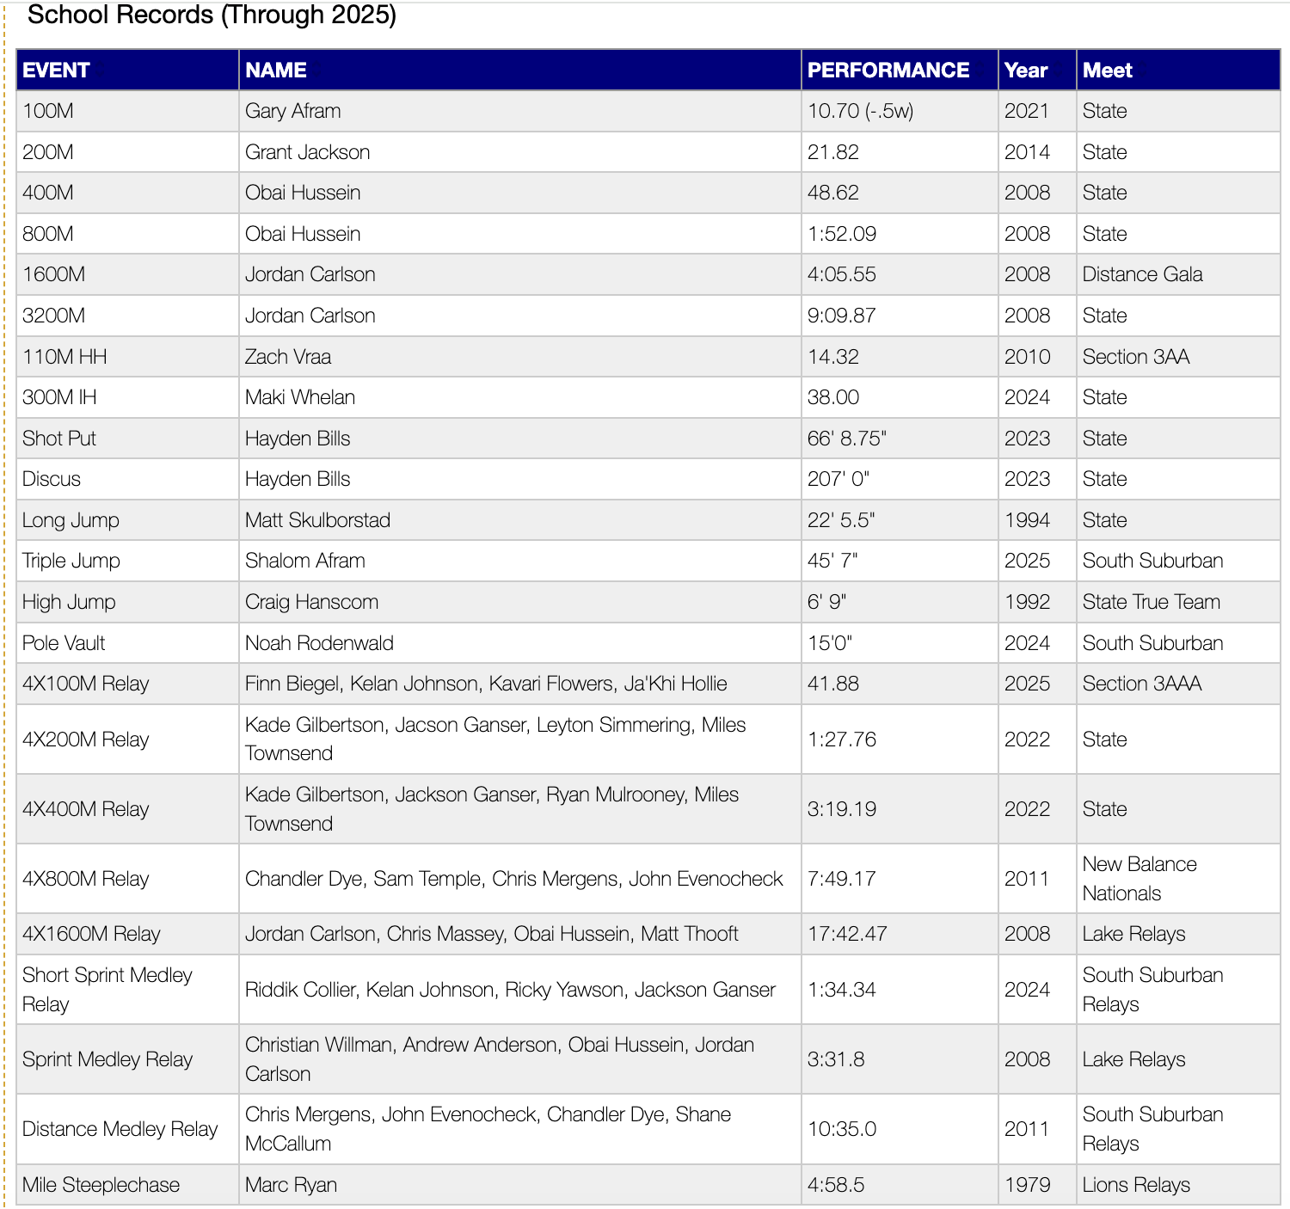

Freshman Records

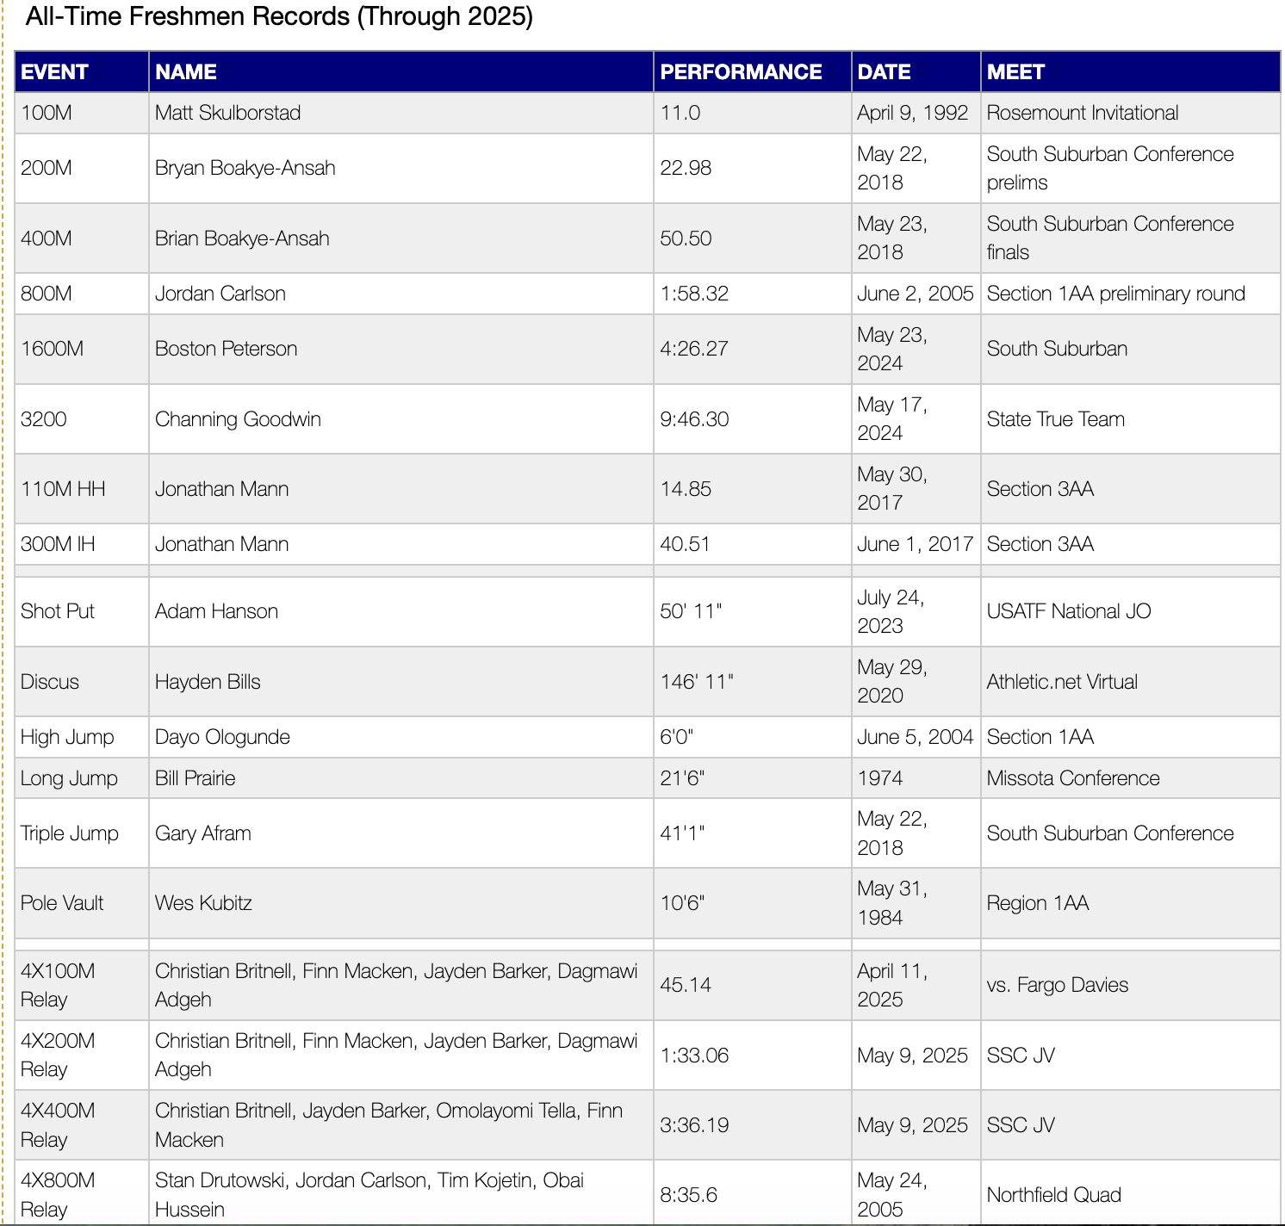

Rosemount High School
Track and Field

Lettering Criteria

1. Earn a spot on the roster (3 per event) for the section true team meet
OR
2. Earn a spot on the roster (3 per event) for the conference championships
OR
3. Earn a spot on the roster (3 per event) for the section 3AAA meet)
OR
4. Automatically letter if you finish the season in good standing and the team wins any of
the following meets: Conference, Section 3AAA, State True Team, MSHSL
State Meet

5. Meet one of the following performance standards
110 high hurdles 17.00
300 meter IM hurdles 45.00
100 meter dash 11.80
200 meter dash 24.50
400 meter dash 55.00
800 meter run 2:12.00
1600 meter run 5:00.00
3200 meter run 11:00.00
long jump 18’00”
triple jump 37’5”
high jump 5’8”
pole vault 10’00”
discus 115’00”
shot put 44’00”

Athletes are required to volunteer 2 hours toward high school, middle school, or RAAA track and field. Details and opportunities will be announced.
AND

6. Finish the season in good favor with your coaches and teammates

