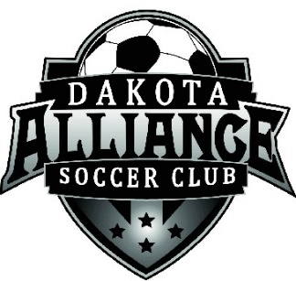
Dakota Alliance Soccer Club Premier Program
2022-2023 Fees
U11 (Players Born in 2012)
- Introduction to Premier Soccer Discount
- Season Runs August - June
- $825 for 11 months of training (Averages out to $75/month)
- Payment Plan options:
  - 1 payment: $825
  - 2 payments: $412.50
  - 4 payments: $206.25
  - 6 payments: $137.50
  - 8 payments: $103.13

U12-15 (Players Born in 2011, 2010, 2009, 2008)
- 2008 (U15) fee only applied to those players not playing High School Soccer
- Season Runs August - June
- $970 for 11 months of training (Averages out to $88/month)
- Payment options:
  - 1 payment: $970
  - 2 payments: $485.00
  - 4 payments: $242.50
  - 6 payments: $161.67
  - 8 payments: $121.25

U15-19 (Players Born in 2008, 2007, 2006, 2005, 2004)
- 2008 (U15) fee only applied to those players playing High School Soccer
- Season Runs Mid October - June
- $765 for 8 months of training (avg. $82 per month)
- Payment options:
- 1 payment: $765
- 2 payments: $382.50
- 4 payments: $191.25
- 6 payments: $127.50

What do you get for your Premier Soccer Fee?
- Maintenance of Facilities. Harrisburg & Sanford
- 2-3 Sessions per week run by a Professional Licensed Coach & Assistant
- Access to Professional Coach for Individual Feedback & Mentoring
- Use of the Harrisburg Training Facility (The H)
- Use of the Sanford Fieldhouse Training Facility
- Use of the Dakota Alliance Office including meeting rooms and field turf training room
- Cost of lights for any training after dark at the H and USF Soccer Field
- New Year’s 3v3 Tournament Entry
- Administrative Costs
- Passes to play US Youth Soccer
- Parent Education programs
- College Recruitment seminars

