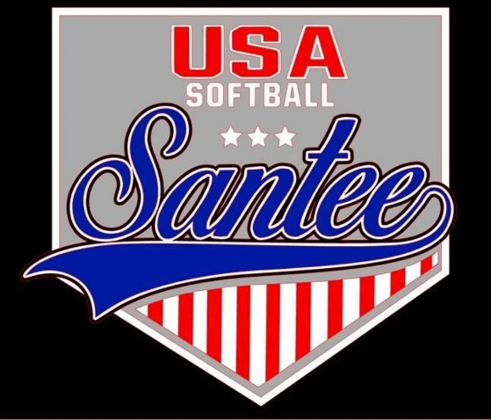
MINUTES TO BE APPROVED AT THE NEXT BOARD MEETING. THESE MINUTES ARE NOT CURRENTLY POSTED AND SHOULD NOT BE DISTRIBUTED UNTIL APPROVED BY USASSCS BOARD.
Board Meeting Minutes July 10, 2023
Location: Santee City Hall
Attendees Shown with Marked Box
President | Jay Strandberg | X | Field Prep | Kevin Hopkins
1st VP/ Field Prep | Erik Ruiz |  | Field Prep | Trevor Henton | x
2nd VP/ Snackbar #1 | Nicole Martinez | x | Field Prep | James Timanus | x
Treasurer | Tiffany Lynch | x | Field Prep | Nate Anderson
Secretary/Safety Coordinator | Kristin Freitas |  | Field Prep | Brad Allen | x
Tax Advisor | Lori Britt |  | Field Prep | Shane Frary | x
Player Agent | Lance Craw |  | Equipment Coordinator | Ryan Zuckerman
UIC/Parlimentarian | Felicia Leca |  | Head Team Parent Coordinator | Dana Hisaw
Field Scheduler/Fall Ball Coordinator | Chris Klima | x | Uniform Coordinator | Jamie DeChant
Webmaster/Social Media/All-Star Coordinator | Alexis Ruiz |  | Picnic Coordinator/Pictures | Karlene Abelon
BOTH Tournament Coordinator | n/a |  | Head Scorekeeper | Bryan Scholar | x
Sponsorships | Kylee Scholar |  | Snackbar #2 | Kelli Timanus | x
Awards | Janis Aiello |  | Snackbar#3 | n/a

Guests: N/A
Meeting called to order: 7:18PM
Meeting Minutes
Trevor Henton motioned to approve minutes from 6/13/23. Kelli Timanus seconded the motion.
Meeting rule – One Topic at a Time
Financial Update (Tiffany L)
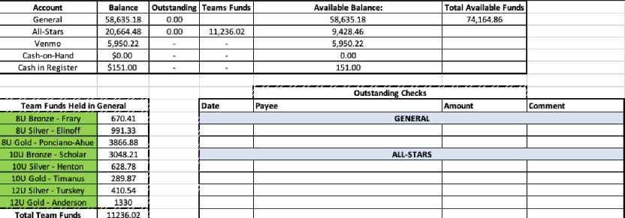

Snack Bar
Nicole looking for people to fill scheduling gaps in snack bar for C State Games tournament

Fall Ball
Registration online beginning Aug. 1
Keeping same registration price as last year ($200 + 50 snack bar deposit)
We are participating in So Cal 1904 Fastpitch League – Scheduling Meeting Wednesday, 8/23?
Halloween Havoc Tournament 10/20 – 10/22
Need to post flyer for fall ball and get link posted on website/social media

Fields/Equipment
Fall ball practices to begin August 17

Meeting Adjourned: 8:39pm
Next Meeting: August 14 7pm

