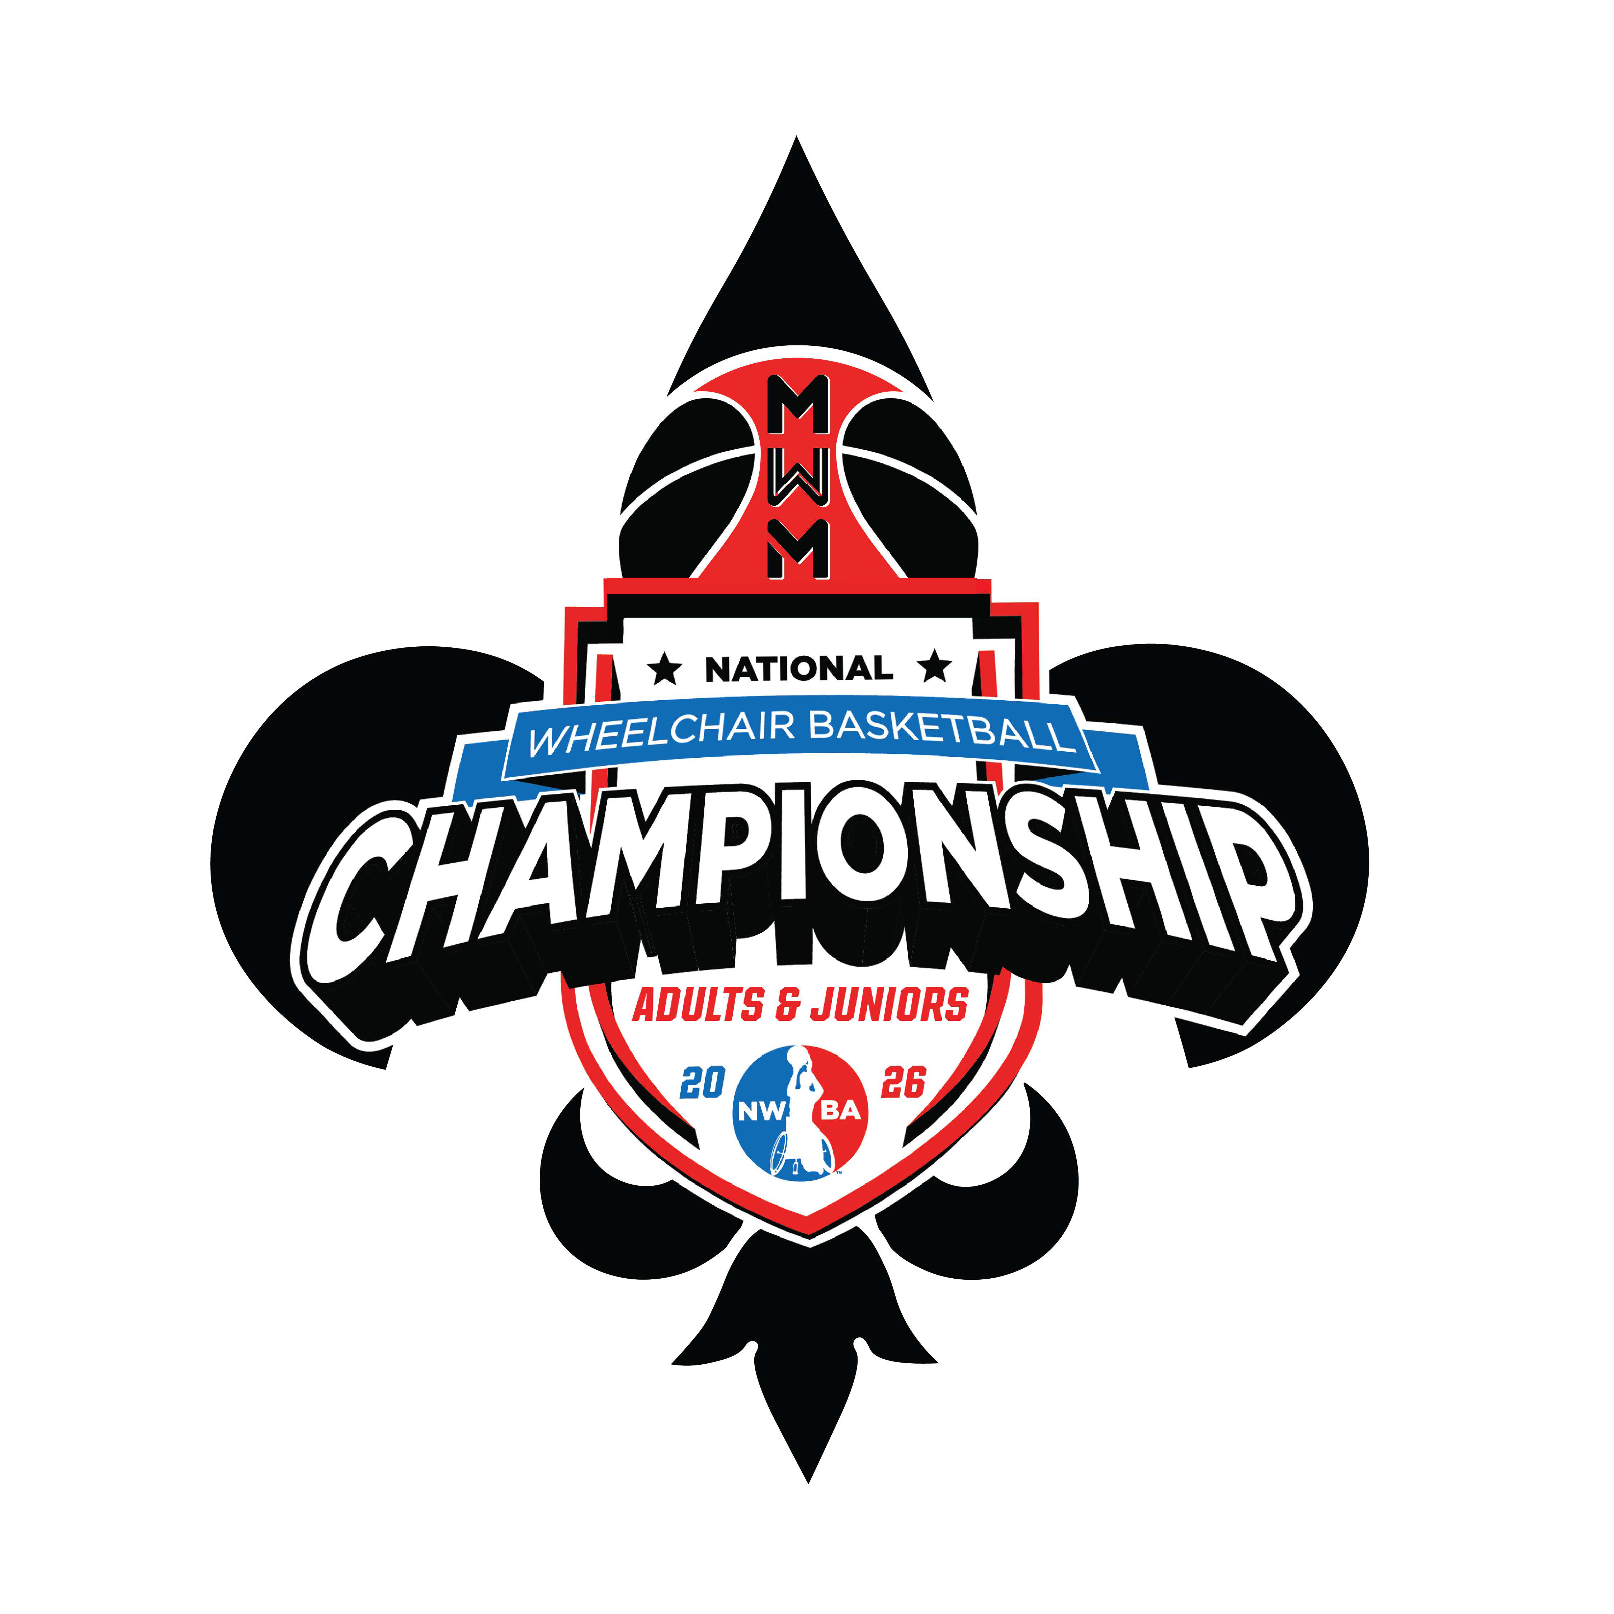
JUNIORS - Tournament Information Pack

TABLE OF CONTENTS

Venue Information General Info
Participant & Spectator Parking Large Vehicle + Trailer Parking Participant + Spectator Entrance Credentials
Tickets Food/Concessions/Water HSEC Court Layout
Team Check-In Team Practices
Chair Drop-Off/Pick-Up Amazon Equipment Shuttle
Tournament Schedule/Flow & Brackets Livestream powered by Per4Max
NWBA Junior Division Banquet at University of Louisiana Monroe
Special Events (Basketball)

Venue Information

General Info

- Name: West Monroe Sports and Events
- Address: 875 Constitution Drive, West Monroe, LA 71291

Participant & Spectator Parking

- Participant & Spectator Parking will be on the front and west side of WMSE. Overflow parking will be at the Ike Hamilton Expo, south of WMSE.
- Please plan to park in the front and West lots. The East lot is reserved for tournament staff and volunteers.
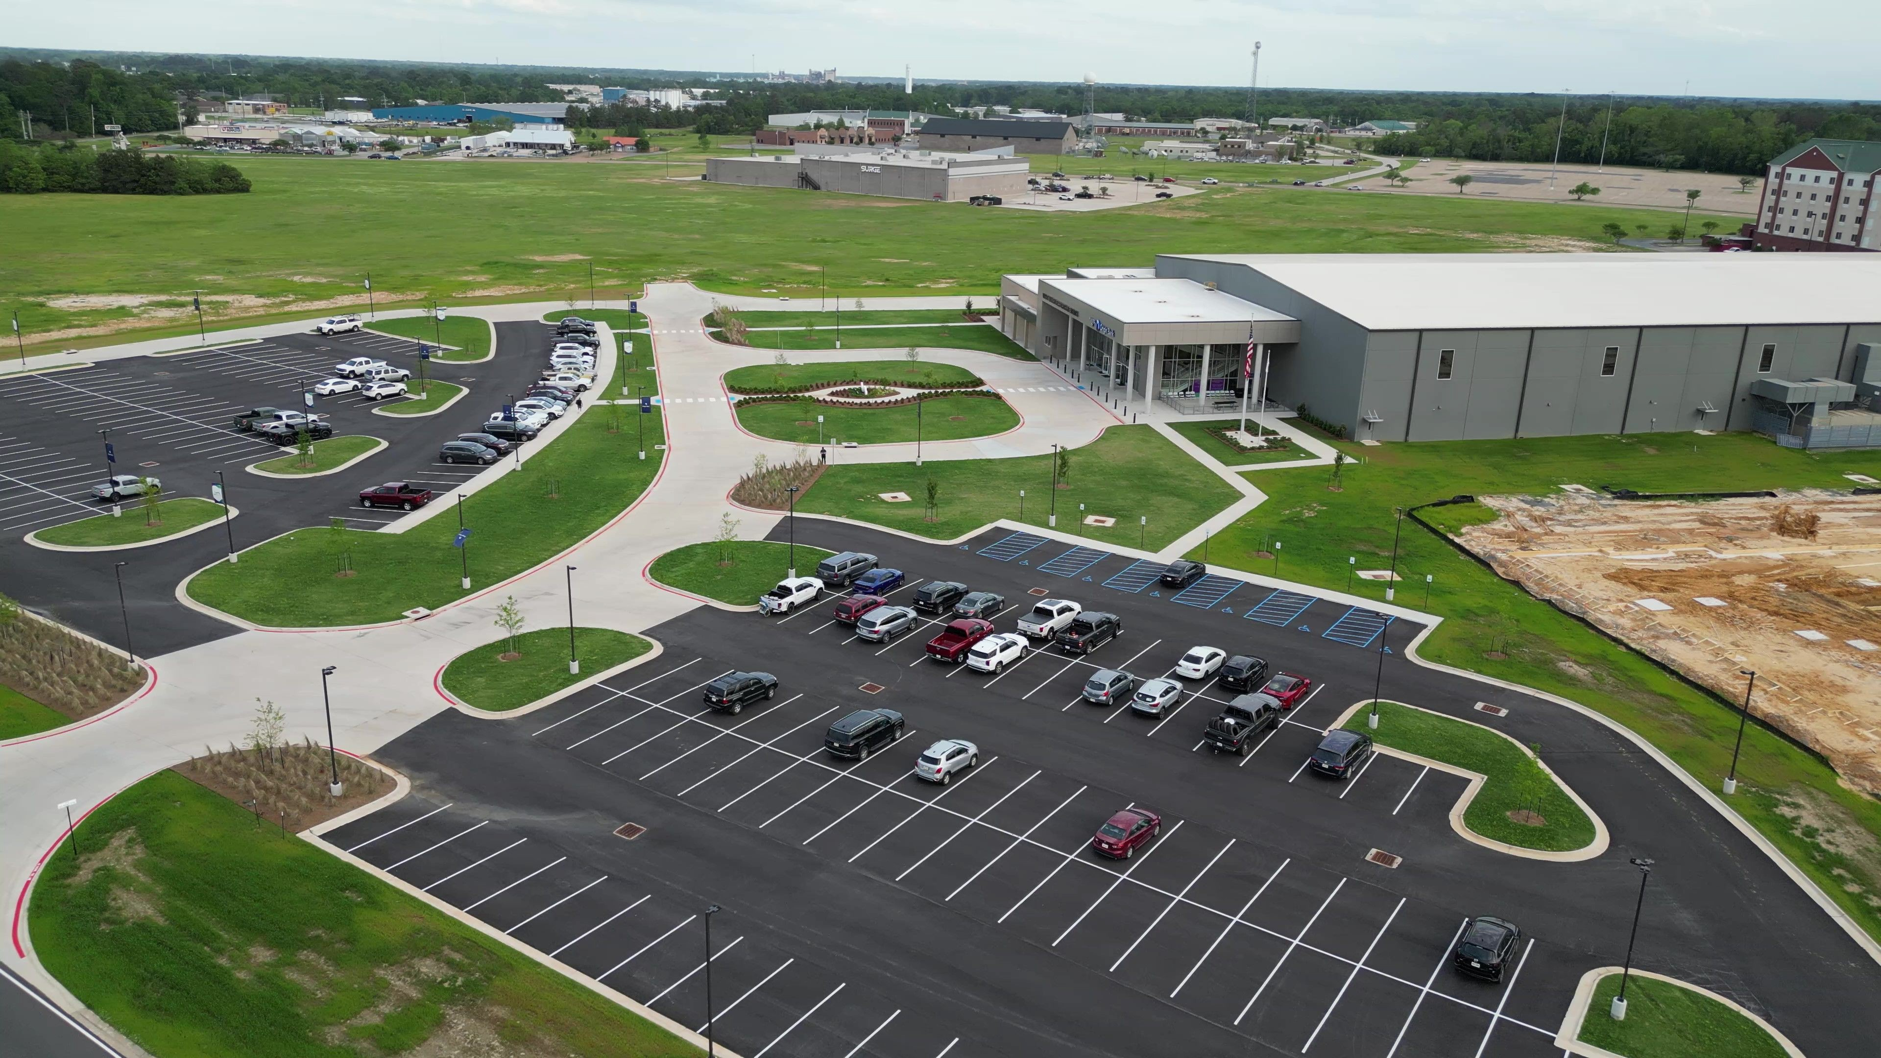
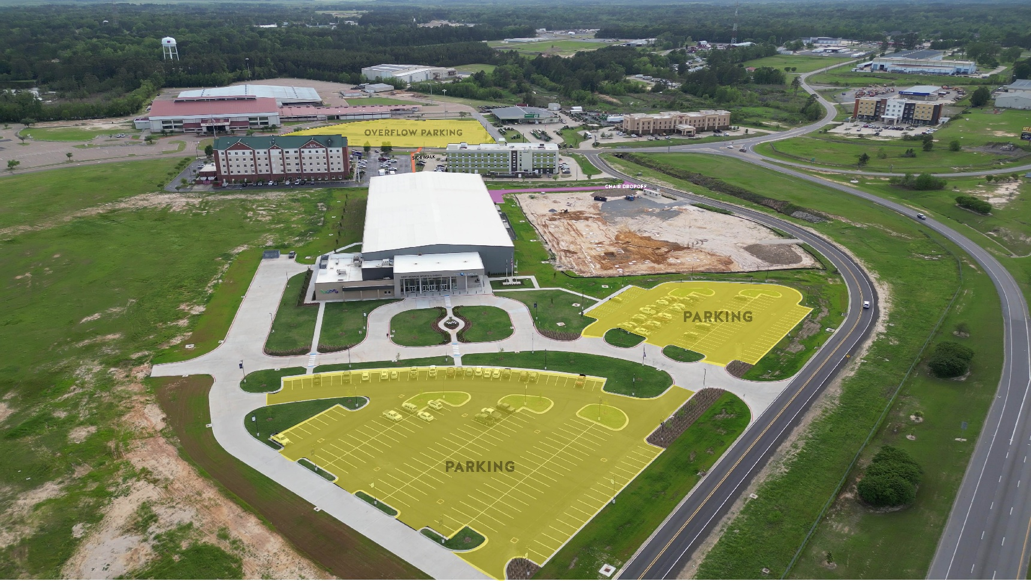
Participant + Spectator Entrance
- Use main entrance – front of WMSE
- Team staff and players must have a credential for entry.
- Spectators must present a ticket for entry. Wristband for re-entry.
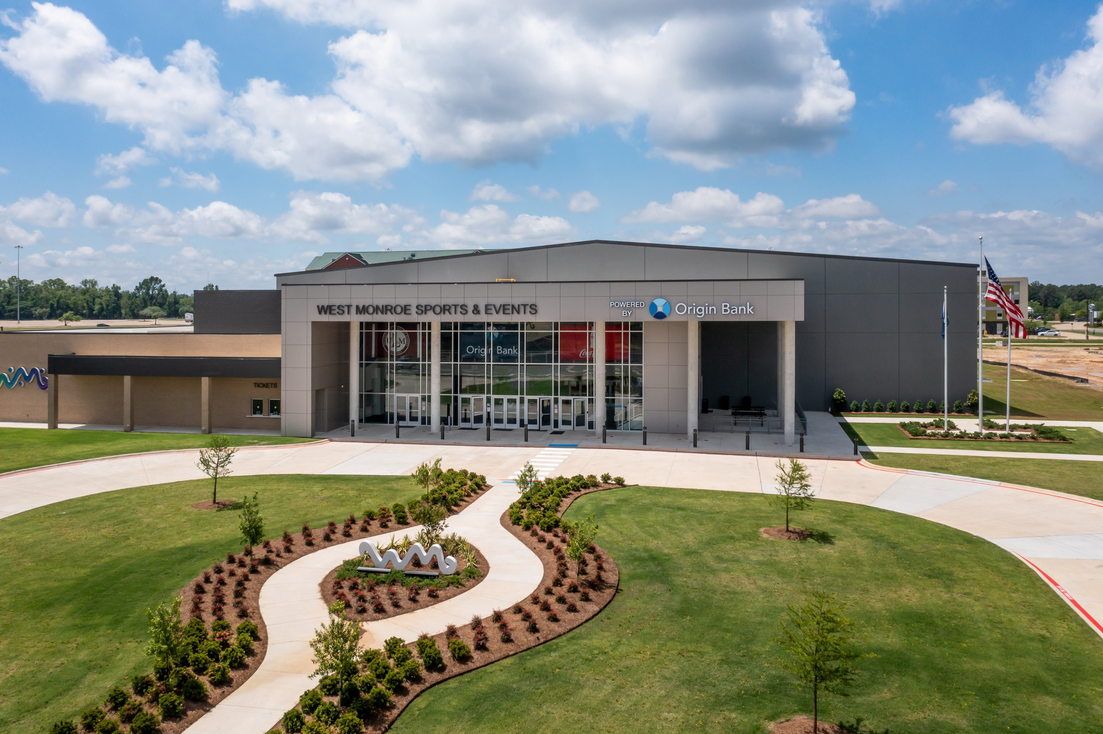

Credentials
- All rostered Team Staff + Players must have a credential for entry throughout the entirety of the tournament.
- Credentials can be picked up at Team Check-In on Thursday, March 19.
- Important Note: If a staff member or player is not currently listed on your team’s roster on nwba.org, they will not receive a credential, will not be allowed to participate in any games, will not be allowed on the bench during games, and must have a ticket for entry to the event.

Tickets
- All spectators are required to purchase a ticket for entry.
- Single Day Ticket spectators will receive a paper wristband upon entry that will grant them re-entry throughout the day, as long as their ticket is scanned.
  - Different color wristbands will be used each day of the event.
- All Access Pass & Family Pass spectators will receive a Tyvek wristband upon entry to the venue for the first time. This wristband will be used for re-entry for Friday-Sunday of the event. Please do not lose this wristband!
- Tickets can be purchased at the door; however, we encourage all spectators to purchase their tickets in advance for a smooth entrance process.

Food/Concessions/Water
- No outside food or drink is allowed inside the WMSE.
- Refillable water bottles are allowed. There are multiple water fountains with bottle-refill functionality throughout the venue.
- Food & drink will be available for purchase at concessions locations within the venue.
- There are plenty of food options available within a short distance from the venue.
  - Reminder: outside food/drink will not be allowed in the venue.
- For options outside the venue, please go to www.discovermonroe-westmonroe.org/eatdrink.

WMSE Court Layout

Junior Weekend Layout

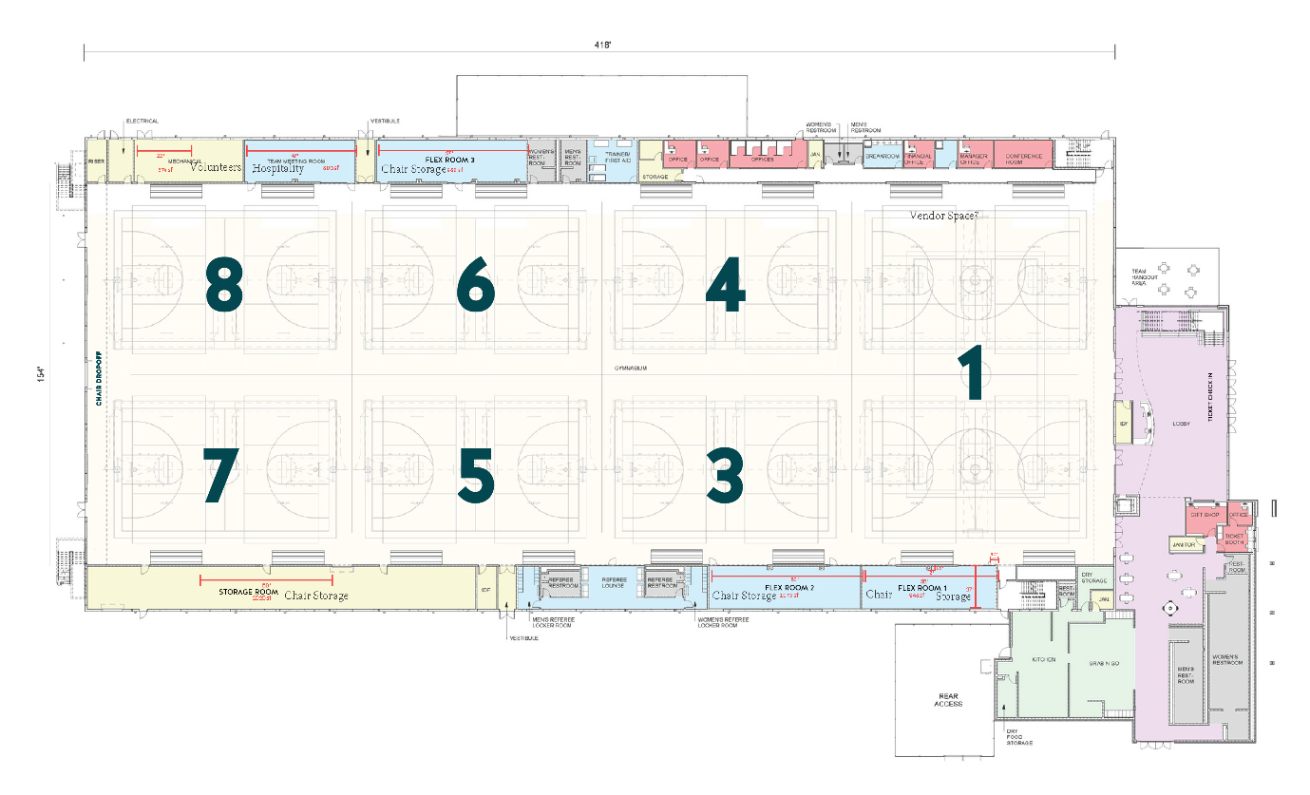

Adult Weekend Layout

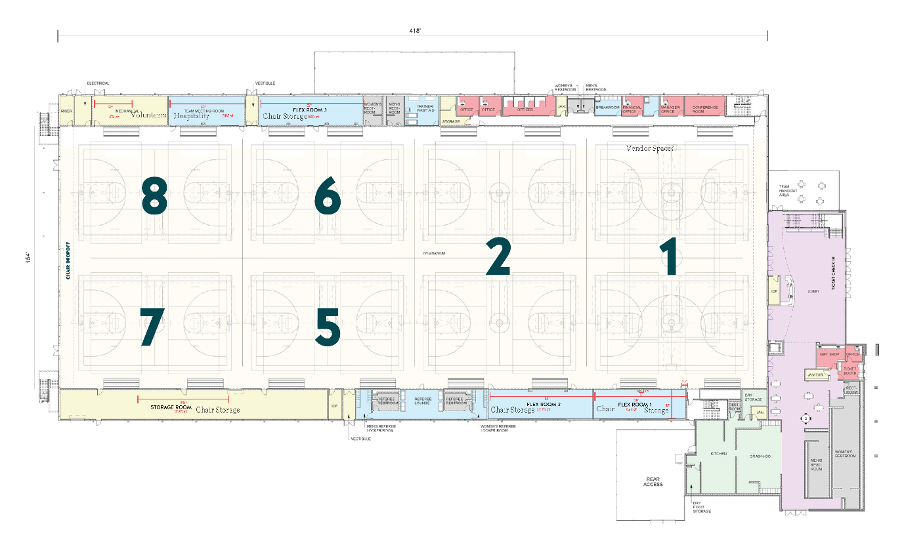

Team Check-In
- Date: Thursday, March 19
- Time: 3:00 - 8:30 PM
- Location: West Monroe Sports and Events Officials Locker
  - Enter through the main entrance, go to the left of the Information Desk through the double doors, and look for check-in by Court 5
- All teams must have a team representative attend Team Check-In to complete the following:
  - Verify team roster
  - Pick up player bags, t-shirts, etc.
  - Pick up team credentials for all team staff + players

If your team is not able to attend Team Check-In based on travel schedule or unforeseen circumstances, please contact Tina Kaufman-Cain ASAP to fulfill your responsibilities and coordinate retrieving your team’s credentials and other tournament items. CHECK-IN MUST BE DONE AT LEAST 1.5 HOURS PRIOR TO YOUR FIRST GAME.
  - Tina Kaufman-Cain | tina@nwba.org | 317-331-8767

Team Practices
- Date: Thursday, March 19
- Time: 3:00 - 8:30 PM
- Location: West Monroe Sports and Events
- Teams can reserve a ½ court for 1 hour for team practice. Balls provided.

Contact Diane Winterstein to reserve your team practice time & court if you have not done so already.
  - Diane Winterstein / dianewinterstein@gmail.com

Chair Drop-Off/Pick-Up
- Date: Thursday, March 19
- Time: 3:00 - 8:30 PM
- Location: West Monroe Sports and Events
- Teams with large vehicles and/or trailers dropping off a group of sports chairs must drop off chairs in the designated location on the back (south) side of the venue.

Do not park your trailer/large vehicle out front of the main entrance for chair drop-off or pick-up
- If you are not dropping off a group of sports chairs together, you are to use the main entrance.
- Chair Storage for teams is located at Flex rooms 1, 2, 3 and Storage Room. These rooms are by courts 1, 3, 5, and 6 .

Monroe Regional Airport Equipment Shuttle
- To support teams flying in and out of Monroe Regional Airport, Discover Monroe-West Monroe will provide sports chair transportation on Nationals weekend this year.

Eligibility:
  - Flights that arrive on Wednesday, March 18th, or Thursday, March 19th
  - Flights that depart on Sunday, March 22nd , or Monday, March 23rd

Those who have not provided their flight information via https://form.jotform.com/252234800091043 prior to their arrival to Monroe will not be eligible.
- Instructions for teams using the equipment shuttle:
  - Please check in with greeters at the baggage claim area at Monroe Regional Airport upon arrival.
  - Discover Monroe-West Monroe Staff & Volunteers will check you in and provide you with luggage tags that correspond with your departure flight date, time and airline.
  - You will need to verify your name, team name, and division for your chair to be placed in the correct storage location for your convenience upon arrival for game play or practice at WMSE.
  - Departure Services for flights will be provided. Upon your completion of play, sport chairs can be dropped with their departure luggage tag at the designated storage room near roll up door.
  - Sports chairs will be at the designated room across from Delta and American flight check in counters for participant to pick up. Volunteers will be available for the pick up two hours prior to flight departure until 30 minutes before departure. You will find your chairs here.
  - You must tag your chair with your completed luggage tag prior to departing the WMSE if you want it delivered to the airport.
  - Wheel bags and toolboxes/bags are eligible for shuttle transportation with sports chairs from the airport to the venue on Thursday, and vice versa on Sunday.
    - These items must also be tagged with luggage tags for identification.
  - Discover Monroe-West Monroe staff and volunteers will load the enclosed trailer with your equipment.
  - Transportation trailer vehicles are scheduled based on flight arrival times and volume of chairs, and will depart from the airport ASAP once loaded to ensure your equipment makes it to the venue in time for team practices.
  - Tournament staff and volunteers will receive your equipment at the venue and place it in your team’s chair storage location (See map).
  - Discover Monroe-West Monroe staff and volunteers will assist with this process.
  - After your final game of the tournament, please ensure all sports chairs are tagged with the athletes’ luggage tag and take them to the staging area in the Storage Room adjacent between court 5 and 7 where a staff/volunteer will check your chairs in as “ready” for the shuttle to the airport.
    - Replacement luggage tags will be available here, but please do your best to ensure those aren’t lost between
Thursday-Sunday.
- Contacts:
  - Alana Cooper – acooper@monroe-westmonroe.org – 318-366-0261
  - Krystle Ivey – kivey@monroe-westmonroe.org – 318-381-0971

- For more details on the overall airport operation plan & transport of sport chairs, please review the airport map below.
  - Any questions about this process, please contact Alana Cooper!
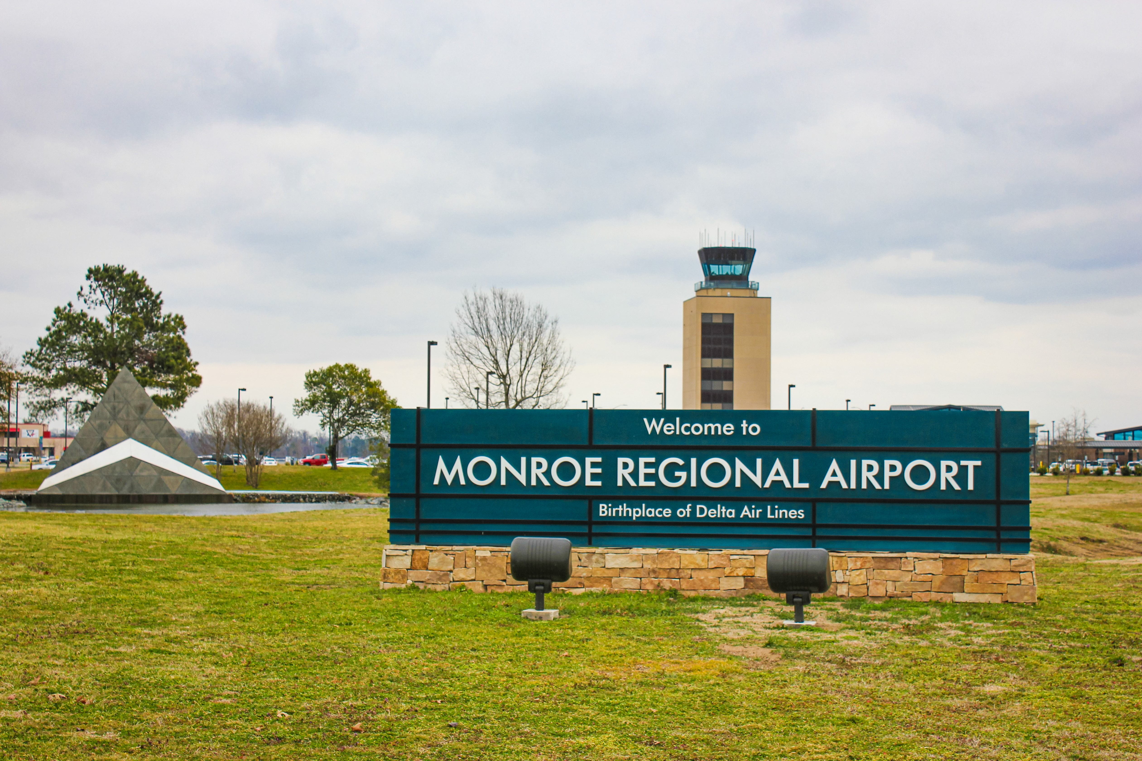

Tournament Schedule/Flow & Brackets

Flow Chart and game schedule

https://www.nwba.org/nationals

Livestream powered by Per4Max

- All courts will have one wide, AI camera that will follow the action. Game graphics for all courts other than the championship court will not be provided.

All streams will be found at https://sportsengineplay.com/

NWBA Junior Division Banquet
- Date: Saturday, March 21
- Location: University of Louisiana Monroe Activity Center
  - 210 Warhawk Way, Monroe, LA 71209

Time:
  - Doors at 6:00 PM
  - Program starting at 7:00 PM
  - Event ends at 10:00 PM
- Cost: Free
- Food included
- Silent Disco, Photo 360, and Cornhole
- DJ + Dance Party
- Please contact Hollis Walker hwalker@monroe-westmonroe.org to RSVP and attend.

Special Events (Basketball)
Visit NWBA.org for more information on the Special Events to be hosted at WMSE on Thursday-Saturday of tournament weekend.

