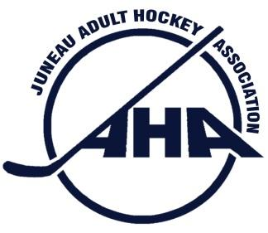
Juneau Adult Hockey Association
PO Box 21046 Juneau, Alaska 99802 * City & Borough of Juneau Tax Exempt # 582

Minutes of the Meeting of the Board of Directors of
Juneau Adult Hockey Association
Held: August 20, 2019
Meeting chair: Jason Soza
Location: Mendenhall Library Conference room
Board members present:
Michele Drummond, Secretary
Thomas McKenzie, Registrar
Adam Bryan, Treasurer
Andrew Dimond, A Tier Representative
Tyler Ferrin, C Tier Representative
Jason Soza, President
Matt Reece, Member at Large B
Brian Thomason, B Tier Representative
Ryhana Akhund, Member at Large A
Chris Coutu, 40+ Tier Representative

Board members absent:
Andrew Ainsworth, Tier D Representative
Rick Driscoll, Vice President
Claire Baldwin, Women’s Tier Representative

Visitors present: none present

1. Call to order at 5:33pm: (Soza)
2. Standing Items
2.1 Public Comment: none
2.2 Rink Update (Anderson) New policies at the rink:
Locker room Key Procedure: 1. Teams will need to sign out locker room keys 30 minutes before games. This can be done by exchanging car keys for the locker room key. The keys will need to be returned to the front desk 30 minutes after games. 2. Keep both doors to locker rooms locked unless the bathroom is in use, This new procedure places the onus of locker room security on the user groups.
- Reminder there is no alcohol allowed inside the rink.
- Troxels will be running the concession booth “Skater’s Stop” hours will be 5pm - 9:30 pm M-F, 9:30am - 9:30pm Sat and Sun. Adjustments according to the rink schedule.
2.3 JHO Update.( Gregson) By email. No increase in JHO fees this season. Referee recertification will be held Oct 4th and 5th.
2.4 Tier Reports In lieu of tier reports the board members discussed season opening and getting the teams to Soza by 8/27, posting by 9/1.
Treasurer -(Bryan) Bank account balance of $60,400. Treadwell arena fees for Fall season have not been paid, nor JHO fees.

3. Old Business:
3.1 JDIC Tournament, will be held August 23, 24, and 25th. 3 on 3 format. If the Skater’s Stop will not be open , then JAHA will provide refreshments, fresh fruit, sports drinks and bars.
3.2 / 3.3 In lieu of helmet stickers JAHA will provide JHO Refs a master list of registered players, and preprinted rosters for games this season. The rosters and list will be kept in the Ref locker room.

4. New Business:
4.1 Slap Shots in the B Tier: Initiate the rule change from waist high to full slap shots. If there are no complaints from the membership, then this rule will change.
4.2 Language change for roster freeze: Instead of within the first 2 weeks of the season to after the first 4 games.
4.3 Subs for league play can only be from the JAHA Fall Season master list. (see 3.2 /3.3)

5. Ending items(Soza):
5.1 Next meeting, September 10th, TBD

Adjourn: 6:55pm (Soza)

