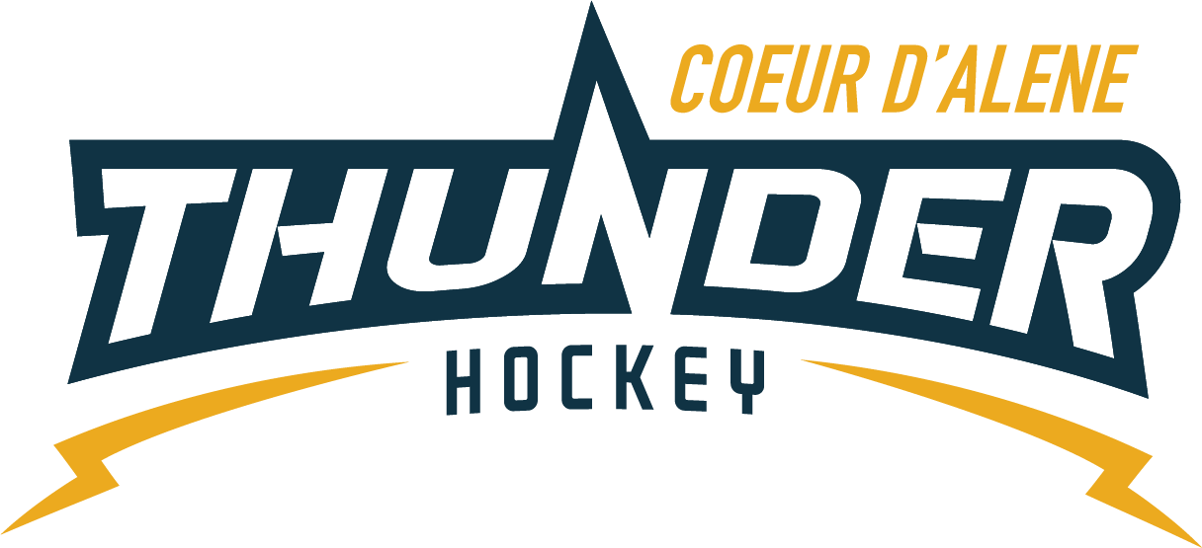

Meeting minutes

Location: Frontier
Date: October 18, 2022
Attendees: Matt Creighton, Meghan Smith, Katie Lovitt, Josh Leppert, Matt Fisher, Jackie Peterson,
Absent: Will Higgins, Kami Winfrey,
Guest: Elliot Taub, Matt Pelz, Cindy Meyer

- Call to order
Matt Creighton, President called meeting to order at – 6: 04PM
- Roll call
As stated above
- Approval of minutes from last meeting
Motion to approve minutes – Katie
Second by - Megan
Passes unanimous
- Treasurers Update
  - Balance and operating budget review – see Katies spreadsheet
    - Discussed reviewing scholarships for 2023 and tabled for now
- Committee Updates
  - Coaching Committee update (5) –Joe - NA
  - Gear Committee update (5) – Sean Meyer – NA
    - Potential to collaborate with Hockey Armor in the future
    - Sean will stay and help out
  - Discipline committee update (5) – Meghan– NA
  - Safe sport Committee update (5) – Matt P
    - Need volunteers to hand out lanyards
    - File cabinet to be moved to room for everyone to access
    - Matt to get with Vince on key for party room
    - Meghan to make stickers
  - Scheduler update (5) – Kami
    - Kami resigned moving to SAyHA
    - All house is scheduled Jackie is caught up
    - Identify more support for cross training

- New Business
Open Board Seats

With Kamis resignation we now have 2 open seats to be filled much discussion about how to move forward
Matt Fisher Motions the following
To Appoint Matt Creighton into the open 2 year seat, appoint April Hocking into Matt Creightons 1 year seat (she only wants one year), Appoint Elliot Taub into the second open 2 year seat. – Second by Katie Lovitt
More discussion about cross training and support with previously elected in good standing members and the support hey bring to all kids.
Voted unanimously by board members
Need for secretary discussed and no one was interested so Josh Leppert motioned to appoint Elliot Taub to the position of Secretary Seconded by Megan Smith. No discussion – unanimously approved
Referees
- Matt read a letter from the IEOA about parent and coach conduct this letter will be shared with the general membership
Bantam Safety Concerns
Josh will handle the discussions from the weekend games, parent comments and the proper use of SE for communication. He will review how we can use LiveBarn for egregious concerns but it is not to be used for general review with officiating
Ideas
Monthly update in a newsletter format maybe link to FB or another website to feed information. Such as stick size, plugs gear or best practices

- Old Business
No updates on old business

- Any other Business
Next Meeting Date: Next meeting Tentatively scheduled for Nov 2 at 7pm at the rink
- Meeting Adjourned
Katie Motioned to adjourn at 7:02 second by Matt Fisher – all approved

