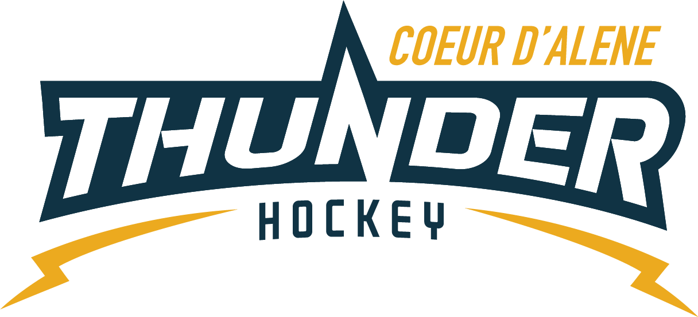

CDAHA

Meeting minutes
Location: Frontier Date: August 31 2021
Attendees: Bob Nelson, Katie Lovitt, Will Higgins, Bart Barrett, Megan Smith, Elliot Taub, Matt Creighton, Jarrod Hansen
Absent -, Matt Fisher, Josh Leppert,
Guest -Joe White, Jennifer Frame, buford Howell, Kyle Wagner, Jackie Peterson
- Call to order
Matt Creighton , Vice President called meeting to order 7/20/21 6:33PM
- Roll call
As stated above -
- Approval of minutes from last meeting
Minutes approved motioned by Megan Smith– Second by Katie Lovitt passes unanimous
- New Items
  - TRESURER UPDATE / Finance Committee
    - Current $132,586
    - See attached report
    - CPA 60 per month reoccurring
  - Referee Update IEHOA – Buford Howell
    - Short referees
    - Incentive to get new referees L1 only ($100)
      - CDAHA would cover costs
    - Rates are the same – want a deposit and a contract coming to the association
    - Coaches meeting for rule changes – discussion
    - Gary is still scheduler for now – right staff for right game
    - Bart motions for a maximum of 1500 to be allocated towards reimburses of youth officiating with L1 class and the completion of 3 games or more. Receipts must be turned in to BOD treasurer for approval. Good for 2021 – Bob seconds – all in favor no opposes it passes
C) Coaching Committee Update
      - Classification – Novice – intermediate and advanced – when are you sending an advanced team and not sending the kids who really want to play – change to blue level green – go to coaches last name
      - Cant we send all kids to all tournaments they want to go too. – Keep the kids together with skill and have them compete in correct groups.
      - Need a 8U coach – Will Higgins has volunteered to help drive the program
      - Updating the team names to last name of coach – Joe will also work with Josh to review the U8 and U10 division for rate skate, teams and tournaments encouraging all to participate. Joe will take the lead with guidance from Josh
  - Gear Committee Update
    - Usage of gear closet
      - Please don’t move stuff in the closet keep it neat –
      - Ask vince about key to room and rubber on the floor or locker – Matt will ask Vince as soon as possible
    - Discipline Committee -
      - No update
  - Safesport Committee update – No report
  - Scheduler update –
    - Had questions about number of teams
    - Tournaments by division
    - List of teams with names of last name of coach
  - Need a volunteer to work with Kyle on the golf tournament – appoint him to the Fundraiser position with CDAHA – Jarrod would be POC for BOD related
  - April update
173 registered
Asked for an update about roster
Added position for registration
No fundraising volunteering
  - Season start state is October 4 for full season and 2 weeks prior is bantam rep
  - Practice nights and dates – Matt will meet with Vince and Joe and on practice dates and times
  - U8 will get ice Fridays for the first months
  - Registrars meeting – April will travel costs to be covered by cdaha or state – funds should go to youth development instead
  - Jersey protocol - leave it as is for now look at next year planning REP V HOUSE then Seniority – Time CDAHA(consecutive) – Then AGE 2nd year over 1st year – then birth date – registration deadline – registration date – lottery and then coach – cut off is september 15
  - Goalie Training –
October 9 and 10th
Need a committee – to help with this
April – is doing SE for registration
Katie is doing flyer
Megan will do FB
5100 total cost looking for 28 goalies
Charge $299 for camp – $200 for registered CDAHA and Cristeros kids
Megan motions to spend 50 on FB to promote the event – Bob seconds motioned passes
- Adjournment
Motion to Adjourn Bob Nelson second by
Minutes submitted by: Elliot Taub
Minutes approved by: BOD
- Next Meeting
  - Wed Sept 15 2021 6:30PM
  - Megan motions to adjourn – Bob seconded

