GIRLS HOCKEY
“SNAP SHOTS”
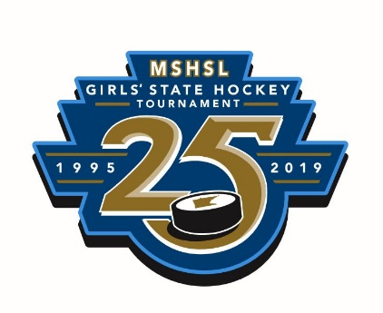
Message from the president:
As we skate into December, this is a good time to briefly reflect on the excellent work that many programs are doing for the overall good of girls' hockey. Perusing through the MGHCA twitter feed, you will see many examples of teams seeing beyond themselves in order to give back, promote, and/or celebrate accomplishments. Sartell/Sauk Rapids and Champlin Park/Coon Rapids just experienced their annual Adopt-a-Family events. Shakopee is holding a clothing drive for those in need. Forest Lake held a Skate with the Rangers for their youth program. Plus, many, many more examples!

Blake, Roseville, and Benilde-St. Margaret's honored the gold medal Olympians who graduated from their respective schools with pre-game ceremonies and retiring of jerseys. I experienced the Blake event personally and it was so awesome to see Dani Cameranesi sign autographs for future hockey players for two full periods during the game.

Please keep up the great work of promoting girls' hockey in your communities and share what you are doing with the MGHCA. We are happy to help promote your events as well through our twitter handle and website. Got a story you want to write? Please do so and share with us! The more we talk, share, and promote, the brighter our sport will shine! …. Shawn Reid, MGHCA President

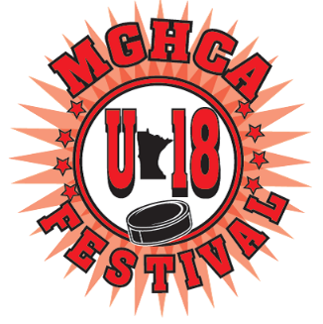

This season hopefully will be memorable for every high school player. With over half of the season left to go, many more exciting games are left to play. Along with the games, there will be other celebrations of the 25th anniversary of the state tournament, exciting tournaments over the holidays and of course, the MSHSL State Tourney in February. The high school season however doesn’t end there. The week after the state tournament, the MGHCA hosts the all-star Senior Classic and the U18 Festival at the Schwan’s Super Rink in Blaine. 136 senior players and 68 juniors who are U18 eligible will compete in an all-star series for bragging rights and possible selection to the MN Hockey CCM High School National Invitational Tournament in April. Twenty seniors and twenty juniors will be selected to play on these two teams against high school players from other parts of the country. There are many post-season hockey opportunities for our high school athletes. Coaches should check the MGHCA website, www.MGHCA.com and the Minnesota Hockey website, www.minnesotahockey.org for more information on any of these high performance programs. Coaches can also contact any of their section reps for info on other MGHCA programs and awards.
We hope everyone has a fantastic holiday season enjoying time with family, friends and teammates and of course by participating in or watching our great sport. Have a happy holiday!!

Submitted by Tim Morris, Executive Director MGHCA
morrisgang@msn.com

