SDAHA Spring Meeting
Saturday, April 9th, 2022
Moose Lodge - Mitchell, SD

- Sign In 8:45 am
- Call to order 9:00 am
  - SDAHA President Tony Leif
- Welcome – Introduction of Voting Delegates
- Confirmation of voting delegates and determination of Quorum
- Adoption of agenda
  - Approval of proposals requiring 2/3 vote on agenda
    - Girls Varsity Officials
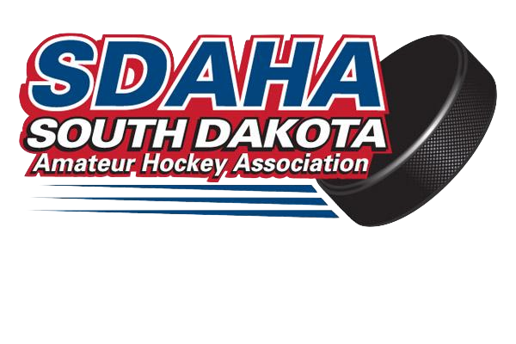
    - Boys JV Resurface
- Approval of Fall Meeting Minutes
- Financial Report – Jeff Scheel, Treasurer
- President’s Report – Tony Leif
- Discipline Report – Mike Hunter, VP/Discipline Director
- Scheduling Report – Jenni Wirkus, Executive Director
- Registrars Report – Annette Stensgaard
- Officials Report – Jared Ahlberg, RIC
- Officials Scheduling – Jenni Wirkus, Executive Director
- Risk Managers Report – Cherry Hunter
- Growth & Retention – Curtis Egan
- Player Development – Girls/Shelby Edwards & Boys/Rob Kittay
- Coaching Report – Rob Kittay, CIC
- National Teams – Jenni Wirkus
- Sioux Falls Power Report – Matt Tobin
- Local Association Reports (Yankton, Watertown, Sioux Falls, Sioux Center, Rushmore, Oahe, Mitchell, Huron, Brookings, Brandon Valley, Aberdeen)
- New Business:
  - Conflict of Interest Policy
  - Records Retention Policy
  - Credit Card Resolution
  - Proposals – Included in Meeting Packet
    - Freeze 10 at Girls Divisions
    - Girls Varsity Officials
    - Warm up Lengths
    - Resurfacing
    - BJV Resurfacing
    - Girls Varsity Tournament Gate
    - SDAHA Officials Compensation
  - Siouxland Sled Hockey’s request to join SDAHA
- Discussion Items
  - Referee Information Session
    - Recruitment/Training/Scheduling
    - Spectator Behavior
    - Referee Performance Tracking (Ref Cards)
    - Referee Training for Coaches
  - Rostering Teams
  - Fundraising Ideas for Friends of SD Hockey Scholarships
  - End of Season Banquet/Hockey Hall of Fame
- Election of Officers
  - Vice President
  - Treasurer
  - Secretary (1 Year Term)
- Date of Fall Meeting: ________, 2022 in Watertown
- Adjournment

