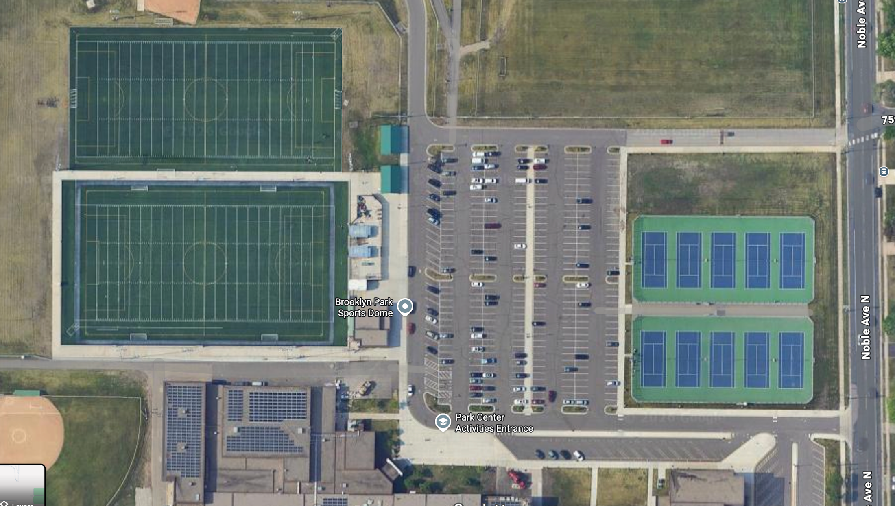
My7on7 Parking Zone
School District Event
No Park Zone at 2PM

