North Carolina Rules & Operations August 2025 – July 2026

Karen Pleasants, NC-SACC
(919)606-2315
Karen.ncgym@gmail.com
nc-usagymnastics.org
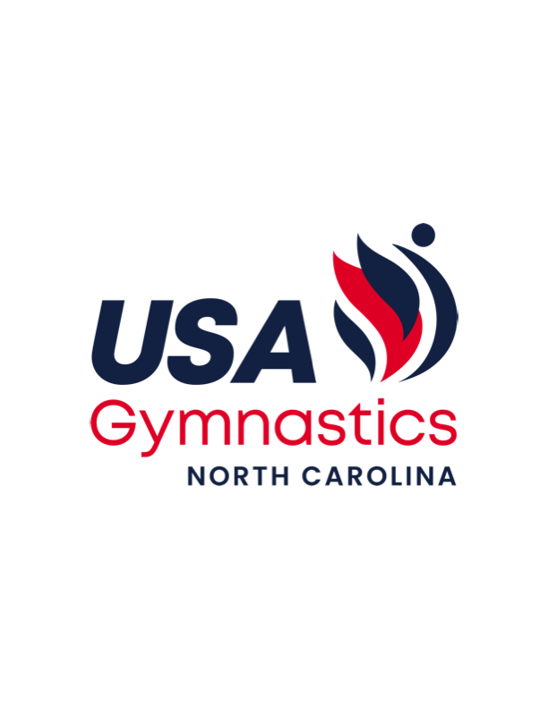

NC-USA Gymnastics State Administrative Committee Members:

Stephanie Bruno sbruno@newberngymnastics.com 252-635-2100
Cindy Cotten cottenpatchkids@nc.rr.com 919-538-2458
Schuyler Hunt sjgh92@gmail.com 704-402-8245
Jen O’Keefe topnotchcoach@aol.com 704-425-6488
Sarah Myers sarah.myers@me.com 336-516-6685
Todd Shahan tshahan@gmail.com 919-398-3410
Suzie Sanocki yougogirl@perfectbalancecharlotte.com 704-651-7525
Elaine Wulf ewomaha@aol.com 919-610-4021

USA Gymnastics Athlete Registration

Athlete membership information is found at the usagym.org website under the heading Member Services. Click on BECOME A MEMBER. Club administrators will continue to be able to add and remove athletes to their club roster, assign the athlete’s competitive level or division and reserve/register athletes into sanctioned events.

North Carolina Athlete Registration Fee

A $15.00/gymnast fee paid by each club for all USA Gymnastics registered athletes (USAG Levels and Xcel Divisions) can be paid on MeetMaker, OR a check can be made to “NC-USA Gymnastics” and mailed to: Karen Pleasants 1921 Eagle Creek Ct., Raleigh, NC 27606

Send athletes names, Levels/Divisions and DOB in an Excel spreadsheet along with coaches contact information.
***Athlete Registration fees may be paid on MeetMaker and will incur an additional $.45/gymnasts in handling fees.***

- Unpaid athlete registration fees by June 1st, 2026 will result in record of delinquent clubs “not in good standing” in NC, who then will be ineligible for team competition at the next State Meets.
  - Unpaid fees will incur $100 charge beginning June 30th, 2026.
(summer 6/25) Fees will be paid to the State Committee
- The NC athlete registration fees support the DP/Xcel programs’ awards, gymnast apparel, coaches apparel, education, training camps, clinics and admin.

Meet Director Information

FOLLOW CURRENT USA GYMNASTICS RULES AND POLICIES 2025-2026 LINK
(Look for the 2025-26 R&P to be available online in the Fall 2025).

After any sanctioned competition (including mobility meets):
- Send competition fee of $2.50/gymnast to “NC USA Gymnastics” and mail to:
Karen Pleasants, 1921 Eagle Creek Ct., Raleigh, NC 27606 OR
pay here on Meetmaker.
If competition fees are not paid by June 1st, 2026 the delinquent Meet Director will not be allowed to host a qualifier for 2025-2026 and will not be considered a Meet Director “in good standing” in NC.
- Unpaid fees will incur $100 charge beginning June 30th, 2026.
(summer 6/25) Fees will be paid to the NC State Committee

- Send completed scoresheet, sanction forms and competition fees to NC-USA Gymnastics.
(pdf or link preferred)
- Completed sanction forms must be returned to the National Office. Fines are imposed for tardiness.

Meet Intent Dates

Fall meet intent – Due August 20th, 2025
Spring meet intent - Due October 1st, 2025
Go to nc-nawgj.org and click on Meet Intent. The commitment is neither required nor binding but greatly encouraged. This allows meet directors to better plan for judges, awards, facility use etc.

Qualifying Meets and State meet qualifying Scores

The qualifier meet submission deadline in order to be placed on the NC USAG calendar is July 31st .
Meet Directors may request a qualifier be added to the schedule after July 31st with the following provisos:
1. Request is made by August 31st (no requests entertained after this date)
2. On the 1st occurrence a warning will be issued; on the 2nd occurrence made by the same Meet Director a $200 fine will be imposed.
3. Addition of the meet to the schedule depends upon judges’ availability. After August 31st NO qualifiers will be added to the calendar. The penalties (warning/fine) are attached to the Meet Director, not the hosting Club.

State meet qualifying scores must be achieved at a USA sanctioned meet:
*****Reminder that 2 clubs are needed for a sanctioned meet to be considered a qualifier*****

- In state qualifier meets approved by NC Committee on NC-USAG calendar.
- Out of state meets – if using an out of state qualifying score, coach must email scores to SACC as verification

State meet qualifying scores:
32.0 AA for Levels 9 and 10
33.0 AA for all other Levels and Xcel Divisions

- Last qualifier is 2 weeks before any state meet
- Declaration date is 2 weeks before each state meet
- State Meet registration is due the 3rd Monday(by midnight) prior to each state meet. Registration will be done on MeetMaker.
- Individual Event Specialists (IES)
  - Level 9/10 may qualify to state meet with a 9.0 at a sanctioned meet (max 3 events)
  - Platinum/Diamond/Sapphire with an 8.5 at a sanctioned meet (max 3 events) -(Reminder no Xcel specialists at Xcel regionals)

2025-2026 North Carolina State Meet Dates & Host Clubs

Dec 13-14, 2025 Compulsory Southeastern, Charlotte
March 21-22, 2026 Bronze/Silver Central Carolina, Kernersville Rec and Event Center
March 27-29, 2026 Level 6-10 RSG, NetSports, Morrisville
April 11-12, 2026 Gold/Plt/Dia/Sa Rose’s, Greenville Convention Center

Entry fees: (updated 6/24)
In-house Compulsory and Xcel $95.00
In-house Level 6-10 $110.00
Outside Facility Compulsory and Xcel $115.00
Outside Facility Level 6-10 $130.00

IMPORTANT STATE MEET REGISTRATION INFORMATION:

BY MIDNIGHT 3 MONDAYS BEFORE STATE MEET, COMPLETE THE REGISTRATION OF YOUR QUALIFIED GYMNASTS INTO MEETMAKER.

ALSO, REGISTER in MEETMAKER (as alternates) THE NAMES OF YOUR GYMNASTS WHO WISH TO ENTER THAT HAVE NOT YET QUALIFIED. A SPOT WILL BE RESERVED.

Note: ***Payment information required at time of entry but will not be charged until the gymnast qualifies. If the gymnast does not qualify then there is no financial transaction.***

This allows the state meet schedules to be created and posted a week earlier using this process.

The 3% MeetMaker online fee will be added to the State Meet registration fees, paid by the registering gym. This will be added to the State Meet Registration Fee at time of checkout.

***********
Coaches are asked to remind gym parents that only professional members should contact the State Meet Director. Schedules will be posted online at Meetmaker.com and the host meet site.

When registering for state meet on Meetmaker.com, verify and enter the earned qualifying score. If the coach does not provide scores, the club’s coaches will not receive free apparel if gymnast qualify to Regionals.

************

State meet team fee is $45.00. Team placements extend from 1st – 6th.

State meet gate fees:
- Adults $20, Children $5, Under 5yrs free
- Family $45 (2 adults, 1 child)
- Seniors (62 years +) $5

*Gate fee will allow entry for whole weekend. There shall be no additional fee to attend more than one day. Credentialed gymnasts may gain entry for whole weekend.

Additional State Meet Information:
- State Committee members will set the State Meet schedule, age groups and competition order.
2024-2025 - Jason Braun and Sarah Myers will create the schedule.
- Rotation order will be created by the Meet Director and implemented after approval by the Committee representatives.
  - The order of age groups for Xcel state meets shall be sequential for session not for rotation. The NC-SAC will determine the starting age groups per division. (effective 8/5/23)
  - The order of age groups for Compulsory and Level 6-10 state meets will be by random draw for session and rotation. A committee member, other than the meet director must be present for the draw.
  - Age Groups shall be created by dividing the number of gymnasts in a session into equal groups by birthdates (ChA, ChB, ChC, JrA, JrB etc…)
  - 5 year old bronzes and 4 year old Level 2’s shall make up their own age group.
  - The Committee recommends that no more than 25 be placed in an age group, preferably 20.
  - The rotation order shall be created by a random draw for starting events and for the order in each rotation. Teams should not have athletes grouped alphabetically for rotation.
  - If a club has 2 squads in a session, place the starting events in the same flight, skipping competition events (ie VT and BB in the same flight)
  - Meals for active coaches and judges should be in separate locations at State Meet
  - State meet host must provide a copier on the competitive floor
  - The required A-1 Awards medals are purchased by NC-USA Gymnastics and delivered to the State Meet site. The host pays $6.00/gymnast for the medals, even though the actual cost is much more.
NC-USA Gymnastics provides this benefit as a service to the State Meet host.
  - The NC USA Gymnastics State Committee augments the State Meet award guidelines from USA gymnastics in the following way:
  - Award medals to ½ of the placements (1/2 + 1 when odd number of gymnasts). Follow USA Gymnastics guideline and extend with NC medals to the ½ number of placements.
  - First AA finisher receives a plaque
  - A “Q” medal (qualifier medal) is presented to each of the gymnasts in each age group who did not medal in the AA. For instance, if 21 gymnasts are in an age group, award 1-6 AA and events with state medals. Extend with NC bronze medals to 11th place. “Q” medals are the presented through 21st place.
  - Team banners are ordered by NC-USA Gymnastics. The cost is $40 for 1st – 3rd places, and $25 for 4th – 6th places and paid by the meet director.
  - A copy of the State Meet Financial Report must be received by the SACC within 6 weeks. If the meet director fails to send the state meet financial report to the SACC within 6 weeks, the meet director will then be considered “not in good standing” in NC. A copy of the report will be presented at the State Committee meeting in late spring.

Criteria for State Meet Bid Selection
- NC Club/Meet Director in good standing; criteria determined by the NC-SAC (per R&P p.70 II. C. a. and D.a.)
- Outside facility preferred
- Ability to run Capital Cup with two sets of identical equipment, including floors
- Successful previous host meet experience
- Generous spectator seating and parking
- Quality equipment and meet specs
- Awareness of geographical location
- Provide medical personnel on site per R&P
- Declare scoring and equipment contracts
- Festive atmosphere & small gift for competitors
- Quality hospitality for coaches / separate area for judges

2026-27 State Meet dates / Hosts and Locations TBD

December 12-13, 2026 Compulsory State Championships
March 13-14, 2027 Bronze/Silver State Championships
March 19-21, 2027 Level 6 – 10 State Championships
April 2-4, 2027 Gold/Platinum/Diamond/Sapphire

*email Karen Pleasants, karen.ncgym@gmail.com to request bid form*

BIDS ARE DUE TO STATE CHAIRPERSION FOR NEXT SEASON STATE MEETS BY APRIL 1ST, 2026.

Judge Information
Number of Judges required for each competition level in NC:

Mobility meets:
- Compulsories 1 judge unaffiliated
- Xcel Divisions 1 judge unaffiliated
- Optionals 2 judge panels

Invitationals used as Qualifiers:
- Level 2, 3 and Xcel Bronze, Silver and Gold 1 judge unaffiliated
- All other levels and divisions 2 judge panels

State meets:
- All Xcel State meets 2 judge panels
- Levels 2-5 State meet 2 judge panels
- Level 6-10 State meet 4 judge panels

*The NC-SAC will provide an additional paid judge on site for the L6-10 State Championships
(summer 6/23)
*The NC-SAC will provide and publish the State Championship judges’ selection process document in coordination with the NC-NAWGJ.

*State meet judges:
If judges are assigned to Regionals, they are strongly encouraged to judge the state meet at the same Level/Division. *If a judge were to “pull off” a state meet for a non-emergency reason the act might negatively impact future state meet assignments.

North Carolina Clubs of the Year
- The Club of the Year for each Level and Division shall be the club placing 1st at each state meet.

North Carolina Compulsory, Optional and Xcel Program of the Year

- This award recognizes the NC program which excels above other NC clubs in Compulsory and Optional Levels and Xcel Divisions of USA Gymnastics competitions.
  - There will be an Xcel POY Regionally and Nationally; criteria will be coming from the Xcel National Committee and Regional Committee
- Points are earned after each State Meet.
(5 points for 1st, 4 points for 2nd, etc…)
- The overall NC Comp and Opt and Xcel Program of the Year shall be determined by the established point system for state meet finishes. The winner will be the club with the most points earned from the state competitions of NC USA Gymnastics. No additional votes taken.
- The winning NC L6-10 program of the year(POY) will be sent forward in consideration for Regional DP POY(per USAG Operating Code p.20-21) and announced at Level 9/10 Regionals.
- A plaque or banner will be presented later in the year

