The Warm up Jacket will cost $74.00
Leotard cost $28.00
Gymnasts will wear 3/4 length BLACK Leggings of their choice.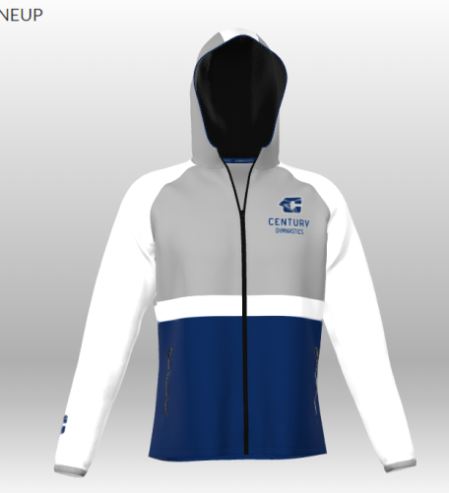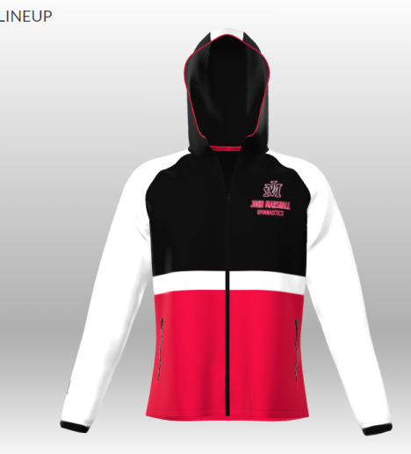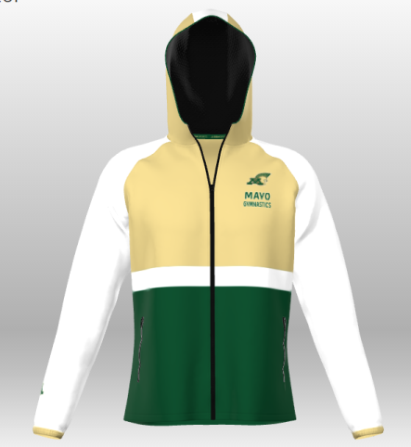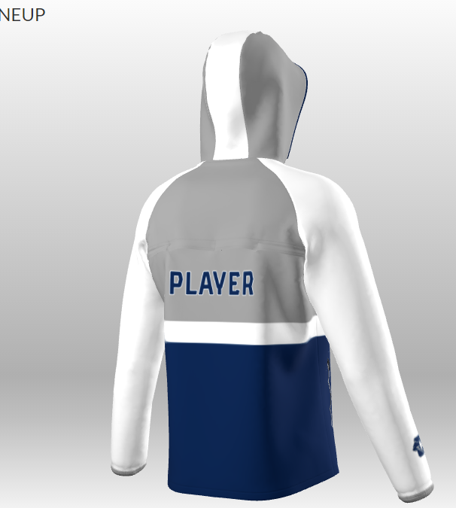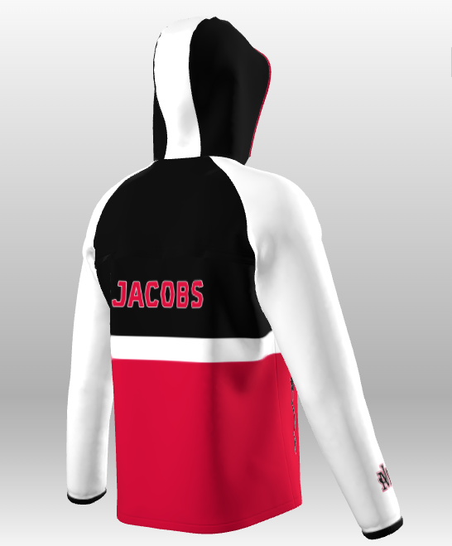 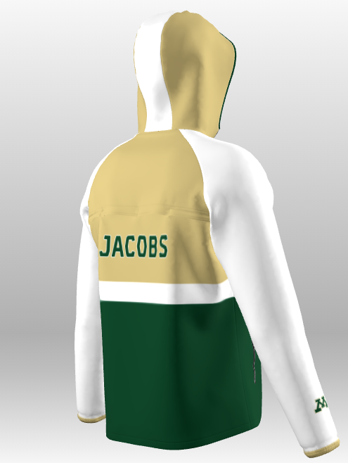
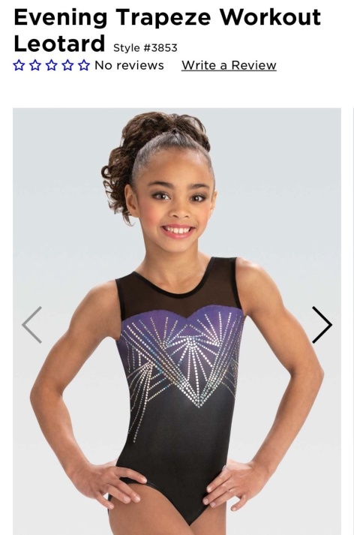
Checks made payable to JM Gymnastics

Gymnast’s name_____________________________________
Jacket Size____________ Leotard size_______________
School__________ Check #_______ Check Amount_________
Name on back_______________________________
(Please write neatly)
Orders will not be placed until payment is made.
Orders need to be turned in by November 8th

