The 2025 Porter Parent Football Association (PPFA) Newsletter – Playoffs4
The LTHS Porter Parent Football Association (PPFA) is a volunteer group dedicated to enhancing the football experience for players. Our goal is to foster a positive, memorable environment for each player, achieved through support for both the players and coaches. The PPFA funds its efforts through various fundraising initiatives, including spirit wear, player sponsorships, and volunteering.
- Twitter @LockportFootba1 - Facebook @ LTHSFootballBoosters  - Lockportfootball.com
Every Week
Varsity Players Pasta Dinner – Every Thursday @ Cooms Corner, but breakfast will be served this week (see below).
Playoffs-4 Breakfast (Cooms Corner): Sat 11/22 @ 9:30am **Parent Volunteer and/or Drink Donation**
** Ask-a-Porter ** - 10Q with Teddy Ponterio
Game Schedule/Results
Varsity: Porters @ Oswego: Sat 11/22 @ 5:00pm Game Preview
Porters over Barrington on 11/15 (35-0) Game Recap
Game Photos (TKMEDIA09) Game Photos (ZL VISUALS) Game Photos (RJ.Prodz) Game Photos (Flicz.By.J)
News and Notes
Save-the-Date: 11/22 – State Playoffs (Semifinals)
11/29 – State Championship @ Hancock Stadium
12/8 – Varsity Banquet (5pm) @ Crystal Grand Banquets (RSVP here) **RSVP** **RSVP** **RSVP**
**Lost and Found** Missing a PPFA 2025 Newsletter? Click HERE

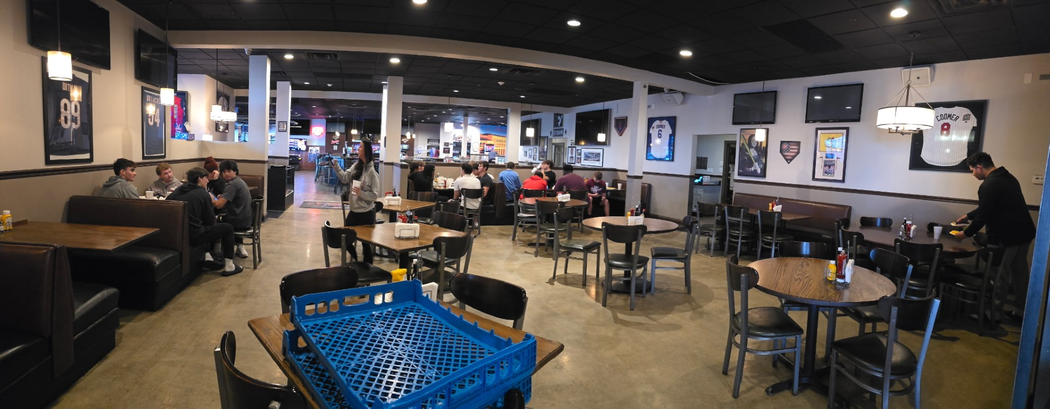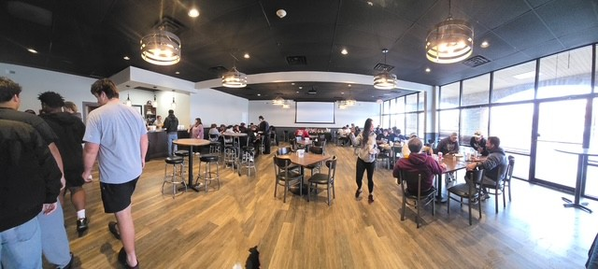
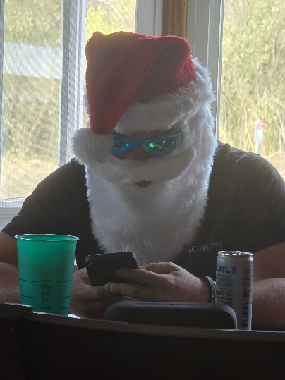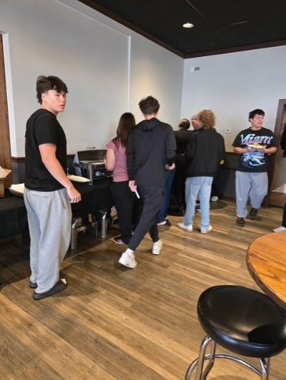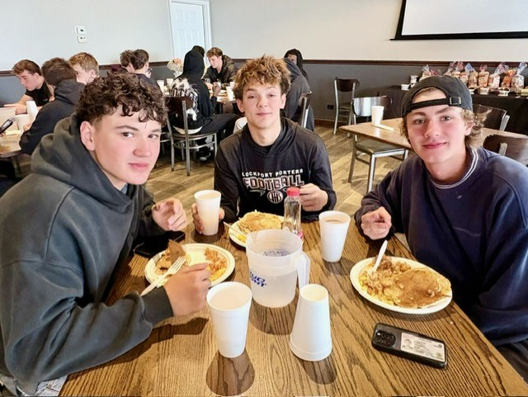
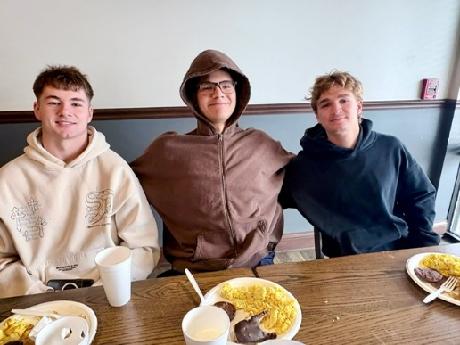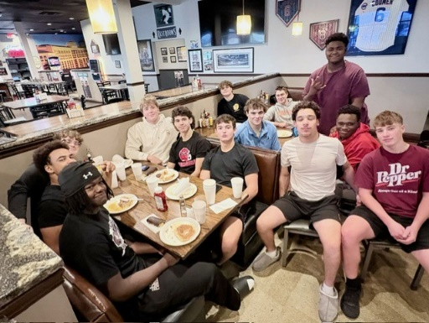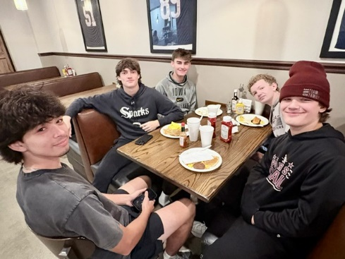
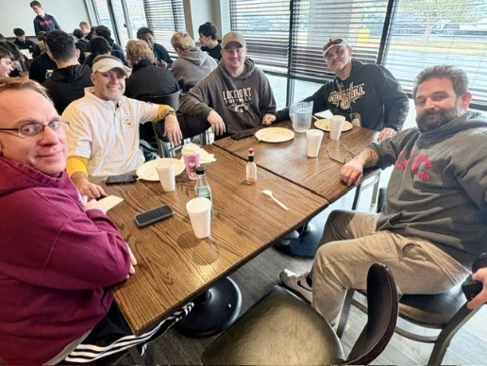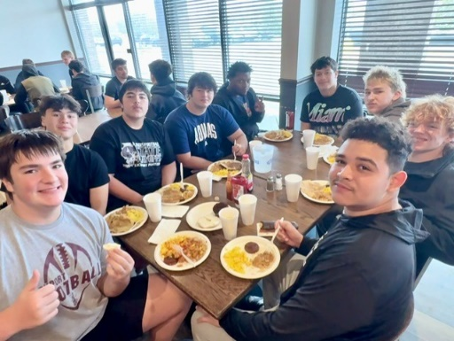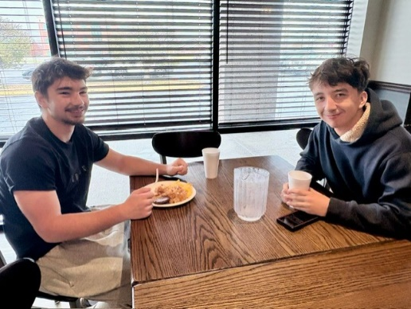
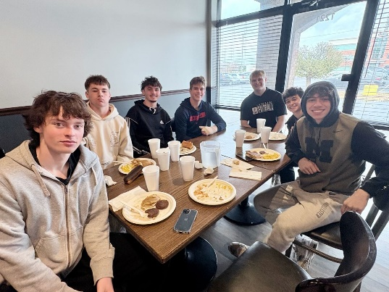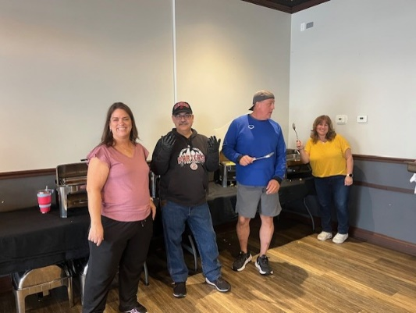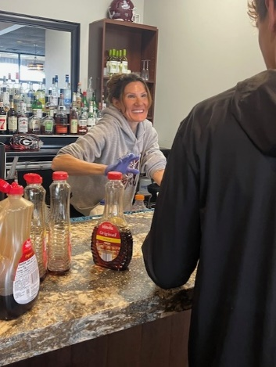
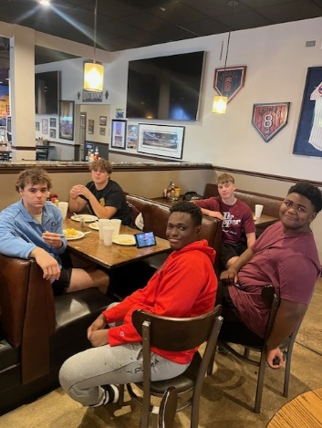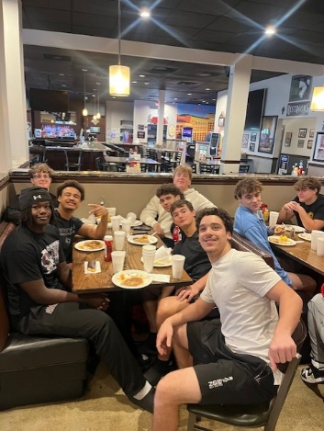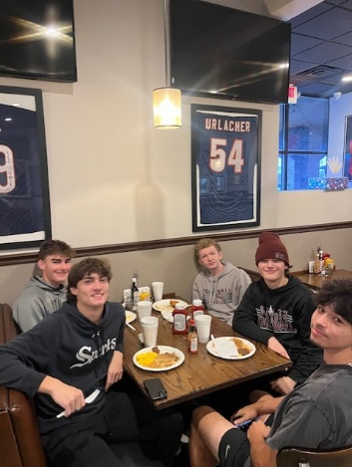
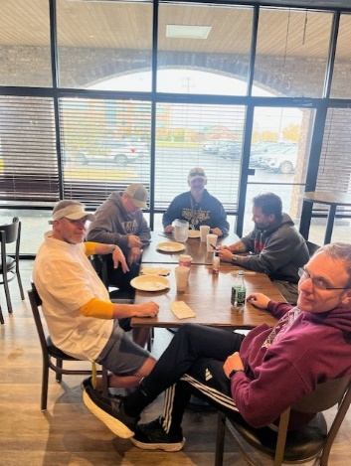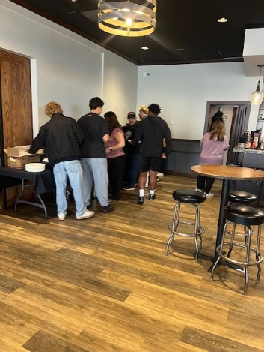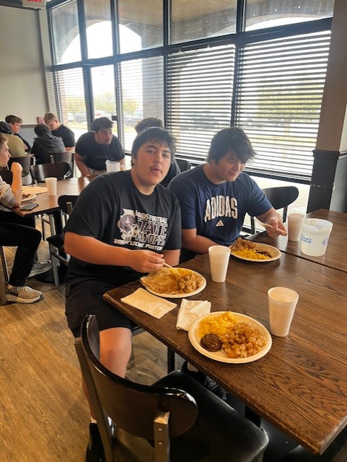
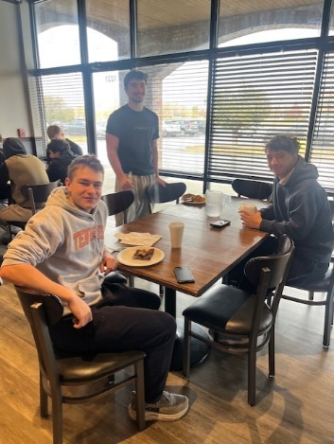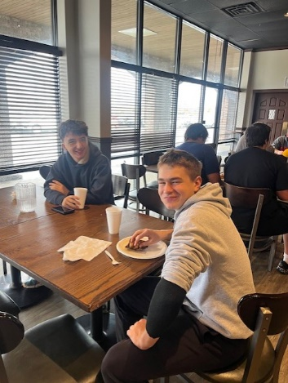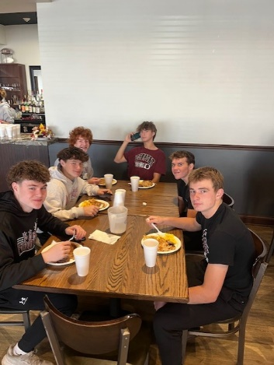
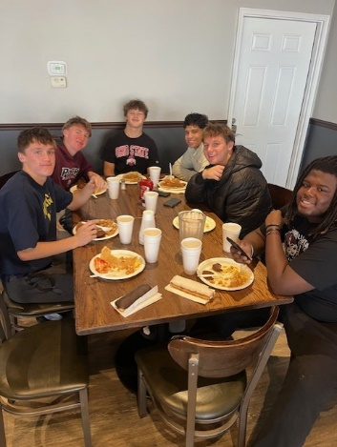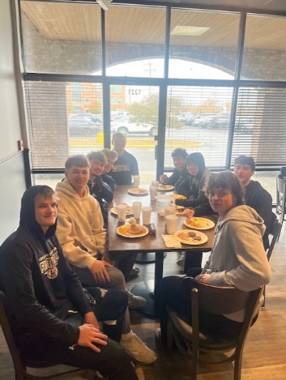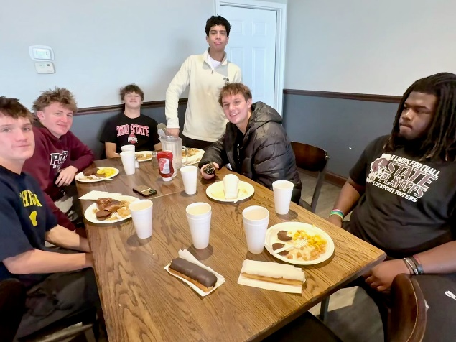

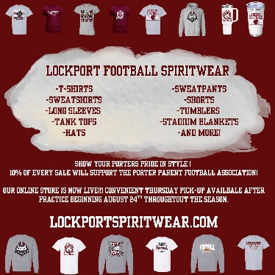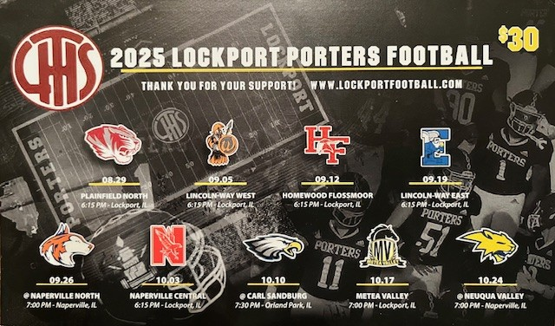
Order your 2025 Lockport Football Spirit wear HERE Discounted 2025 Coupon Book - $20? Contact mailto:mkmatthes@yahoo.com
Helpful Links
Spirit Wear Game Digital Tickets IHSA Football Info 8to18

