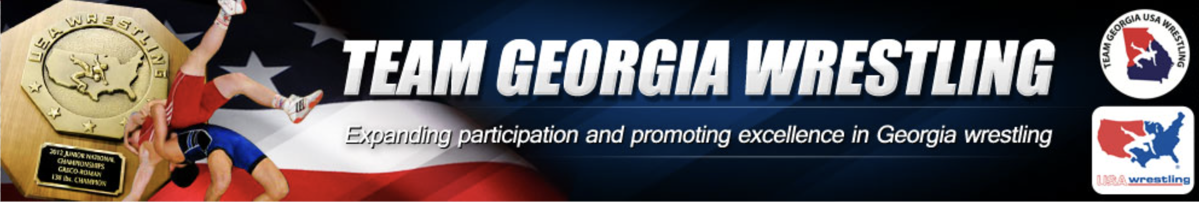

Dear Youth Supporter,

The bearer of this letter has earned the opportunity to represent their school, community, and the State of Georgia at the 2026 USA Wrestling National Greco-Roman/Freestyle Championships or National Duals. This honor is achieved by only a select group of wrestlers in each state.

The USA Wrestling Greco-Roman and Freestyle National Championships are among the largest and most prestigious wrestling events in the United States. College coaches from across the country attend these events to identify and recruit top talent.

In June 2026, National Duals will be held in various locations including Florida, Indiana, Iowa, Utah, and Wisconsin. The 2026 U.S. Marine Corps / USA Wrestling Cadet and Junior National Championships will take place in Fargo, North Dakota in July 2026.

While this is an incredible opportunity, there are significant expenses associated with participation, including travel, lodging, meals, tournament entry fees, equipment, and other related costs.

Your support can make a meaningful difference. By donating, you are helping a dedicated young athlete pursue their goals while also investing in the youth of your community and state.

Team Georgia Wrestling is a nonprofit organization exempt from federal income tax under Section 501(c)(3) of the Internal Revenue Code. Contributions may be tax-deductible as allowed by law. Our Federal Tax ID is 58-2026096.

If you would like to support a specific athlete, please contact our treasurer at treasurer@teamgawrestling.org and include the wrestler’s name in your message. You will receive instructions on how to complete your donation.

Thank you for your support of our athletes and the continued growth of wrestling in Georgia.

Sincerely yours,

Jason L. Griner
State Chairman
Team Georgia Wrestling

