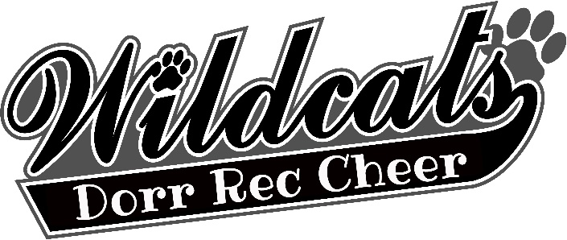 | dORR rEC Cheer  DONATION FORM
Our program wouldn’t and couldn’t exist without the amazing and continued support from our community! With that being said, as we gear up for the upcoming cheer season, we are looking for help to update our very old, used and battered uniforms, which have been in use since before 2015. The cost is $100.00 per child.
Would you be willing to contribute to my new uniform?? THANKS!!!
Item # | nAME/cOMPANY |  | dONATION
Item #1
Item #2
Item #3
Item #4
Item #5
Item #6
Item #7
Item #8
 | TOTAL DONATED |  | $

Please turn in forms and any money collected by July 1st, 2024.
They can be mailed to Dorr Rec P.O Box 65 Dorr, Mi. 49323. Or email us dorrrecreation@gmail.com to set up a time to drop off your donation form.
(Also as we are a non-profit any business that donates can use this as a write off.)

