SLPYHA Board Meeting Agenda
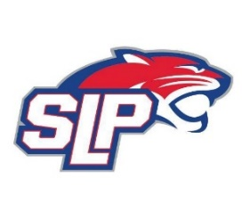
Date: 9/8/22
Bricks
7:00pm

Attendees: Scott Lichter, Mike Mliner, John Pitzl, Kevin Mitties, Jon Tranby, Mike Fitzpatrick, Pat Cleary, Nick Peterson
Guests: Justyn Cowman

- President Report: Scott Lichter
- Call to order: 7:02pm
- Approve agenda
- Approve minutes from 8/7/2022, motion: Lichter move: Mliner
- Latest D10 updates
- Waiver Sign-off
- Fogerty – Rink Dividers & 40th Anniversary
- Golf Tournament – Jess Scott
- Secretary – Justyn Cowman
- Initial team declarations to D10
- Vice President Report: John Pitzl
- Treasurer Report/Gambling Report: Mike Mliner
  - 2022-2023 budget
  - August gambling report - $35k transfer to hockey account
  - 2022-2023 hardship scholarships
  - Board approves monthly gambling expenses
- Secretary Report:
- Traveling Director Report: Adam Kiedrowski
  - Tryout volunteers – clock, bench, check-in, locker room monitor
  - Tryout/pre-skate schedules
  - Tryout judges
- Girls Traveling Director Report: Kevin Mitties
  - CSLP Kick-off event
  - Open enrollment issues, recruiting
  - U8 levels
  - Summer Birthdays’ – tryout/levels
- Mite Director Report: Mike Fitzpatrick/Pat Cleary
  - Mite pre-skate & evaluation dates
  - 10/1 try hockey for free
  - 10/2 start of Panther Cubs
  - Mite scheduler
- Player Development Report: Jon Tranby
  - Registration numbers
  - Team levels
  - Team sizes
- New/ongoing Business:
- Motion to dismiss: 10:27pm, motion: Tranby move: Mitties

