Entering Pitch Count Instructions.
- Click on your team page.
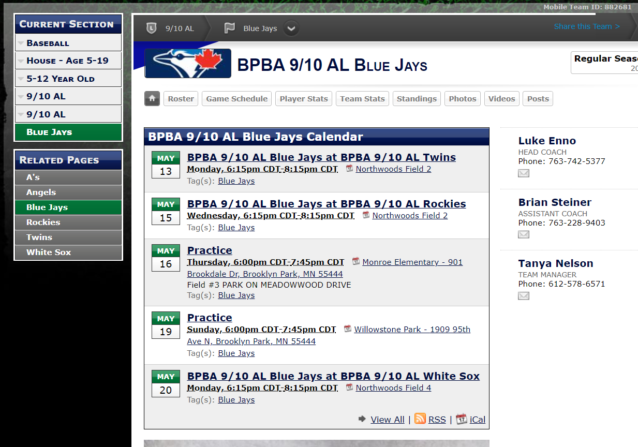

- Click on game schedule.
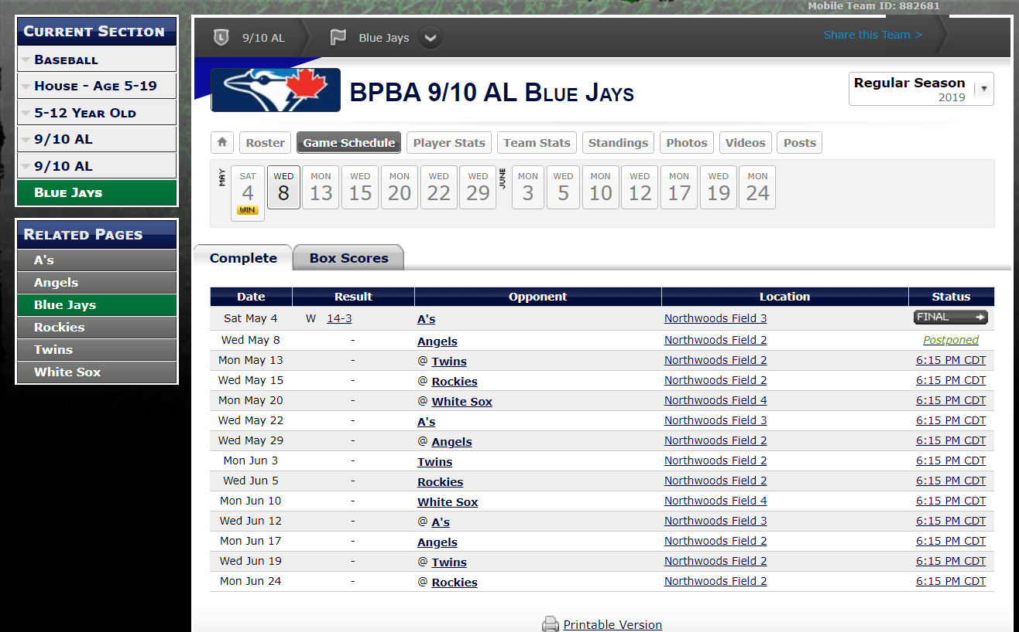

- Click on the game status,
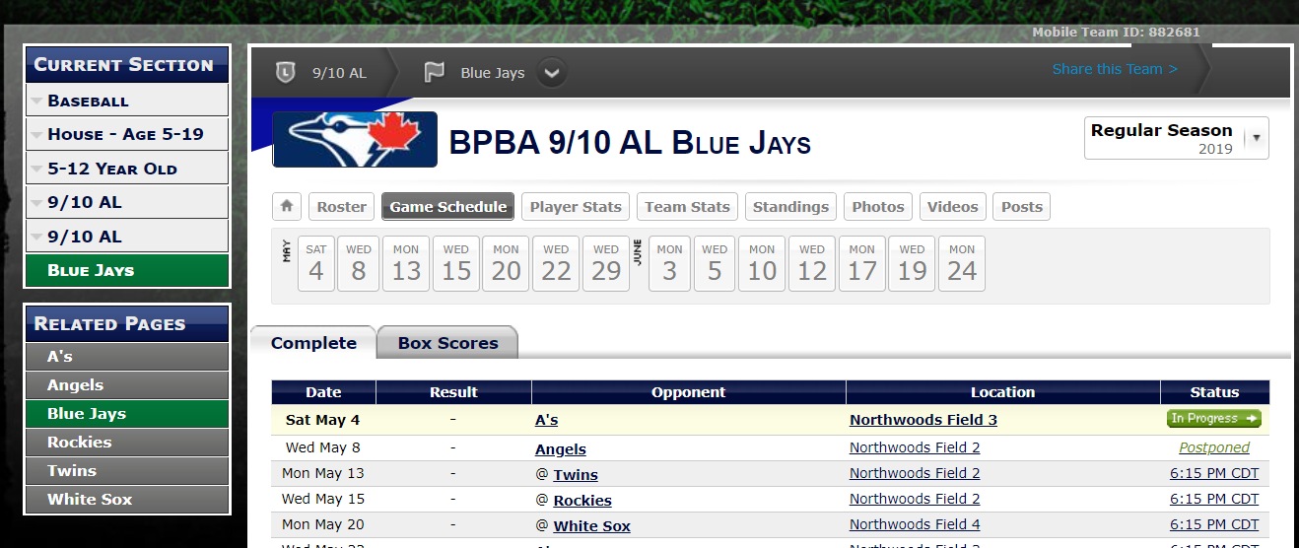

- Change your EDIT/USER to “EDIT”.



- Change game status to “In Progress”, (options are Scheduled, In Progress, Final) needs to be “in Progress” to update pitch counts.

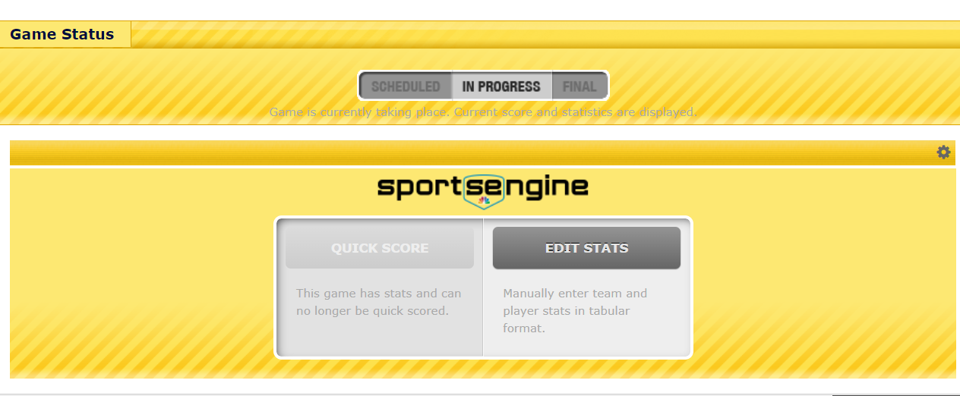
- Click on “Edit Stats”
- Under Pitcher Stats, add player and enter pitch count total in the PC box. 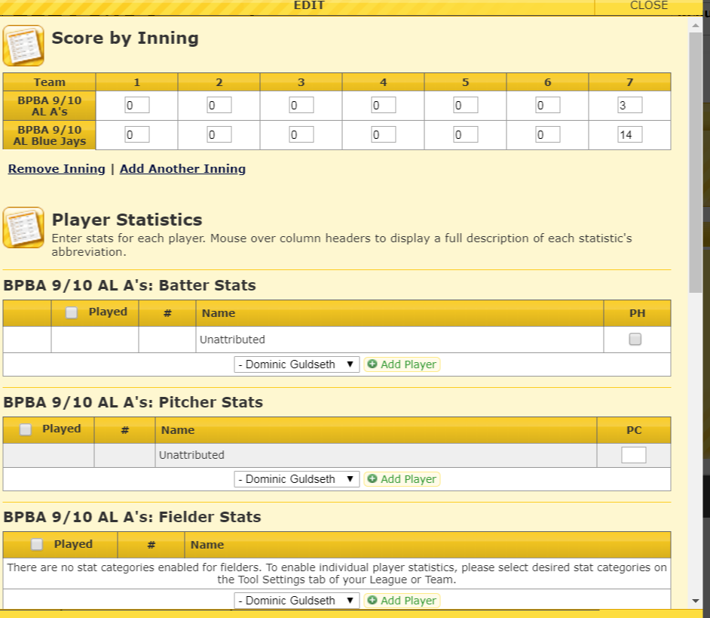

- Then click on Save stats on bottom of the form.
