Ontario Player Development League (OPDL)
To visit the OPDL website, please click here! Or visit opdl.ca
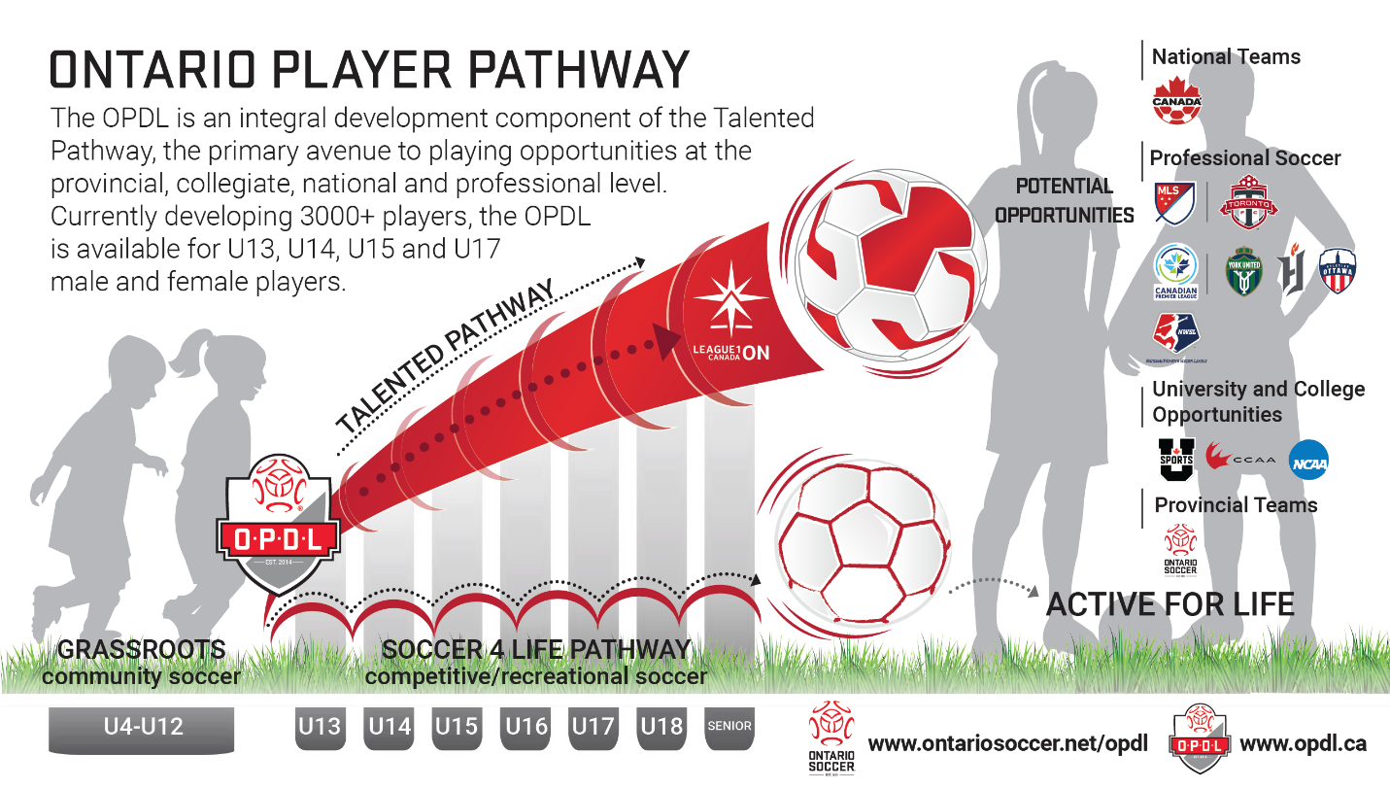
Launched in 2014 with the 2001 age group, the Ontario Player Development League (OPDL) is one of the province's first standards-based, youth high performance league that combines top level competition with strict high performance training standards. This innovative exciting youth high performance program is an important component of the overall movement to adopt the core principles of Long-Term Player Development (LTPD) across soccer at large in Ontario and Canada. OPDL encompasses the U13 to U17 age categories, for both males and females.
OPDL represents young players' early graduation to a genuine high performance training environment, targeting the top athletes in the province from age groups U13 to U17, constituting the highest level of competitive youth soccer in Ontario. OPDL operates more as a high-performance training program than merely a league.

