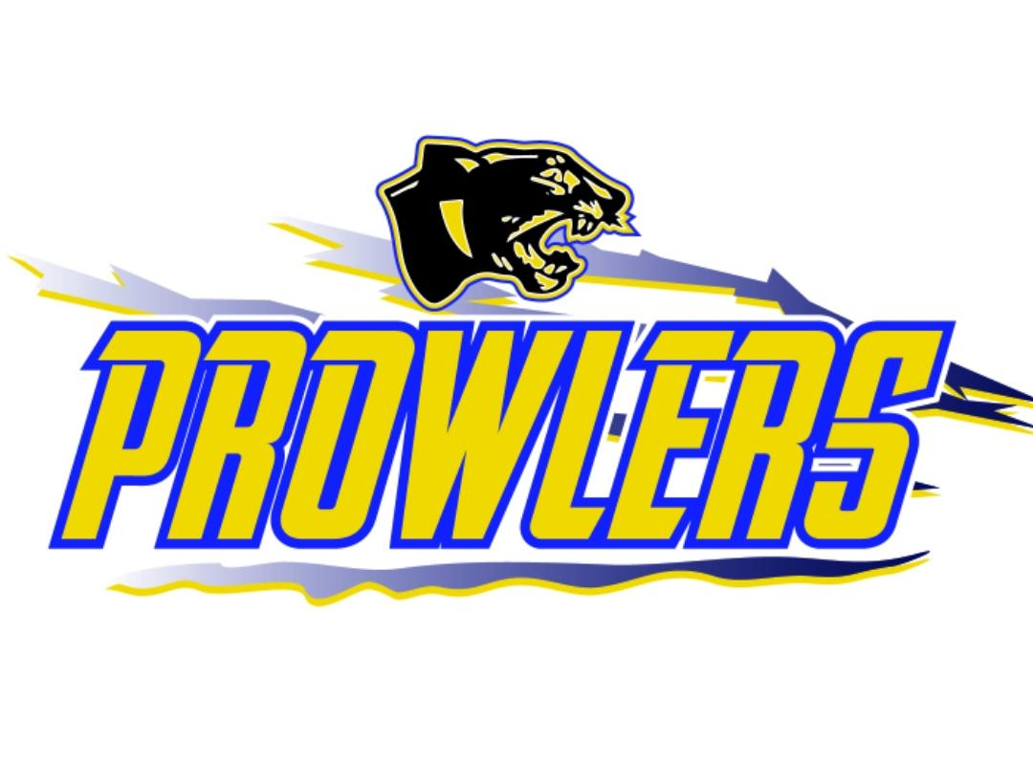
Thief River Falls Amateur Hockey Association
Regular Board Meeting Agenda
Monday February 20th, 2023
5:30 PM Finance Meeting
6:00 pm City Auditorium Basement

- Call Meeting to Order:

- Review and Approve Agenda:

- Requests to Appear:

- Approve Minutes of: 12-05-2022 , 12-19-2022 , 01-02-2023, 01-16-2023, 02-06-2023

- Treasurer’s Report/Finance Committee
- Finance Committee report
- Approve checks

- Gaming report.
- Finance Committee report

- Administration
- Committee Reports and Assignments
i.Master Schedule
ii. Safe Sport Committee Report
iii. Tournament Committee
iv. Gaming Committee
v. HOC Committee Report
vi. Old Arena
vii. Other Committees and Committee Assignments

- Old Business
i. Policies and procedures
ii. Coach/Gm Appreciation

- New Business
A.) Extra hours for accountant. (Leif)
B.) End of season coaches meeting (Matt)

- Adjournment

Assignments

Note the President is a de facto member of all committees whether listed or not.

Assignments (Current Members)
Gaming Manager (Kelsie Dicken)
HOC (Mike Roff, Greg Bottem, Jon Bushy, Mike Eickman)
Game Scheduler (James Hurst)
Equipment (Davina and Nathan Pray)
Referee Scheduling (Taya Mossestad)
Website and Social Media (James Hurst)
Tournament (Team GM)
Old Arena (Leif)
Budget/Finance (Jon B., Elizabeth, Leif, Jon H.)
Practice Scheduler (Cody Bottem)
Registrar (Kacie Arlt)
Concessions Scheduling (Elizabeth Bottem)
Mega Raffle (James)
Summer Camp (Cody Bottem)
Safe Sport (Leif and Nate)
Handbook/Bylaws ()
Marketing (Leif, Nate)
GM Coordinator (James Hurst)

