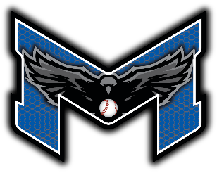
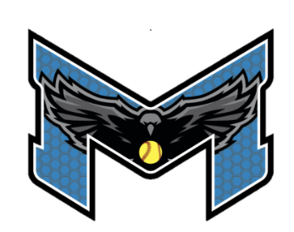
Michigan Blackhawks Tournaments
In consideration of being allowed to participate in any event run by, sponsored or organized by
Michigan Hawks Fastpitch Inc, or Michigan Blackhawks, related to tryouts, tournaments, practices, games, events and/or activities otherwise defined, the undersigned acknowledges, appreciates, and agree that:
- The risk of injury and/or illness from activities involved in the program is significant, including the potential for permanent paralysis and death, and while particular rules, equipment, and personal discipline may reduce the risk, the risk remains.
- The risk to have contact with individuals, who have been exposed to and/or have been diagnosed with one or more communicable diseases, including but not limited to COVID-19 or other medical conditions, diseases, or maladies does exist, and it is impossible to eliminate the risk that I could be exposed to and/or become infected through contact with or close proximity with an individual with a communicable disease;
- I knowingly and freely assume all such risks, both known and unknown, even if arising from the negligence of the releases or others, and assume all and full responsibility for mine and the participation of my minor child.
- I, for myself, my child and on behalf of my heirs, assigns, personal representatives and next of kin, HERBY RELEASE AND HOLD HARMLESS THE Michigan Hawks Fastpitch Inc and any legal affiliate, their officers, officials, agents and/or employees, other participants, sponsoring agencies, sponsors, owners, and lessors of the premises used to conduct all events, with respect to any and all injury, illness, disability, death, or loss or damage to person or property, whether arising from the negligence of the releases or otherwise.
- I HAVE READ THIS RELEASE OF LIABILITY AND ASSUMPTION OF RISK AGREEMENT, FULLY UNDERSTAND ITS TERMS, UNDERSTAND THAT I HAVE GIVEN UP SUBSTANTIAL RIGHTS BY AGREEING TO IT ON MY OWN BEHALF OR ON BEHALF OF THE YOUTH PARTICIPANT ASSOCIATED WITH THE MICHIGAN BLACKHAWKS, AND I SIGN IT FREELY AND VOLUNTARILY WITHOUT ANY INDUCEMENT.
- This waiver will remain active for a period of 2 years from date signed unless renewed sooner.
Team Name: __________________________________________________
Player # | Player Name | Parent Name | Signature | Date
If more slots are required use second form.

Coach Name: _____________________________ Coach Signature: ___________________________________
I ACKNOWLEDGE TO THE BEST OF MY ABILITY THAT THIS ROSTER IS ACCURATE AND TRUE. I ACCEPT THAT ANY OVERSIGHTS RELATED TO PLAYERS AGES OR ELIDGABILITY MAY BE SUBJECT TO FORFEITE. I CAN PRODUCE BIRTH CERTS IF REQUIRED.

