

Save Our Rink – Fundraising Campaign

Dear Community Member,

Burnett Youth Hockey Association is a small hockey association located in Siren, WI. We offer youth hockey and a home indoor rink for our high school team. This offers oppurtunities for kids in the Siren, Webster, Grantsburg, Frederic & Luck areas to play hockey in a safe indoor enviroment.
In the winter months we also offer weekly open skate for the public. This is an inexpensive activity that we are happy to provide the Siren community and surrounding communities. Our facility is also availible for private rental and we do host many school activity/events during the winter months.
We also host 8 tournaments during the winter months. This brings many people in to the area for a full weekend. It does help the local economy, especially in the lodging and hospitality areas.
Our rink was rebuilt after the tornado in 2001. Currently we are in desperate need of a new chiller system and we are starting the “Save Our Rink” fundraising campaign. In total we need to raise $475,000 to replace our current system. We are looking for any type of donations from our local community to help raise the funds for this major upgrade. The new system is not only needed, but it will be much more efficient in the following years to continue to provide a indoor ice arena for our community.
As part of this fundraising campaign we will be displaying all our donors on a permanent donor wall inside the hockey arena. Attached is the donation form if you are interested in assisting us in our monetary needs.
We strive to keep this much needed facility available for everyone in the community.
Our slogan is, “A Kid on Ice is seldom in Hot Water”
Sincerely;
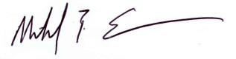
Mike Swanson
BYHA President Donation/Receipt Form 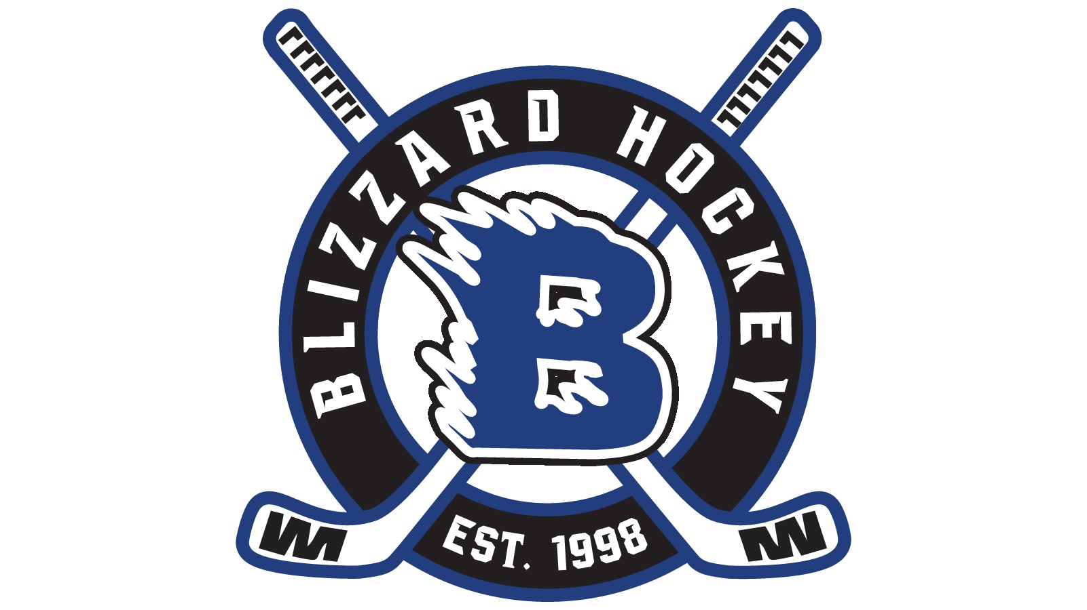
Our program is seeking donors for a new chiller system for our arena. As part of the “Save Our Rink” fundraising campaign we will be putting up a permanent donor wall inside the arena. The different donor levels will be:
*Blizzard Mite Level donor - $1000 - $2499
*Blizzard Squirt Level donor - $2500 - $4999
*Blizzard Peewee Level donor- $5000 - $7499
*Blizzard Bantam Level donor- $7500 - $9999
*Blizzard All-Star Level donor- $10,000 and over

If you would like to make a smaller donation that would be great! Please use this form when submitting donations for this specific fundraising event.

Business/Individual Donating:________________________________________________________________
Contact Person:____________________________________________________________________________
Contact Phone:_____________________________________________________________________________
Name to be displayed on donor wall:____________________________________________________________

Donation amount; $______________________

Thank You for your Donation!!
Proceeds go directly to the “Save Our Rink” Fundraising Campaign All donations are tax deductible to the extent provided by law. Please return this form with your donation to BYHA P.O. Box 82 Siren, WI 54872

Our Federal 501(c)(3) Tax ID number is 39-1935267

