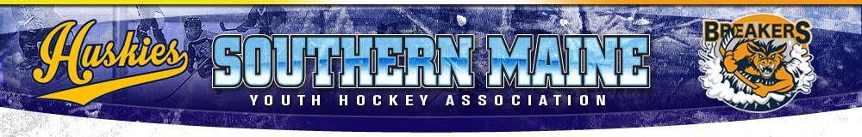
Coaches Code Conduct

- Coaches, Players and Parents associated with SMYHA are always expected to act with sportsmanship, dignity and respect as a representative of the program, either on or off the ice.
Poor Sportsmanship includes but is not limited to the following:
1. Arguing with coaches, officials, opponents or spectators.
2. Using threatening or profane language.
3. Baiting or taunting coaches, officials, opponents or spectators.
4. Inappropriate behavior on the Ice, bench, locker room or any other Association related activity/activities

- Failure to adhere to the Code of Conduct will result in disciplinary action that will be at the discretion the Board. Disciplinary action may rise to the point of ultimate removal.

Coaches Signature: ______________________________Date: __________

