TONKA WRESTLING CLUB
2018-19 ANNUAL MEMBERSHIP

Thank you for joining us. The Tonka Wrestling Team is excited and energized for our 2016-17 wrestling season. We have a solid group of new and experienced wrestlers, coaches, and boosters committed to build a nationally recognized wrestling program at Minnetonka High School.

As a member, you will be listed in our Tonka Wrestling Program – which is distributed, free of charge at all home wrestling meets, and you will be listed on our new Tonka Wrestling website. You will also receive Tonka Wrestling Decals, Wrestling Event passes and a copy of our Wrestling Program.
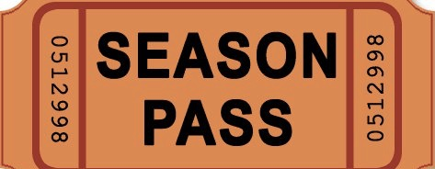


MEMBERSHIP LEVELS

PLATINUM: 2 Tonka Wresting Window Decals, 4 Season Passes $500 or more
to 2016/17 Home Wrestling Events, Program Listing,
Wrestling Program and a panoramic team picture.

GOLD: 2 Tonka Wrestling Window Decals, 2 Season Passes $250 - $499
to 2016/17 Home Wrestling Events, Program Listing,
Wrestling Program and a panoramic team picture.

SILVER: 2 Tonka Wrestling Window Decals, 4 Home Wrestling $100 - $249
Event Passes, Program Listing, Wrestling Program.

BRONZE: 2 Tonka Wrestling Window Decals, 2 Home Wrestling $ 25 - $ 99
Event Passes, Wrestling Program.

NAME: ______________________________________________________________________
NAME IN PROGRAM:______________________________________________________________
Check here if you do not want your name listed:

ADDRESS:_______________________________________________________________________
CITY/ST/ZIP: ____________________________________________________________________
PHONE: ________________________________________________________________________
EMAIL: _________________________________________________________________________
Please make check payable to: Tonka Wrestling Parent Organization, E-mail: josh.frie@minnetonkaschools.org Phone: (612)865-9303 (This form must be received by December 1, 2017 to make our printing deadline.)
Thank You for Your Support of Tonka Wrestling!

