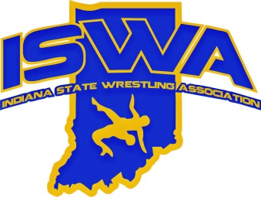
INDIANA STATE WRESTLING ASSOCIATION, INC.
P.O. Box 157, Beech Grove, IN 46107 Phone: 317-780-1885

2025 Folkstyle Developmental Director Report

2025 marked the 15th year of the ISWA hosting the Elementary Duals State Championships. The tournament was once again held at Franklin Community High School and featured 30 teams in a three-division format: Large, Medium, and Small. Congratulations to the following champions:
Large Division: Crown Point Wrestling Club
Medium Division: Bloomington South
Small Division: Garrett Wrestling Club

This year was the 5th edition of the ISWA Middle School Duals State Championships, which took place at the Fort Wayne Coliseum. Eight teams competed in a single division. Congratulations to Crown Point Wrestling Club for winning the 2025 Middle School Duals State Title.

The Middle School State Championships were once again hosted by Center Grove High School. The event ran smoothly, showcasing Indiana’s top middle school talent. Thank you to Center Grove and the IHSWCA for their continued support of this important event.

Indiana was honored once again to host the USAW Folkstyle Kids Nationals at the Fort Wayne Coliseum. The ISWA, in partnership with USA Wrestling, delivered a fantastic event that saw significant growth from the prior year. It was an incredible opportunity to have both girls' and boys' national championships in our state, and we look forward to hosting again in the future.

Indiana’s National teams had another strong showing at the USAW Heartland Duals in Council Bluffs, Iowa—widely regarded as the premier dual tournament for elementary and middle school athletes.
Elementary Boys
Indiana Gold: 2nd Place – our highest finish ever
Indiana Blue: 13th out of 27 teams
Middle School Boys
Indiana Gold: 3rd Place
Indiana Blue: 8th out of 27 teams
Girls Teams
Indiana Gold: 15th out of 21 teams
Indiana Blue: 16th out of 21 teams

The Folkstyle State Championships were held at Nexus Park in Columbus, Indiana, a new and beautiful facility that allowed us to host the entire tournament under one roof. The event ran exceptionally well, and we are excited to continue building this event at Nexus Park in the coming years.

Freestyle and Greco State Championships were once again hosted by Avon High School and ran smoothly. We appreciate the outstanding support and effort from Avon’s staff and volunteers.

The ISWA remains committed to elevating wrestling in all styles and age levels across Indiana. The
growth of our youth programs is evident through events like the Elementary and Middle School Duals and the strong national performances from our teams.
As always, if you have feedback, ideas, or concerns, we encourage you to reach out to any ISWA board member directly. Thank you to all who contributed to another outstanding season—let’s keep building Indiana wrestling.

Ryan Parrish
ISWA Folkstyle Developmental Director

