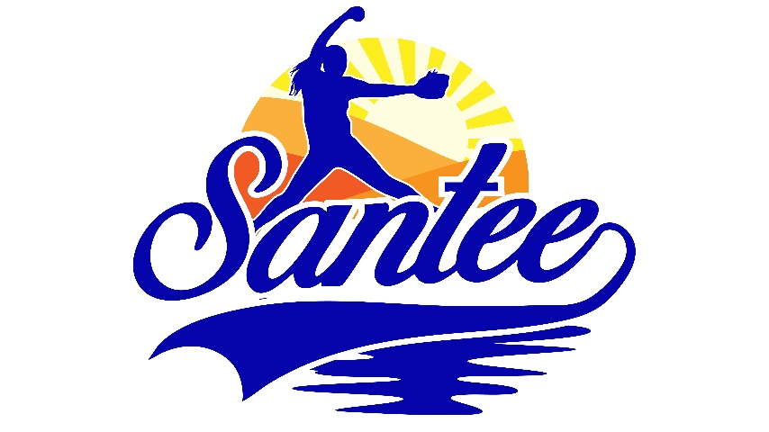
MINUTES TO BE APPROVED AT THE NEXT BOARD MEETING. THESE MINUTES ARE NOT CURRENTLY POSTED AND SHOULD NOT BE DISTRIBUTED UNTIL APPROVED BY USASSCS BOARD.
Board Meeting Minutes November 10, 2025
Location: Santee City Hall
Attendees Shown with Marked Box
Guests:
President | Erik Ruiz | x | Awards | Janis Aiello
1st VP/ Field Scheduler/Fall Ball Coordinator | Chris Klima | x | Field Prep | Trevor Henton | x
2nd VP | Kelli Timanus | x | Field Prep/Uniforms | James Timanus
Treasurer | Tiffany Lynch | x | Field Prep | Shane Hanson
Secretary/Safety Coordinator/Head Scorekeeper |  |  | Field Prep | Brad Allen | x
Tax Advisor | Lori Britt |  | Field Prep/Equipment | Shane Frary | x
Player Agent | Lance Craw | x | Field Prep | Eric DeChant
UIC/Parliamentarian | Bryan Scholar | x | Head Team Parent Coordinator | Shahday Galloway
Webmaster/Social Media/All-Star Coordinator | Alexis Ruiz
BOTH Tournament Coordinator/Picnic Coodinator/Social Media Coordinator | Karly Dwyer | x | Snackbar #1 | Katja Moskowicz | x
Sponsorships | Kylee Scholar | x | Snackbar #2 | Ashley Knepp | x
Field Prep | Erik Medrud | x | Snackbar #3 | Victoria Brennan | x

Meeting called to order: 7:11 PM
Meeting Minutes
- Financial Update (Tiffany L)
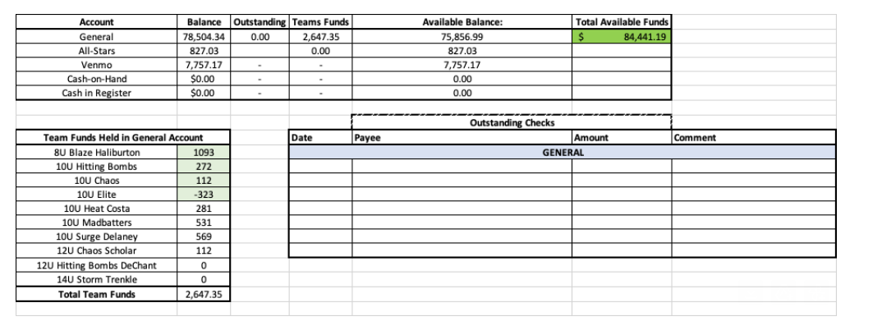
  - Outstanding invoice from Sports Engine that will be paid
- Halloween Havoc Recap
  - Snack bar proceeds $3,568.61
  - Overall proceeds of $8,896 for the tournament
  - Ended up with about 40 t-shirts left over (Youth Small & Youth Medium)
- USA Softball Meeting – November 23
- Kelli Timanus & Katja Moszkowicz will attend the conference
4. Bring on the Heat will move to last weekend of May beginning in 2026 – Voted during meeting
5. Fields will close from after November 24, 2025 until January 12, 2026
- Chris Klima will ask for at least 2 fields to be open beginning January 7 for the Warm- up Clinics January 7 – 9 and Player Evaluations on January 10 - 11
6. Snack bar
- Inspection to take place on Thursday, November 13
7. Equipment
- Parts for one pitching machine will be ordered
Next Meeting: December 8

