U5/U6 Session 3
Warm up
Frog Attack
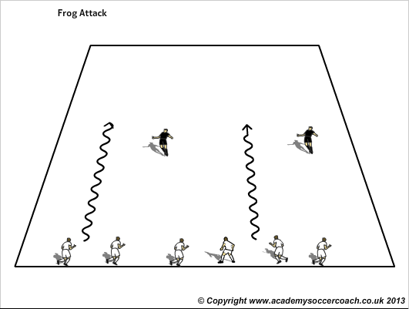
The game takes place in a rectangle; all the players start on one side and try to get to the other side. Two players who are "frogs" must hop to try and tag the other players as they try to get to the other line. When a player is tagged, they become a "frog" as well. Play until two players are left.
Tunnel Soccer
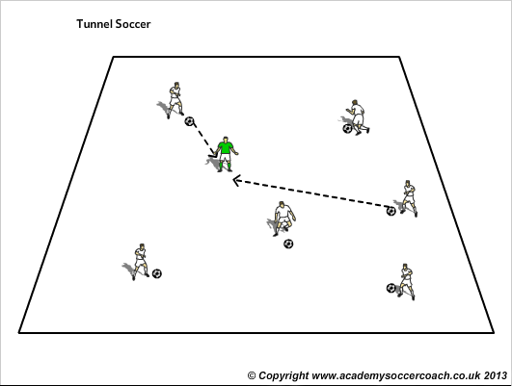

Each player has a ball. The coach has no ball but moves around the field with the players. From time to time the coach stops and spreads his legs to form a tunnel. The players dribble after him and try to pass through the tunnel whenever he stops. After a few shots the coach moves on again. Who can score the most points? If to many kids, allow them to be the tunnel.
Bingo
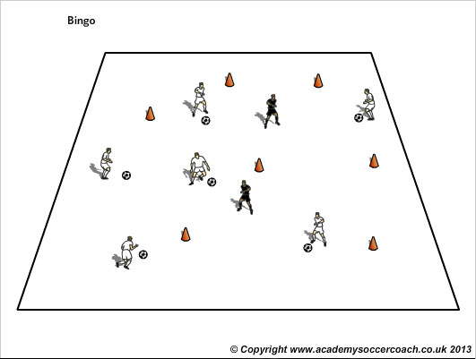
A number of tall cones are distributed throughout the field. Designate two "replacers" (coaches). Each player has a ball. The players dribble around and try to knock down as many cones as they can yelling "bingo!" as they do. The ‘replacers’ stand the cones back up immediately. Who can get the most bingos?
Progression: Must be 3 yards away to knock cones over, must strike ball with Push pass/outside of foot/laces

