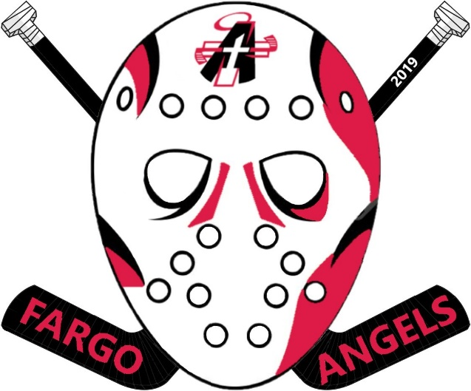

Fargo Angels 2018 Squirt Pin

In preparation for the Squirt International Tournament in February, it is time to order your Angels pins for 2019!! The picture above is what the 2018 pin looks like. The pin is about 2-3/4” wide and 3 inches tall.

The Pins are going to cost $3.80 each and you must pre-order using this form. No additional pins will be ordered so please plan accordingly. Also, please note that a limited number of pins are being ordered so we will fill orders on a first come first serve basis.

Pin trading books (to put the pins in) are also available for $25.00* each.
** Pin trading books are also readily available for sale by various vendors at the tournament** We will be distributing the pins/books to all of you as soon as they arrive.
Make Checks payable to: Fargo Angels Hockey club

Name of Player:

Parents Name and Phone:

Team Name:

# of Pins I want to purchase ($3.80 each):

# of pin trading books I want to purchase ($25.00 each):

ALL COMPLETED ORDER FORMS SHOULD BE TURNED INTO YOUR TEAM MANAGER BY JANUARY 7TH, 2019 OR AS SOON AS POSSIBLE.
The Squirt International Tournament is Feb 7-10 (Squirt White) and Feb 14-17 (Squirt Red), 2019.
If you have any questions, please contact Chuck Hale 701-799-3612 or chale@ecisystems.com

