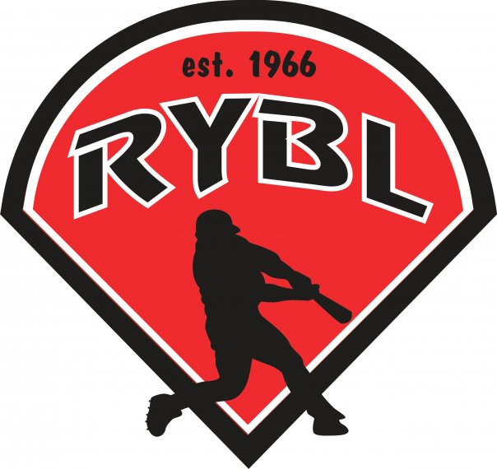
RYBL January 2023
Board Meeting
01/26/2023 5ish PM
- Call to Order 5:18pm
- Opening Prayer: Bryan
- Previous Board Minutes Approval – Andy Keogh
  - December 2022 Minutes – Approval approved
- Treasurer’s Report – DJ Butcher PayPal set up – 1st farmers was charging us $7 every month is handled – where are the registration fees going not to the account? Babe Ruth how much money do they have we owe? TWO DUKE PAYMENTS? approved
  - Current Bank Balance: $29,612.46
    - Outstanding Bills:
    - Accounts Receivable:
- Office and Committee Reports: list lawn renewal contract- pay it up front – motion passed – new concession stand manager DeWayne came to the meeting – seems ready for action – candy for a dollar
- Secretary – Andy Keogh
- President – Bryan Altmaier
Need to order raffle tickets when registration closes
Need dates on Lions Club for draft possibilities, that Monday is Lions Club meeting, but we should be able to use big room
After tryouts will get schedule started, do we want to keep doing interleague play? Yes. Do we want to include Kokomo this year or exclude them? NO
Reached out to Lairds Training about batting cages, haven’t heard back. Also asked about renting their field for outdoor practices. If we do the upkeep, he is good with us using. Places for teams to practice? Where do we do it?
- 1st Vice President- Chris Pavey: Draft Feb 4th start practices on Feb 19th – Justin Edwards wants to be the T-ball director voted in – need two tall managers – martin bros have one kid signed up
- 2nd Vice President – Mickey White: one minor manager still needed – all bags need tags – bags are inventoried –
- Player Agent – Brandon Darling: 47 Trying out -11 Ma 15 Min 21 Ro -
164 players registered as of 1/26/2023
29 Major, 25 Minor, 53 Rookie, 57 T-ball
- Equipment Manager – Dawn Hyman: baseballs are ordered here and sent out logos – move T-ball logo to rookie logo – team names have been submitted – color changes are approved – background check program, safe site - we can pick how long we want the checks are good for two years , basic is $11, level one includes the county it is $17 – motion supported and approved for the background check – 12 year old jackets again – 1st initial last name – mother son $25 a couple – march 18th -
Baseballs have been ordered $2,393.15
- Umpire in Chief – Matt Adams: talked to duke about grants waiting to hear back
1 Umpire for Rookie and Minor and 2 umpires for major will be our format this season
- Media Director- Taylor White: dance flyer completed March 18th –
- Website updates? Bryan/Brandon will fill in if Taylor is not there.
Sponsors have all been covered for teams.
- Unfinished Business- Fundraiser for lights, Grants, Any new equipment? Set $10,000 set over on the side for a light fund – motion supported – more grants we do the better
- New Business- Tryouts, who can help? – 1st come 1st serve – help with rookie – full time pitching machine – everyone is invited –
Uniform pattern for this year
Background checks will be done thru the company the school uses
Tball games, what day are we playing them? 10 and 11 on Saturdays
Need to order new nets for batting cages, can someone get a measurement on the size we will need for at least minor league cages.
Any other issues anyone can think of that need addressed from last season? Need wind screens – we have a bunch in the shed – mickey is looking into them – motion to move martin bros to minors due to sign ups being low passed – drive down the cost for the students
- Adjournment – Next board meeting Feb 16th 7pm 6:50pm

