Team Reports Form for ISWA Member Guide
Team: 14U Team Indiana – Freestyle

Team Leaders & ISWA Title: Steve Livingston – 14U Team Leader

Coaches: Tanner Boman, Charles Taylor, and Joe Wilson

Volunteers & Others You'd Like to Thank: A huge thank you goes out to Terri Shaw who worked the table at each of our duals helping run Track Wrestling and/or operating the camera. Ben Davis High School stepped up and hosted our camp.

Team Results: 5-4 and placed 5th in the Copper/Bronze Pool (13th overall)
Florida defeated Indiana 46-35
Indiana defeated Rhode Island Gold 57-25
Indiana defeated Colorado 54-26
Indiana defeated Florida 43-42
Ohio Grey defeated Indiana 50-29
Maryland defeated Indiana 45-35
Oklahoma Blue defeated Indiana 52-29
Indiana defeated Georgia 43-36
Indiana defeated Texas 43-41

Roster:
71 – Colton Wiseman (9-0) ALL DUALS TEAM
77 – Haedyn Cochran (5-4)
83 – Landon Burkett (1-8)
87 – Deacon Gibbs (4-5)
92 – Eli Kincaide (1-8)
92 – Reese Nunn (Team X)
97 – Jaxon Smiley (1-8)
102 – Jeremy Carver (8-1)
106 – Camden Hook (8-1)
110 – JJ Doty (4-5)
114 – Caleb Asa (7-2)
119 – Andrew Wilkins (1-8)
125 – Joseph Paun (5-4)
130 – Charles Faurote (4-5)
130 – Emmit Abernathy (Team X)
136 – Lincoln Hinchman (9-0) ALL DUALS TEAM
149 – Bane Metcalfe (1-8)
165 – Austin Manley (8-1)
187 – Giovanni Celis (6-3)
250 – Shawn Jackson (0-6)

Narrative: Team Indiana began the tournament in Pool C where we were able to finish in fourth place. That moved us into the Copper/Bronze pool where we finished in fifth place. Colton Wiseman and Lincoln Hinchman both went undefeated and earned All Duals honors. Lincoln Hinchman was fifth out of all competitors’ with the most technical falls in the least amount of time. Colton Wiseman was third overall for the most team points scored. Camden Hook was third in most match points scored. Joseph Paun was seventh place for most points scored in a single match. This was a fun group of wrestlers to watch compete.

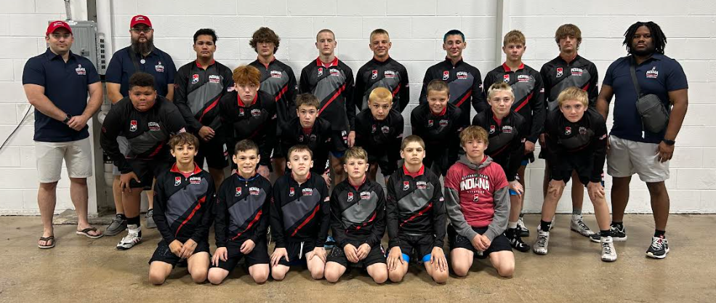
-Back Row: (L to R) Coach Tanner Boman, Charles Taylor, Giovanni Celis, Austin Manley, Joseph Paun, Emmit Abernathy, Lincoln Hinchman, Bane Metcalfe, Charles Faurote, Coach, Coach Joe Wilson
-Middle Row: Shawn Jackson Caleb Asa, Reese Nunn, JJ Doty, Jaxon Smiley, Jeremy Carver, Andrew Wilkins
-Front Row: Deacon Gibbs, Haedyn Cochran, Colton Wiseman, Landon Burkett, Eli Kincaide, Camden Hook

