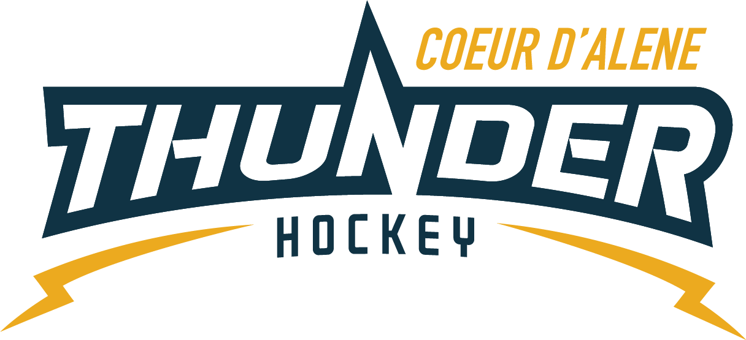

CDAHA

Meeting minutes
Location: Frontier Date: December 15 2021
Attendees: Bob Nelson, Katie Lovitt, Megan Smith, Elliot Taub, Matt Creighton, Bart Barrett, Will Higgins

Absent -, Josh Leppert, ,Matt Fisher
Guest –, , Kami Winfrey, Matt Pelz
- Call to order
Matt Creighton , Vice President called meeting to order 12/15/21 6:38PM
- Roll call
As stated above -
- Approval of minutes from last meeting
Minutes approved motioned by – Bob Nelson second by Katie Lovitt passes unanimous
- New Items
- Treasurers Update
  - See attachments
  - Trying to keep up with invoices and other items to get managers caught up for invoicing it’s a difficult issue
  - Look at tournaments for next year save MORE money for tournament deposits
  - Look at number of tournaments and costs and budget appropriately
  - Protect the tournament process and make sure that select teams program matches the big picture– select teams are getting practices not games – needs to follow the process
  - Each age group doing their own thing to make it work for the select and all kids – follow the commitment that the parents agreed to in registration - potential take select kids out of house tournaments to balance the number of games
  - Put Tournament cost back into registration – look at the financial impact and protect the integrity of the program so they cant skirt –
  - Rep starts at Pee Wee
  - Make sure all payments go through the association
Holiday 3 v 3 all ages
  - Dec 28th 6 -9 pm Free to CDAHA registered players
  - Will replace the Xmas skate and be coordinated by Matt if he needs help he will let the BOD know
Coaching Committee Update
      - no update yet
  - Gear Committee Update
- Don’t mess with the closet it was destroyed and a lot of effort went into cleaning it.
  - Discipline committee update – Sean Myer new Chair and his wife Amber will help with Mites
- Some cases came through and addressed through P and P – Discipline handed out and agreed
  - Safesport update – Matt Pelz is new SS
- Need more locker room monitors
- April to blast coaches for safesport monitors as there have been a shortage and needs to be followed and enforced
- Will order lanyards and cards for safe sport coordinators – 8 per team Bob motions $120 for lanyards and tags Katie seconded all in favor it passes
- Scheduler Update
  - All scheduled
- Mite gear needed – 4 more sets of goalie gear due to the high volumes of teams we have at Mites. After discussion BOD and Will agree to 2 kits this year and 2 next year -
  - Bob motions to purchase 2 sets at 524 for both 250 from coaches budget and 250 from the association Will seconds – all in favor passes
  - Bob will provide sticks
- Skate sharpener schedule – no update
- Feedback from golf tournament -fundraiser etc – should be 2500 donation will be saved for Robby Glantz
Minutes submitted by: Elliot Taub
Minutes approved by: BOD
- Next Meeting
  - Wed Dec 15 2021 6:30PM
  - Bart motions to adjourn – Bob seconded
MERRY CHRISTMAS EVERYONE!

