Click on the Post Scores tab, then on the Division name.
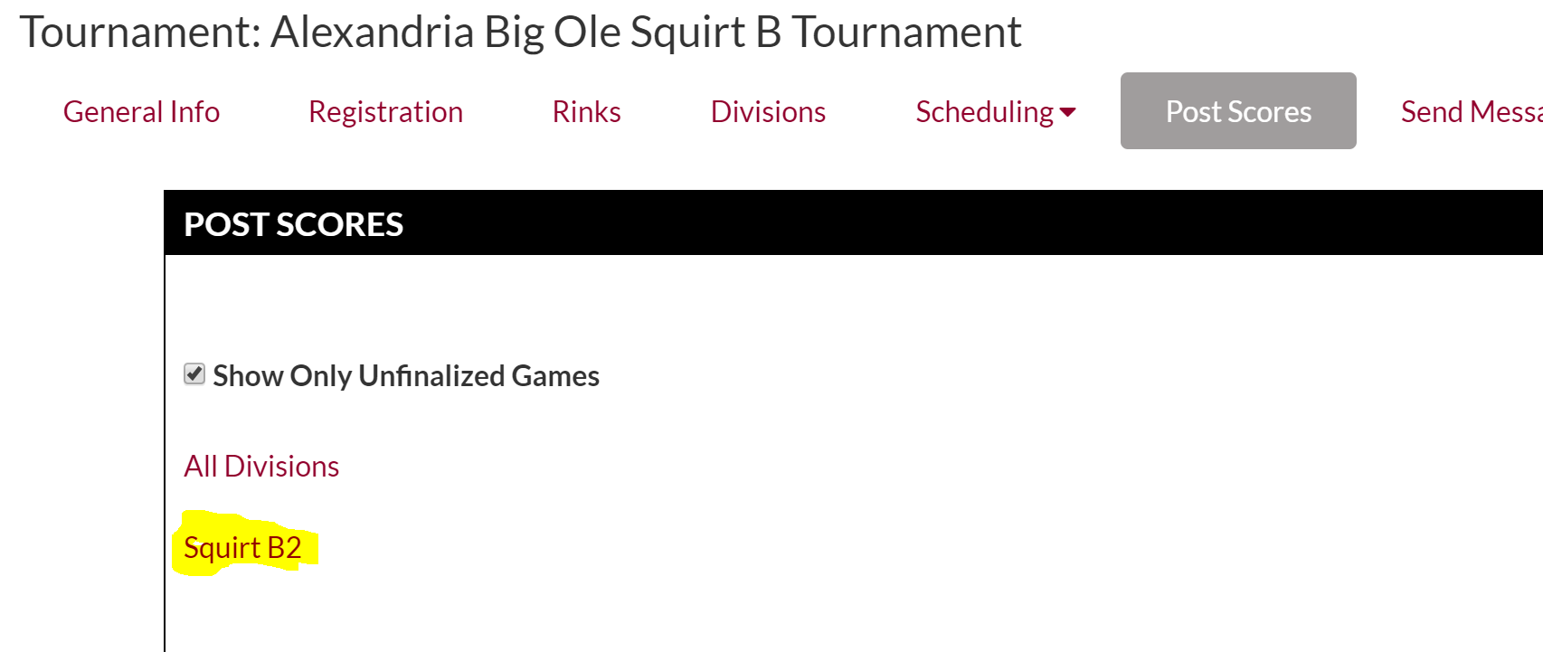

Go down about halfway on the page to ‘Select Pool Below to Set Places’. Click on each Pool (at this point, there will be a note that says (Pool Play Complete – Places not Set)
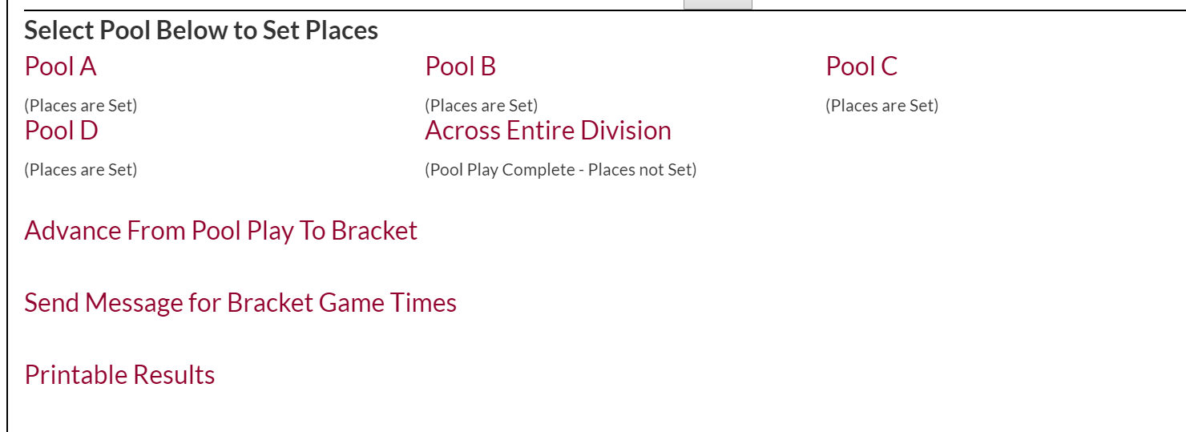

Once you are in a pool, set the places (The app puts them in the right order – should only have to intervene if you need the ‘coin flip’ tie breaker)

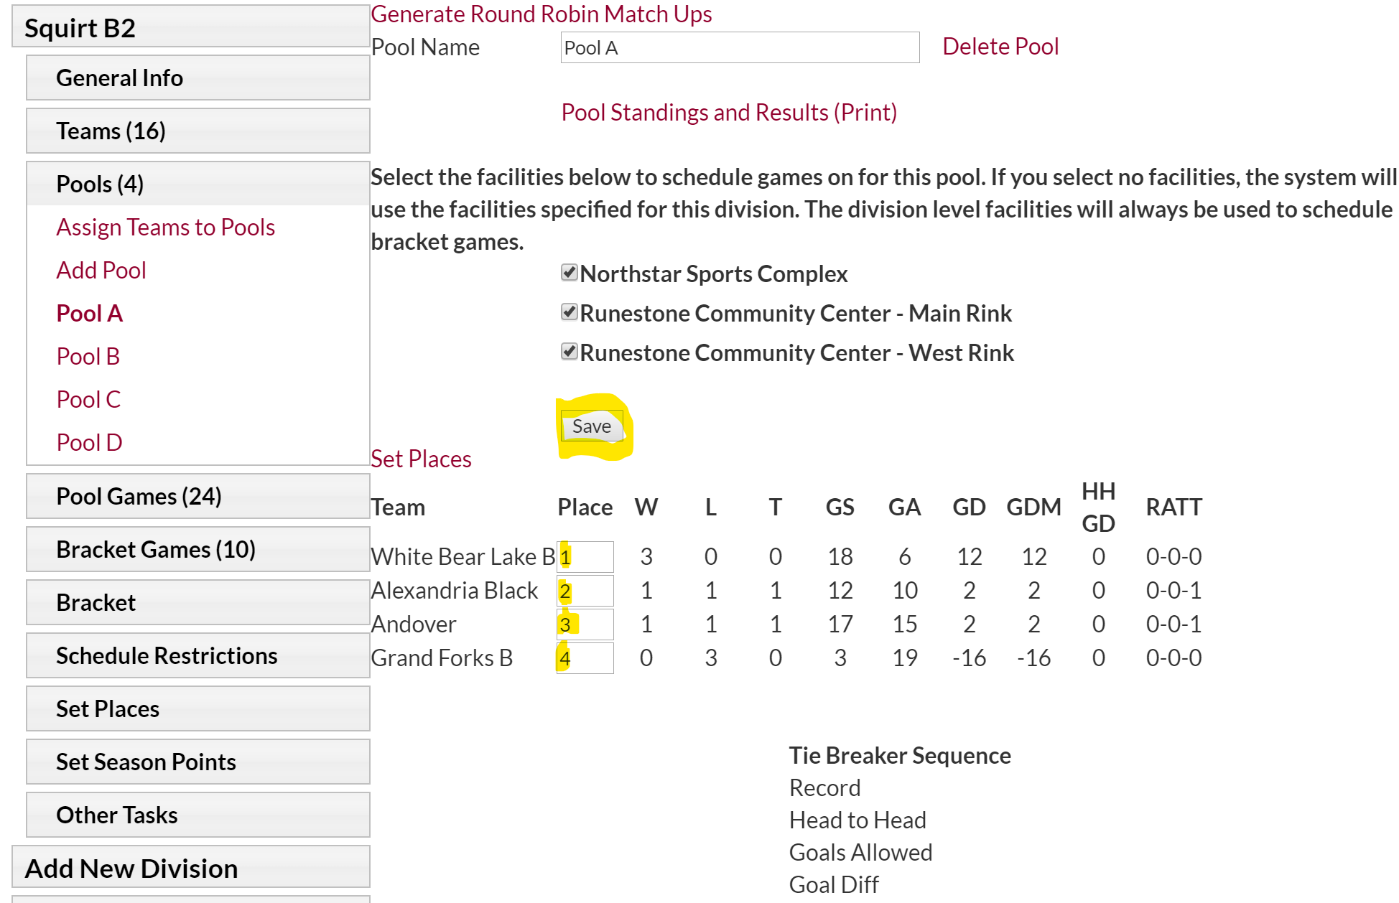

Save when the places have been entered.
Click on the next pool (choices on the left) and do the same.
Once all brackets have been set, go back to the ‘Post Scores’ Tab, then choose your division, and go back to the ‘Select Pool Below to Set Places’ area

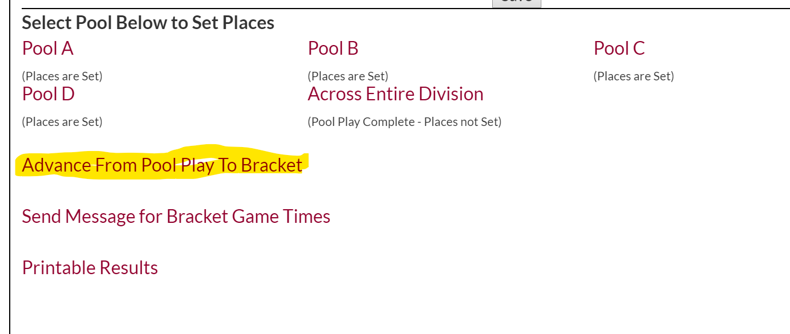
*I can’t recall for sure what happened at this point….You either got a screen like before where you have to hit ‘Advance Teams to Bracket’ or
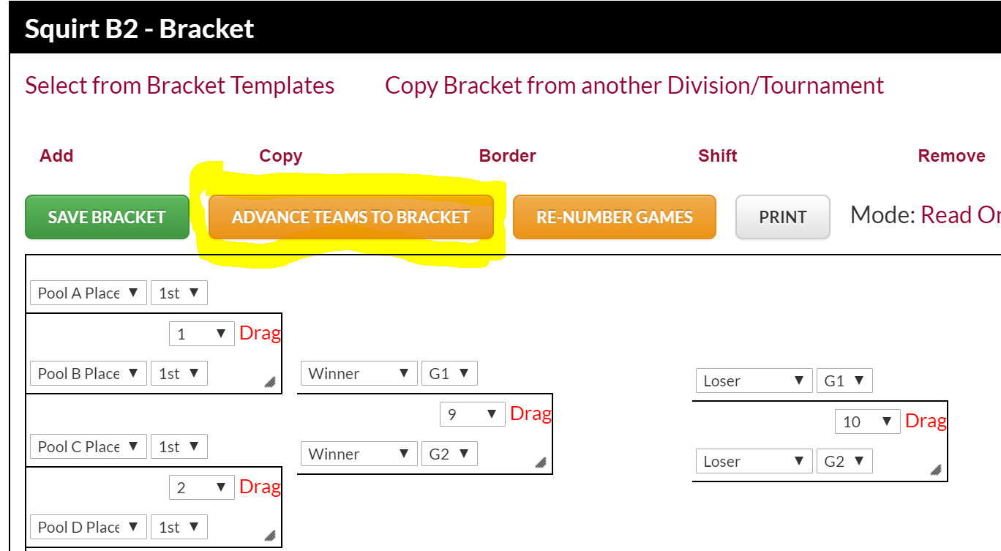

You get a screen like this with the teams already filled in and then you have to ‘Confirm Bracket’
