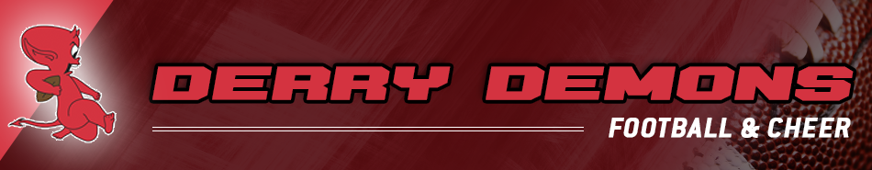
In attendance
President - David Simonelli | X | Assistant Cheer – Christina Wilson | X
V.P – Jennifer Ouellette | X | Football Coordinator- Craig Cox | X
Treasurer – Alex Lord | X | Assistant Football- Phil Ouellette | X
Registrar – Troy Robichaud | X | Communications – Mara Walker | X
Cheer Coordinator – Crystal Morin | X | Fundraising – Laura Daly | X
Merchandise Coordinator – Valerie Alfaro | X | Volunteer Coordinator – Chrystal Munoz | X
Meeting called to order 6:33 pm by Dave Simonelli – notes recorded by Laura Daly

President/Vice President’s Report:
- NHYFSC Final Book Certification 9/10
  - Updated headshot needed for 1 D10 athlete
- Board Coverage at games and responsibilities
  - Discussed chain of command
    - Team mom > Coach > Then Board
  - Emphasized differences in JHL rules vs AYF
- Demons night @ Pinkerton home game
  - Mara to reach out to Pinkerton for football player walk out
- Need for sending out bylaws and schedule meeting for any change requests
  - Proposed amendments to the DFS must be submitted by 10/31
- Need for meeting minutes to be added to website
- Food Truck Updates
  - Jenn and Chrystal working to secure vendor for next game

Treasurer’s Report:
- $83242.58

Registrar’s Report:
- Nothing to report

Cheer Coordinator’s Report:
- Pep Rally update
  - 10/4
  - We have the Gym from 5:30-10
  - Pep Rally starts at 7:30
  - Football players required to attend
  - Val to follow up with flowers for cheer
- Comp
  - Volunteer, raffle, and additional information sent out
  - Cheer xplosion website is live

Football Coordinator’s Report:
- Flag Jamboree @ Londonderry 9/21
- Concerns with coach(es) and injuries have been addressed
- Discussion over JHL concerns
  - Board to have meeting with coaches
  - Motion to remove Jay as coach made by Christina
    - Seconded by Val
    - Vote unanimous with the exception of 1 abstaining vote
    - Vote approved to refund his sponsorship donation unanimous

Merchandising Report:
- Nothing to report

Fundraising Coordinator Report:
- Remaining Tagging Hours
  - Final notice will be sent to families that do no complete tagging hours
    - Will be invoiced $125
- Sponsorship Plaques
  - Will be handed to donors this week
- Nationals Fundraising discussion
  - Went over timeline for fundraising
  - Motion to purchase Bruins Tickets for post-season raffles made by Laura
    - Seconded by Jenn
- Board to explore fundraising initiatives for football family in need
  - Blanket Fundraiser
  - Bake Sale for clap out

Volunteer Coordinator Report:
- Picture Make-ups
  - There will be no make-up day
- BC/Louisville Game update
  - Chrystal to post about it
  - 10/25
  - 7:30 pm

Meeting Adjourned at 8:41 PM

