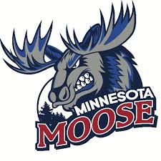
Games Operations Intern
The Minnesota Moose Hockey Club, located in Blaine, Minnesota, is seeking an enthusiastic and motivated Games Operations Intern to join our team for the 2025-2026 season. This internship will provide valuable hands-on experience in the sports industry, particularly in the area of game-day operations. The intern will assist with various tasks related to event setup, fan engagement, and operations during home games. This is a great opportunity for those looking to gain experience and build their resume in sports management.
Key Responsibilities:
- Assist with the setup and breakdown of game-day operations, including preparation of the arena, locker rooms, and other team areas.
- Assist in organizing in-game promotions, contests, and fan engagement activities.
- Help coordinate game-day logistics and assist with coordinating in-arena entertainment (music, videos, crowd engagement).
- Collaborate with the operations team to ensure smooth communication and execution of the game-day experience.
- Provide administrative support as needed, including data entry and assisting with ticketing or guest management.
Required Qualifications:
- A strong passion for hockey and a desire to work in sports operations.
- Excellent communication and interpersonal skills, with the ability to work well with a team.
- Detail-oriented, highly organized, and able to multitask in a fast-paced environment.
- Availability to work evenings, weekends, and potentially some holidays (game days).
- Ability to work independently with minimal supervision.
Compensation and Benefits:
- Must be a technical, undergraduate, or graduate enrolled in a college credit internship program, preferably pursuing a degree in business, sports administration, marketing, communications or a related major.
- Valuable hands-on experience working with a Junior hockey team.
- Networking opportunities in the sports and entertainment industry.
- Team merchandise and tickets to games.
How to Apply:
To apply, please send your resume and a brief cover letter explaining why you're interested in the Games Operations Internship with the Minnesota Moose to mnmoosecoach@gmail.com.

