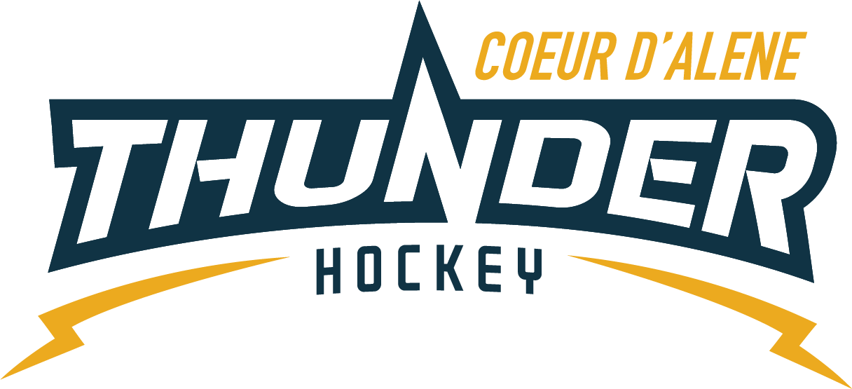

CDAHA

Meeting minutes
Location: Frontier Date: September 15 2021
Attendees: Bob Nelson, Katie Lovitt, Will Higgins, , Megan Smith, Elliot Taub, Matt Creighton, Matt Fisher, Josh Leppert, Jarrod Hansen
Absent -, Bart Barrett,
Guest -Joe White, Jennifer Frame,Jackie Peterson
- Call to order
Matt Creighton , Vice President called meeting to order 7/20/21 6:33PM
- Roll call
As stated above -
- Approval of minutes from last meeting
Minutes approved motioned by Bob Nelson– Second by Josh Leppert passes unanimous
- New Items
- Presidents Message
  - Jerseys need 360 from CDAHA – matts committed to the kids and keeping the cost down vs paying more would rather spend the money on the kids vs getting jerseys
  - Bob motions not to spend 360 dollars on jerseys’ for goolie inc camp, Second by Katie Lovitt Board agrees not to add cost for jerseys is unanimous that
  - Look over ice schedule and decide what to do based on registration numbers
  - Potential move LTP to mite program
  - TRESURER UPDATE / Finance Committee
    - Current $159,444.62
    - See attached report
    - CPA 60 per month reoccurring
  - Joe White – update on HIS coaching ap –
  - Matt Fisher motions to spend up to 600 for HIS for the 2021 season for 10 teams – Will Higgins Seconds – all in favor passes
C) Coaching Committee Update
      - Goalies – need to share agree for t2 yer ply up will work with coaches to ensure we have coverage
      - BOD will need to sponsor gear to keep and give players a chance to try and fill in.
      - What is the skate sharpener plan –
      - Laminate list with contacts and who has a key to help sharpen skates – we set a time and day for age groups post on the door of closet
      - Continue to do it as a fundraiser
  - Gear Committee Update
    - Usage of gear closet
    - Agree to sell helmets for 30.00
  - Scheduler Update
  - – needs team names for all division and ages- agreed to use last names of coaches – i.e. team Leppert or team Nelson
  - – need black out for dates squirt tournaments before 10/4
  - – scheduler meeting October 4
  - Email vince for re key to fun room or to rekey it so we can get in – matt
  - Penalty time table until after coaches meeting

- Adjournment
Motion to Adjourn Bob Nelson second by
Minutes submitted by: Elliot Taub
Minutes approved by: BOD
- Next Meeting
  - Wed Sept 19 2021 6:30PM
  - Megan motions to adjourn – Bob seconded

