CLOCK
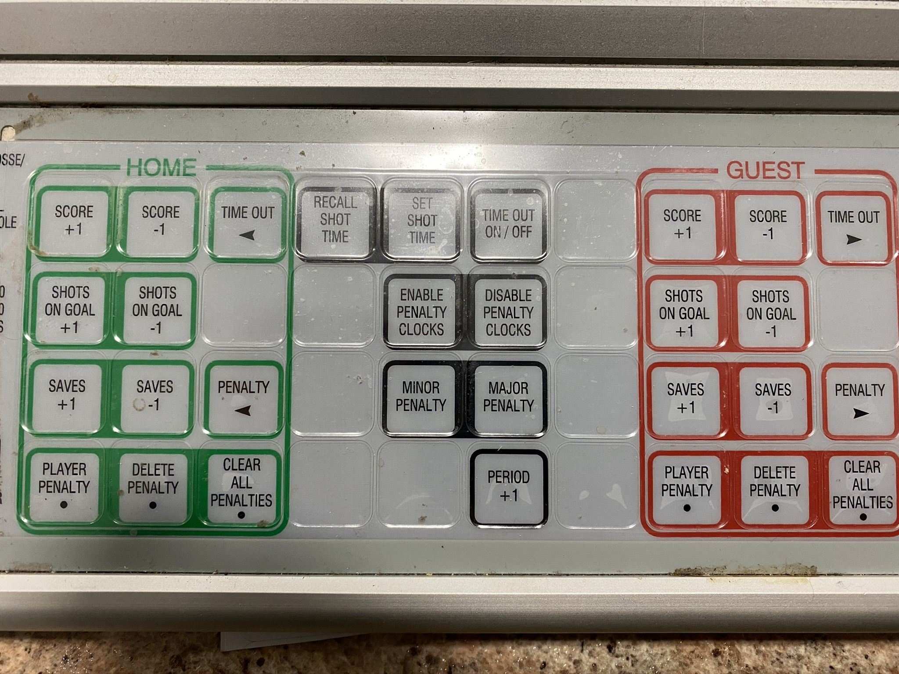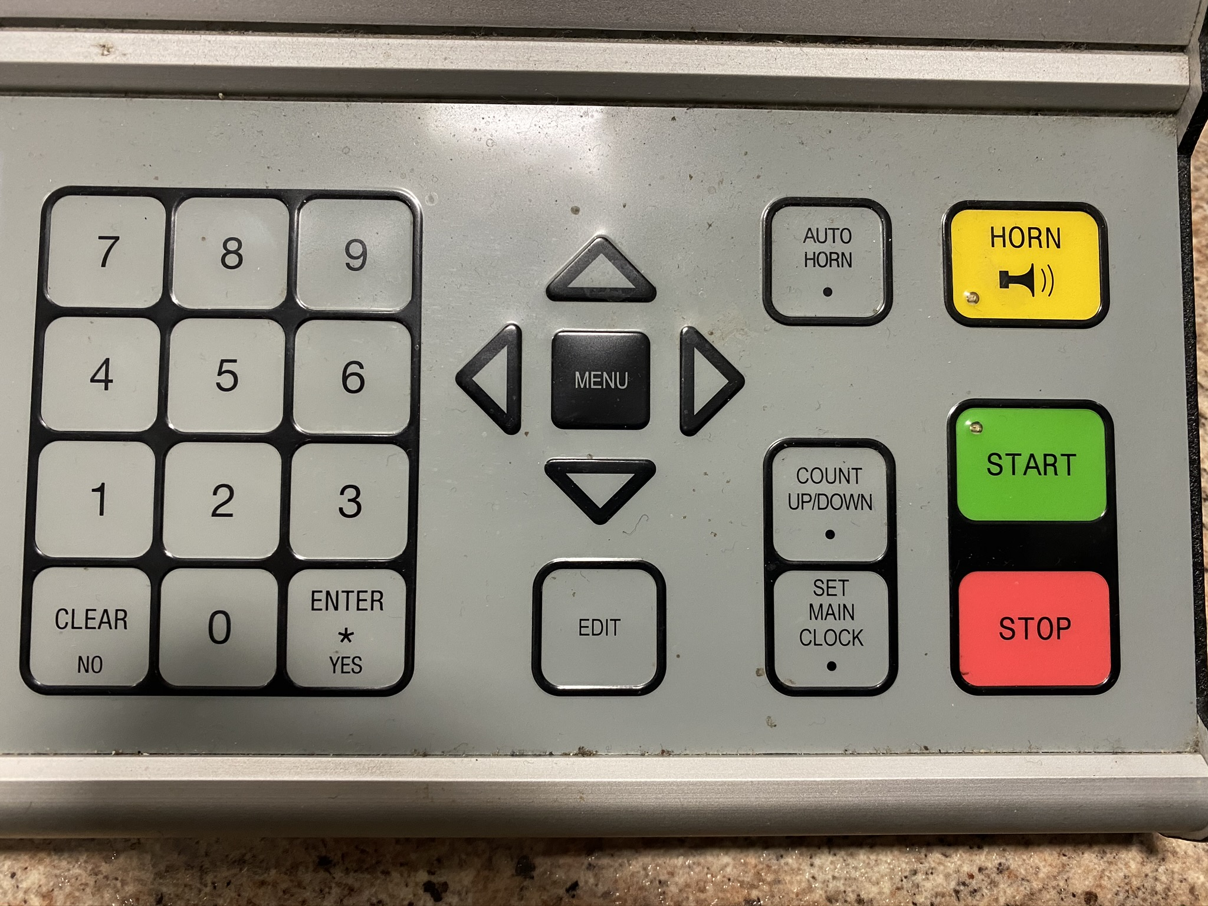

Hockey Mode – 4402 (if the clock every gets changed) New Game? yes
*the BOLD are BUTTONS (Double check the display on the clock)
Set Main Clock – warm up 5000 yes start
Periods. 15000 yes start when puck drops
Breaks 5000 yes start
*warm up, period, and break times are on the back for every level.
Home team = Green Visitor team = Red
Period: Period +1 (no -1 button so have to cycle through it all)
Goal: Score+1 or Score-1
Shots: Shots on Goal +1 or Shots on Goal -1
Time Outs: I just keep time on a different clock (phone or watch)
Penalties:
- Player Penalty
- Input players jersey # Enter*Yes
- Input penalty time 1300 Enter*Yes
  - See back for all penalty time lengths and information
- If period ends before penalty ends
  - Disable Penalty Clock before starting break time.
  - Enable Penalty Clock before starting the next period time.
Deleting penalty - When opposing team scores penalty is done.
- if only 1 penalty, hit Clear All Penalty and then click Enter*Yes
- If 2+ penalties, hit Delete Penalty and use arrow buttons to find the player with the shortest time left and click Enter*Yes

Please note times for warmups, periods, breaks, and penalties vary between levels!

