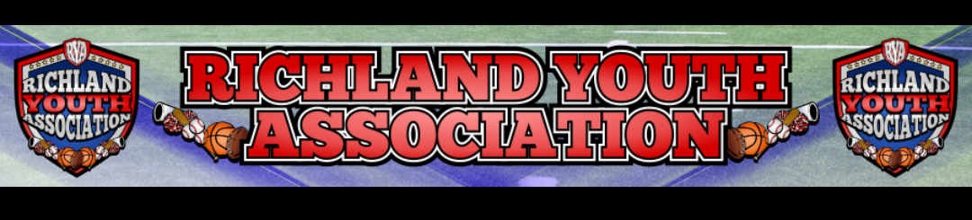
RYA JANUARY 2023 BOARD MEETING
Meeting Date: January 4, 2022 – 6:42pm
Board Member Attendees: Mike Cowan, Ben Earley, Blair Armfield, Richard Stutheit, Lisa Willis, Eric Gomez (speakerphone), Erica Stutheit, Emily Standifer (speakerphone), Brandon Lewis
Absent: n/a

General Board Items / Old News
- Insurance paid for 2023 – including insurance for kids with writers for NWTYFA, NCS, among others.
- No restitution payments from convicted individual.
  - Individual still owes $11,566 and has paid $13,444 to date.

Basketball: Blair Armfield
- All bills have been paid for season, except for officiating fees.
- Teams will play an 8-game season with games played on Saturdays.
  - Games start at North Richland MS this Saturday.
  - $3 tickets / game and $20 / season passes.
- Jerseys and shooter shirts have been received from Zexez – bill has been paid.
- Rings and medals have been ordered for each age division.

Rec Baseball: Richard Stutheit
- Registrations are open and early numbers are looking good – 78 registrations before meeting.
  - In-person registration to be held on January 21, 2023 at Dick’s in Hurst, time TBA.
- 15 additional signs have been ordered from Golden Rule Printing, approx. $9.50 / sign.
- Coaches Meeting on 1/21 also, time still TBA
  - Between 23-28 coach volunteers to this point
- Field repairs are still needed, especially on RF1 and RF2. Ben will check with city for timeline.
- Player Look – February 11th – 9am-noon
  - Prefer using RYA fields, but waiting for permission from NRH Parks and Rec.
  - Possible to use public field, Foster Village Fields (Watauga), or D-Bat Indoor Facility.
  - Informal setup to allow coaches to work with kids and get general sense of abilities.
- Interlock agreement with Haslet and Justin Youth Associations
  - Working to finalize uniformed rules between the three associations to avoid conflicts.
  - Potentially creating joint alliance group – NTXYBA – to help attract other nearby towns, adding extra teams and create community-building opportunity.
- Rule Changes – merging contradictory rules from website
- Spring Events – will work with Emily to finalize these
  - Parent Meeting on February 11th
  - Opening Day on March 25th
    - Need to work to get vendors – sno-cones, bounce houses, wiffle ball stations, honorary first pitch, National Anthem, etc.
  - Picture Day on April 15th with America’s Best Photography

Premier/Tournament Baseball: Kevin Vorpahl
- 1 team signed up for 8u Premier Baseball games only on RYA website
- 1 team signed up for 10u TEBA practices and games
- 2 teams plan to sign up for 14u TEBA practices and games
- 4 tournaments are scheduled for Spring season – posted on RYA and NCS websites

Football: Eric Gomez
- Multiple unpaid players – Eric will contact to see if some of that money from their registrations
- Potentially putting together 7-on-7 teams for RYA to play through Texas Elite for Spring

Cheer: Lisa Willis
- Pushing for more Cheer inclusion in NWTYFA – including cheer positions on their board.

Marketing: Brandon Lewis
- Cashapp-style program to take credit payments involving ticket sales, etc. at football events.
- Looking into creating a Fan Store platform on RYA website.
  - One company suggested was Black Acid Apparel (SC), which takes small cut for fees and manufacturing clothing items, then RYA would get a portion of proceeds. Could be kept open year-round.

Communications: Erica Stutheit
- Communications will be running updates to the website and to the social media pages.
  - Make everything uniform between the different sports programs to ensure that there is solidarity when communicating with parents.
  - Access regained for RYA Twitter account and attempting to regain access for Instagram.
  - Create more events on Facebook for RYA activities to build more community interest.
- Google Drive for Board documents created.

RYA Bank Accounts totaled $8,295.55 and $1,968.50

Meeting adjourned at 9:05 pm

