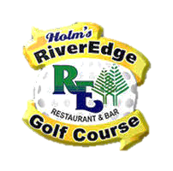
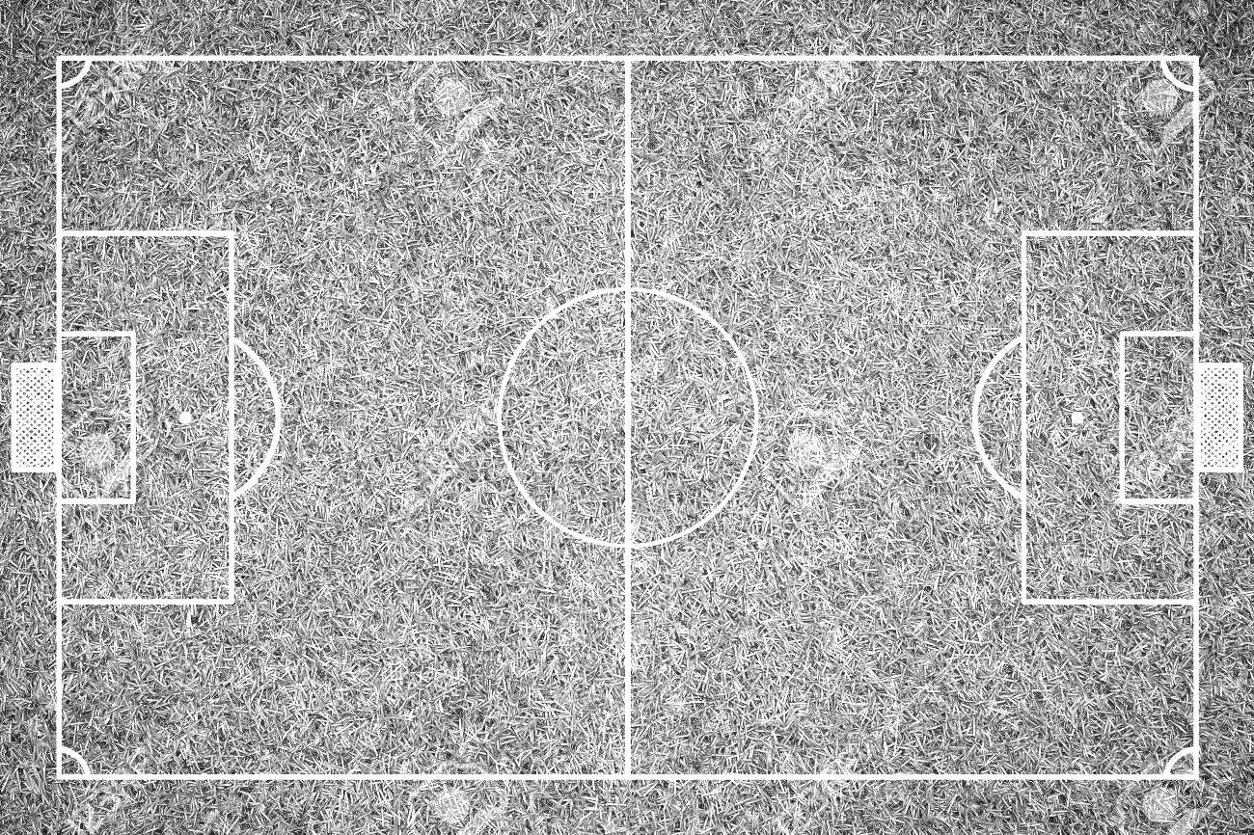
Tiger Turf Tour

Sponsorship Opportunities

Company Name:
Contact Person:
Phone #:
(please place a check next to the Sponsorships you are willing to provide)
- Beverage Sponsor: $1000
    - Free Registration of Four Golfers/One Team

- Cart Sponsor: $250
    - Signage Included and Free Register of One Golfer

- Hole Sponsors: (includes signage)
  - $300 for a Par 3 (Free Registration of 2 Golfers)
  - $400 for a Par 4 (Free Registration of 3 Golfers)
  - $500 for a Par 5 (Free Registration of 4 Golfers/One Team)

- Flag Event Sponsor: $100 per Event
  - Additional $50 for Two Signs

Sponsorship Total = $
# of Free Registrations (if earned):

Will bring door prizes: Yes No
Will bring an item to raffle: Yes No
Will donate money to the Committee to purchase prizes: Yes No

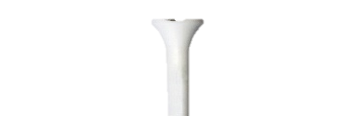
***All checks are payable to United School District of Marshfield (USDOM)
***Donated prizes may be dropped off at Ameriprise Financial, 1204 S Oak Ave, Marshfield, WI

