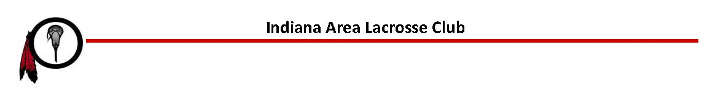

SPONSORSHIP INFORMATION

Dear Local Business Leaders, Supporters, and Friends,
Lacrosse is one of the fastest-growing team sports in the United States, and right here in Indiana County we are proud to be part of that momentum. The Indiana Area Lacrosse Club offers boys and girls in grades 1–8, as well as Indiana Area High School athletes, the opportunity to learn, play, and develop a lifelong love for the game.
We are a volunteer-run 501(c)(3) non-profit organization, committed to growing youth lacrosse and ensuring every child who wants to play has the chance to step on the field. Last year, more than 150 young athletes participated in our programs — a number that continues to increase as interest in the sport grows.
Thanks to the continued support of the Indiana Area School District, we have been able to keep registration costs lower for families, helping make lacrosse more accessible to youth across the community. However, to provide a safe and competitive program, we must still cover essential operating expenses including equipment, field rentals, medical trainers, uniforms, field side medics, tournaments, and certified referees.
This is where local partners like you make a real difference.
We are seeking sponsors for our 2026 season whose generosity will directly support opportunities for youth development, fitness, teamwork, and leadership. Your sponsorship is more than a donation — it is an investment in our community’s children.
Research and experience show that youth involved in sports:
• Build confidence and leadership skills • Are more likely to have positive academic and social outcomes • Stay active and maintain long-term healthy habits • Learn teamwork, communication, and discipline
Sponsorship opportunities and our online commitment form can be found at:
www.ialacrosse.com
Whether you sponsor a team, donate equipment, or support us financially, your contribution will help young athletes grow on and off the field. We truly appreciate your consideration and would be honored to partner with you this season.
Thank you for supporting youth athletics in Indiana County.
With appreciation,
The Indiana Area Lacrosse Club

Indiana Area Lacrosse Club
President: Melissa Campisano Vice President - Varsity: Molly Russell Vice President – Youth: Elizabeth Poje Hawk Treasurer: Tracy Buterbaugh Secretary: Katie Rescenete
Board Members:
Brenda Lonetti, Amy Ligas, Tammy Lowman, Kristy Myers, Rhonda Peiffer, Heather Redinger, Renee Thomas

Indiana Area Lacrosse Club Sponsorship Form

Company Name: ___________________________ Contact Name: _____________________

Contact Email: _________________________________________________________________

Contact Address: _______________________________________________________________

Amount of sponsorship: $________________________________

Game Winner Goal Sponsor $500 or more
- Business with company logo or family name listed on Club Facebook page, website (ialacrosse.com) home page and sponsor page with website link (if applicable)
- Recognition during announcements at home games and team events
- Prominent T-shirt advertisement
- Free T-shirt and free IALAX decal

Top Cheddar Goal Sponsor $250
- Business with company logo or family name listed on Club Facebook page, website (ialacrosse.com) home page and sponsor page with website link (if applicable)
- Recognition during announcements at home games and team events
- Prominent T-shirt advertisement

Face-off Sponsor $150
- Business with company logo or family name listed on website (ialacrosse.com) sponsor page with website link (if applicable)
- Recognition during announcements at home games
- T-shirt advertisement

Ground Ball Sponsor $100
- Company logo or family name listed on website (ialacrosse.com) sponsor page
- T-shirt Advertisement

Scoop and Cradle Sponsor $50
- Business card ad or family name listed on website (ialacrosse.com) sponsor page
- T-shirt Advertisement

Please return this form with your check by February 28, 2026 to:

Indiana Area Lacrosse Club, PO Box 151, Indiana, PA 15701
** Please email an electronic logo to ialaxclub@gmail.com **

