Instructions for Ordering Jimmy John’s for Sports Teams
**DUE TO QUANITY OF ORDERS, ORDERS MUST BE PLACED AT LEAST 24 HOURS IN ADVANCE**
**NO EXCEPTIONS, THE ORDERS MUST BE PLACED 24+ HOURS IN ADVANCE**

- Go to jimmyjohns.com
  - Choose Pickup – 55901
    - Select the 2986 41st St NW location
  - Create Account – YOU MUST CREATE A NEW ACCOUNT AND FOLLOW INSTRUCTIONS FOR TEAM ORDERS. (EVEN IF YOU ALREADY HAVE AN EXISTING ACCOUNT)
    - First Name Box – Type student’s FIRST AND LAST name into box.
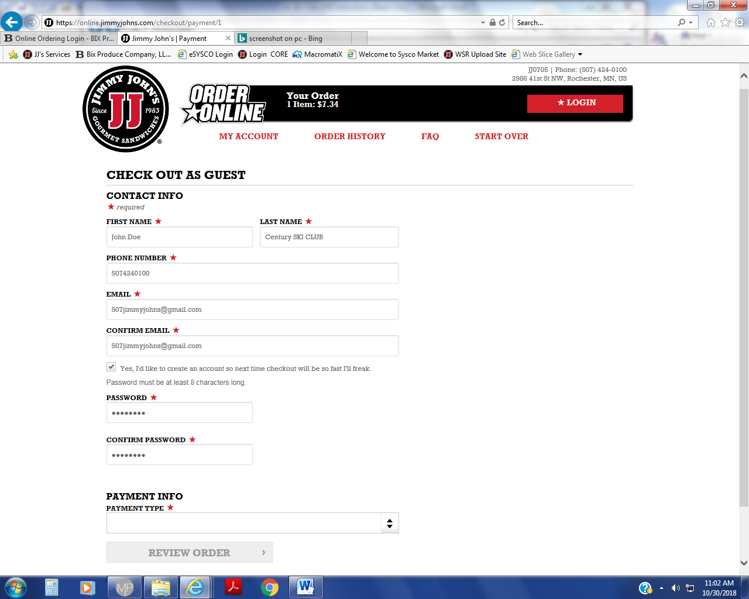
    - Last Name Box – Type student’s SCHOOL, SPORT, & SQUAD into box. (Include Boys or Girls team!)
    - Please re-read and follow these instructions accordingly, as steps I and II are very important!
    - You can order up to 30 days in advance.
    - If you make a mistake while ordering, you will need to call the store to fix any errors.
  - ORDER
- Choose Sandwich and sides of choice
- To prolong the freshness of sandwiches we recommend you order NO mayo on the sandwiches and add it on the side. We DO NOT offer TOASTED sandwiches for Sports Teams.
      - Customize Sandwich > Mayonnaise “NO”
      - Customize Sandwich > Add Mayo/ Mustard Packets
- Order Only WATER to drink, as that’s the only beverage allowed on the Bus.
  - CHECKOUT
    - Select Date and set Pick-Up Time using the table below
      - Shaeffer Academy – 1:30
      - Century High School – 1:45
      - John Marshal High School – 2:00
      - Lourdes High School – 2:15
      - All Other teams use 2:30
(Note: These times help Jimmy John’s organize your orders more efficiently, the actual pick up time is determined by our team contact. Please make sure the appropriate time is selected.)
    - All orders that are specified with school and team name will go together. If you don’t specify the school and team name, your student won’t get their order! We handle MANY teams at once, so please be sure the order is labelled correctly!!! – All orders without team information are assumed to be regular pick up orders and are left on the pickup shelf!
    - With your new account, you will be able to save your order and payment information for easy re-ordering.
    - Double check the phone number is correct on the checkout page to ensure we can contact you if we have any questions about your order.

