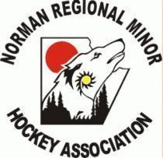
Norman Minor Hockey Association
2026 Manitoba Games - Thompson MB March 1-7

Hockey Manitoba is pleased to share information regarding their new Gold Standard development program. Phase #1 will be at the Manitoba Games being held in Thompson this season. This program is for 2013 born (boys) and 2013 & 2014 born (girls). Please click the link for more information about this program. https://docs.google.com/document/d/1IuRVD9TtMuks21Fw4_9R_Yg3RzkRPeB8/edit

Norman Minor Hockey is working with Hockey Manitoba and will be hosting a tryout for all players interested in this program.

Manitoba Games Team Norman - Tryout dates: Dec 22 &23 in Flin Flon (Sportex).

Tryout fee: $50 (e-transfer available)

Link for players to register: https://docs.google.com/forms/d/e/1FAIpQLSfpoUUh_PMzT_Deb6e6xX7FXHeiT6jmDPhutMj-yprK8gHHDQ/viewform?usp=header

Link for coaches to apply : https://docs.google.com/forms/d/e/1FAIpQLSdtmmCYsx0WvjXYQiznkZgjv5b4rXGI4TbytftzcbAKXPZY_w/viewform?usp=sharing&ouid=115208551795701715817

Manitoba Games links : https://games.ccsam.ca/

Itinerary to follow after registration deadline : Based on # of registrations.

