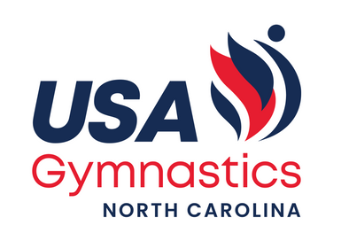
2025-2026 IMPORTANT DATES

*NC Qualifier Submission Deadline: 7/31/2025
*USAG Athlete/Coach Membership Renewal begins 8/1/2025 *Meet Intent (Fall 2025 Meets): 8/20/2025
*Meet Intent (Spring 2026 Meets): 10/1/2025

*Compulsory State Meet: Dec. 13-14, 2025 (Southeastern)
*Compulsory State Meet Entry Deadline: 11/24/2025 *Declaration Date & Last Qualifier Date: 11/30/2025

*Bronze & Silver State Meet: March 21-22, 2026(Central Carolina)
*Bronze & Silver State Meet Entry Deadline: 3/2/2026 *Declaration Date & Last Qualifier Date: 3/8/2026

*Optional State Meet: March 27-29, 2026 (RSG/Morrisville)
*Optional (L6-10) State Meet Entry Deadline: 3/9/2026 *Declaration Date & Last Qualifier Date: 3/15/2026
*G/P/D/Sa State Meet: April 11-12, 2026 (Rose’s)
*G/P/D/Sa State Meet Entry Deadline: 3/23/2026
*Declaration Date & Last Qualifier Date: Meet: 3/29/2026

