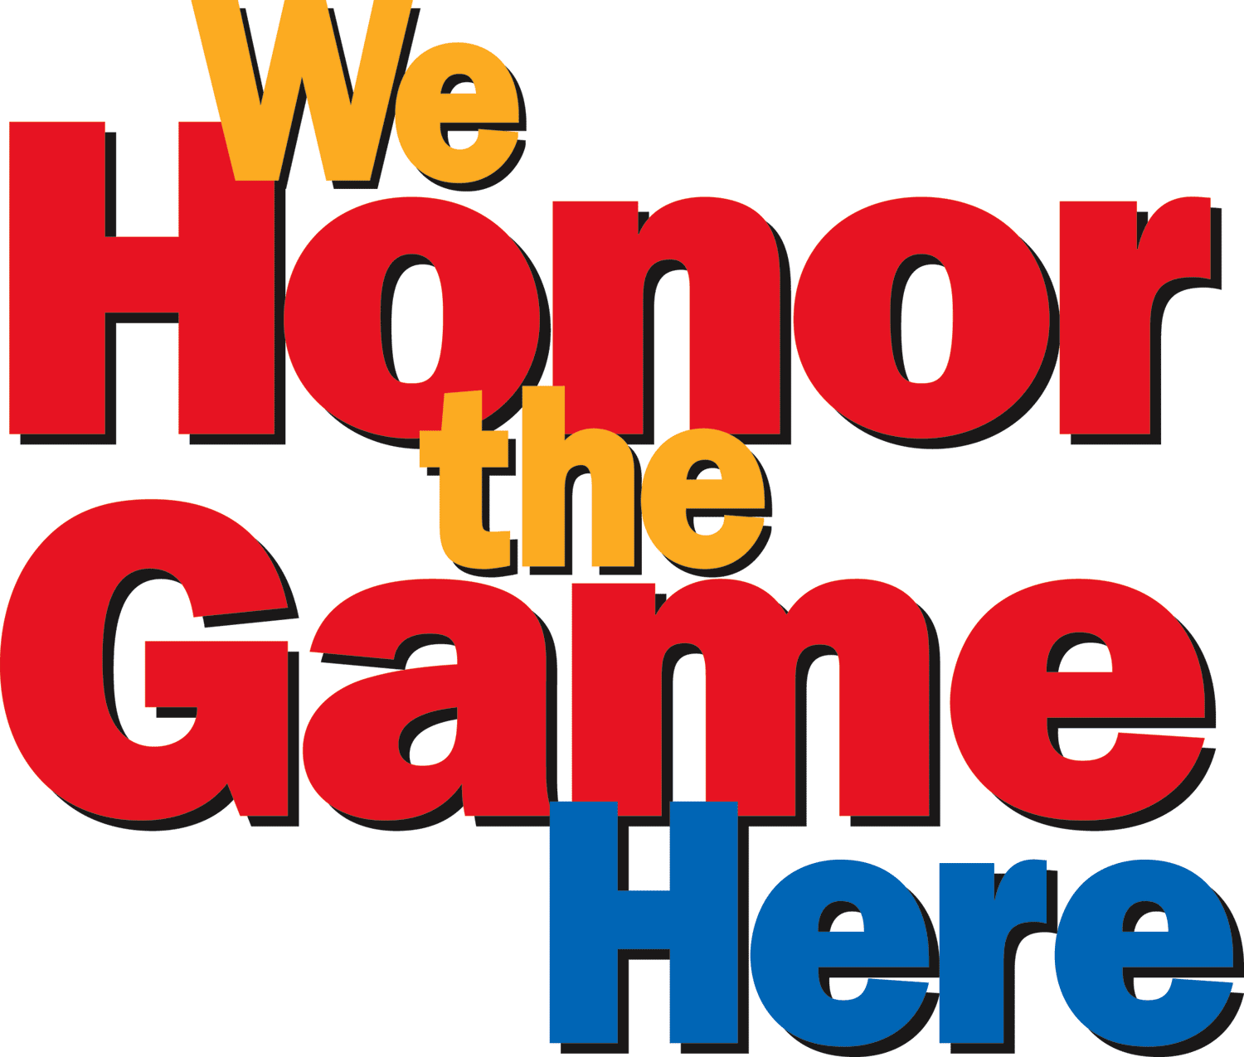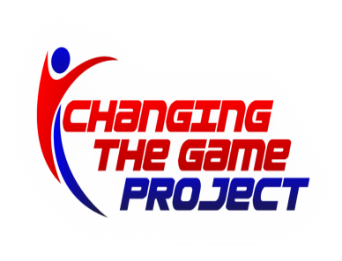
GBL Membership Meeting 9/17/18

-Minutes of prior meeting online
-Registration update- Registration going as hoped, a few lagging leagues, but generally at or ahead of this time last year
-Coach selections ongoing, commissioners meeting upcoming
-New GBL Rules for 2018-2020 have been posted on the site
-Bylaws changes were unanimously approved and adopted. New bylaws are posted on the GBL site.
-Carter Welch will now be the GBL Scheduling Coordinator
-Mark Matlosz will serve as 3rd grade girls commissioner
-Travel teams will be finalized with 2 new B teams at 5th grade boys and 6th grade boys. Depsite a valiant effort by Ray Iglesias, 6th girls will not have enough players to field a B team.
-Rec Coaches meeting upcoming 10/16 on the site
-Attendees: John Letizia, Allan Voytek, Enrique Rivera, Shawn Love, Damian Lynch, Bob Meehan, Angela Philbin, Bruce Freeman, Thatcher Zuse.

